

**SpiraTest®, SpiraTeam®, SpiraPlan®**

**Administration Guide**

Version 6.0

Inflectra Corporation

Contents

1. Introduction 1

2. Installing SpiraPlan® 2

2.1. System Prerequisites 3

2.2. Installing the Software 10

2.3. Security Considerations 18

3. System Administration 19

3.1. System: Workspaces 23

3.2. System: Users 30

3.3. System 39

3.4. System: Integration 54

3.5. System: Reporting 59

3.6. Product: General Settings 72

3.7. Product: Users 79

3.8. Product: Planning 81

3.9. Template: Requirements 85

3.10. Template: Releases 92

3.11. Template: Documents 97

3.12. Template: Test Cases 103

3.13. Template: Incidents 110

3.14. Template: Tasks 120

3.15. Template: Risks 126

3.16. Template: Custom Properties 134

3.17. Template: Notifications 139

4. Appendices 144

# 1. Introduction

The Spira™ family of applications from Inflectra® are a powerful set of tools that help you manage your software lifecycle.

SpiraTest® is our powerful and easy to use requirements, test and defect management system, ideal for quality assurance teams.

SpiraTeam® is our integrated Application Lifecycle Management (ALM) system that manages your product's requirements, releases, test cases, issues and tasks in one unified environment.

SpiraPlan® expands on the features in SpiraTeam® to provide a complete Enterprise Agile Planning® solution that lets you manage products, programs and the entire organization with ease.

This administration guide outlines how to setup a working installation of all three Spira™ products (for on-premise customers), and how to perform routine administrative tasks.

It assumes a basic understanding of how to setup and administer a Windows Server®, or Windows® workstation, and also assumes that you have access to a valid Administrator level account.

For information on how to use the features of SpiraTest®, SpiraTeam®, or SpiraPlan®, please refer to the *SpiraPlan®**User Manual* instead.

# 2. Installing SpiraPlan®

This section outlines how to prepare your system for installation of SpiraPlan®; how to install the software; and how to ensure that your web-server is correctly configured to ensure secure operation.

The first sub-section will outline what hardware and software configurations are supported and the exact installation sequence for the different versions of Windows Server. The second sub-section will explain how to load the SpiraPlan® software onto the server, and discuss common problems and solutions.

The minimum hardware and software requirements for running the SpiraPlan®system are:

|  |  |
| --- | --- |
| **Server Requirements** | |
| **Requirement** | **Minimum Specification** |
| **Processor:** | Intel® or AMD® x86 or x64 compatible processor |
| **Memory:** | 4 GB, 8 GB recommended |
| **Operating System:** | Windows Server 2019 (recommended)  Windows Server 2016 (recommended)  Windows Server 2012 R1 & R2  Windows Server 2008 R1 & R2  Windows 10, 8, 7 (for demoing) |
| **Database:** | Microsoft SQL Server 2017  Microsoft SQL Server 2017 Express Edition  Microsoft SQL Server 2016  Microsoft SQL Server 2016 Express Edition  Microsoft SQL Server 2014  Microsoft SQL Server 2014 Express Edition  Microsoft SQL Server 2012  Microsoft SQL Server 2012 Express Edition  Microsoft SQL Server 2008 R2  Microsoft SQL Server 2008 R2 Express Edition |
| **Web Server:** | Internet Information Services (IIS) 7.0 or higher  ASP.NET Web Extensions 4.6 or higher |
| **Client Requirements** | |
| **Requirement** | **Minimum Specification** |
| **Web Browser:** | Microsoft Edge  Internet Explorer 11.0+  Mozilla Firefox  Google Chrome (Desktop and Android)  Apple Safari (Desktop and iOS)  Opera |
| **Other Components:** | Microsoft Excel 2003+ (optional)  Microsoft Word 2003+ (optional)  Microsoft Project 2003+ (optional) |

*Note that SpiraPlan®can be loaded onto either Windows Server or workstation editions, provided that the IIS web-server is installed and that SQL Server is available as a database engine. However, Windows workstation editions can only support a maximum of 5 concurrent user web sessions. In general, unless there are only going to be a couple of client machines hitting the server, we recommend using Windows Server.

## 2.1. System Prerequisites

Assuming that you have already installed the appropriate version of Microsoft Windows onto your computer (or that has been pre-installed for you), you need to then make sure that the various prerequisites have been correctly added to your installation before trying to install SpiraPlan®. The SpiraPlan®installer will check to ensure that the various prerequisites are in place, and will abort the installation if any are missing, indicating to you what action needs to be taken.

We recommend that you install / configure the prerequisites in the following order:

* Install the .NET Framework v4.6
* Install SQL Server 2017, 2016, 2014, 2012, 2008R2
* Install the latest version of Internet Explorer that your server OS allows
* Ensure that IIS is installed
* Ensure that ASP.NET 4.6 is enabled

### 2.1.1. Install the .NET Framework v4.6 or v4.7

On most modern Windows 10 and Windows Server installations, Microsoft .NET Framework v4.6 is usually installed as part of the factory configuration, whereas on earlier operating systems, you might need to manually add the .NET 4.6 components to the factory configuration.

To see which version of the Microsoft .NET framework installed, open up Windows Explorer® and navigate to C:\WINDOWS\Microsoft.NET\Framework and then the subfolders listed will indicate which version(s) of the framework you have installed:

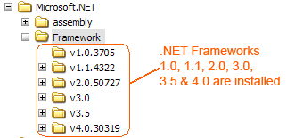

To install the .NET Framework, launch Internet Explorer and enter the URL: <https://www.inflectra.com/CustomerArea>. Once you have logged-in to the customer area, under the “My Downloads” section there will be hyperlinks to download and install the appropriate version of the .NET Framework (version 4.6 at time of writing). Click on the option to download and install the .NET Framework, and follow the instructions provided. Once you have completed the install, verify that the installation was successful by looking in the “Administrative Tools” folder as illustrated above. You also need to make sure that .NET 4.6 has been installed if necessary.

### 2.1.2. Install SQL Server 2017, 2016, 2014, 2012, or 2008R2

If you do not have a SQL Server instance ready, you can install the appropriate version of the database software, following the instructions provided with the installation. We recommend SQL Server Express Edition® for most users. This free version of SQL Server will offer sufficient performance for most installations and can be easily downloaded from either the customer area of our website (<http://www.inflectra.com/CustomerArea>) or directly from the Microsoft® web-site at <http://www.microsoft.com/express/sql>.

### 2.1.3. Ensure that IIS is installed

On Windows Server OS installations, IIS is usually installed as part of the factory configuration, whereas on Windows workstation OS installations, you typically need to manually add the components to the factory configuration. The steps that you need to take to verify its installation are listed below:

To check if you have IIS installed, click Start > Control Panel > Administrative Tools. Under the “Administrative Tools folder”, you should see an icon for “Internet Information Services (IIS) Manager”. If you don’t see this icon, then it means that you need to add IIS to your computer:

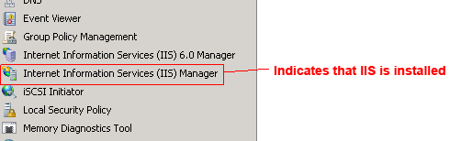

**a) Windows 7**

To install IIS on **Windows 7**, you need to click Start > Control Panel > Programs and Features, then choose the option to “Turn Windows features on or off”. This will bring up the list of features and roles that can be configured on the server:

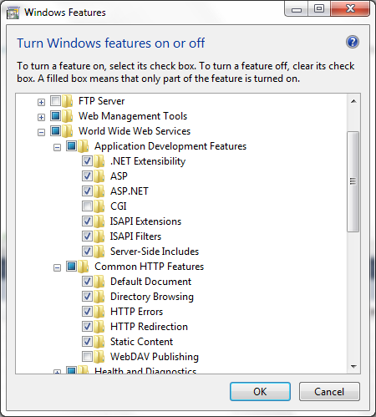

**b) Windows 8, Windows 8.1**

On **Windows 8 or 8.1**, to install IIS, you need to click Start > Control Panel > Programs and Features, then choose the option to “Turn Windows features on or off”. This will bring up the list of features and roles that can be configured on the server:

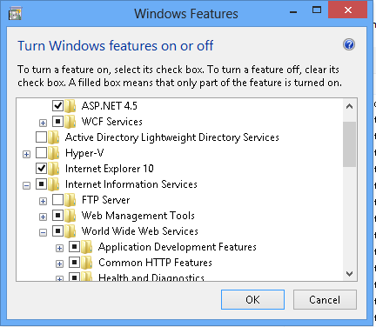

**c) Windows 10**

On **Windows 10**, to install IIS, you need to click Start > Control Panel > Programs and Features, then choose the option to “Turn Windows features on or off”. This will bring up the list of features and roles that can be configured on the server:

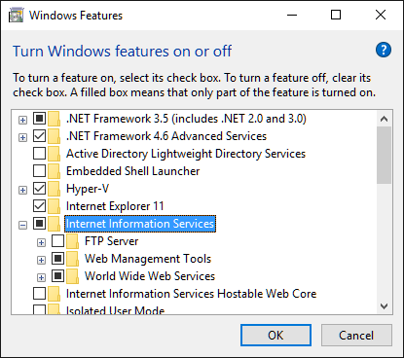

Make sure that the following features are enabled within the 'Internet Information Services' folder:

* Web Management Tools
  + IIS Management Console
  + IIS Management Service
* World Wide Web Services
  + Application Development Features
    - .NET Extensibility 3.5
    - .NET Extensibility 4.6
    - ASP.NET 3.5
    - ASP.NET 4.6
    - ISAPI Extensions
    - ISAPI Filters
  + Common HTTP Features
    - Default Document
    - Directory Browsing
    - HTTP Errors
    - HTTP Redirection
    - Static Content

In the same panel ('Turn Windows Features on or off') you also need to check that the following features are enabled in the '.NET Framework 4.6 Advanced Services' folder:

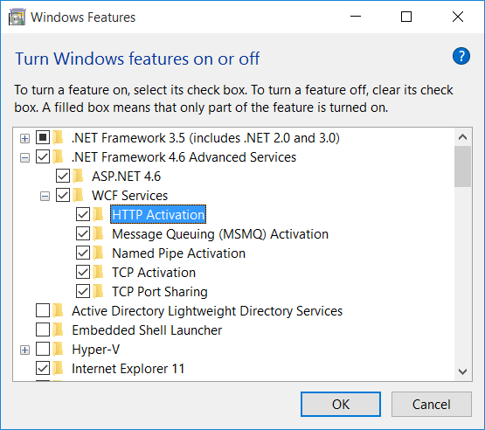

* .NET Framework 4.6 Advanced Services
  + ASP.NET 4.6
  + WCF Services
    - HTTP Activation
    - TCP Port Sharing

To verify that this IIS is now installed, type [http://localhost](http://localhost/) into the address bar of Internet Explorer on your computer. You should see a screen displaying the initial IIS startup page:

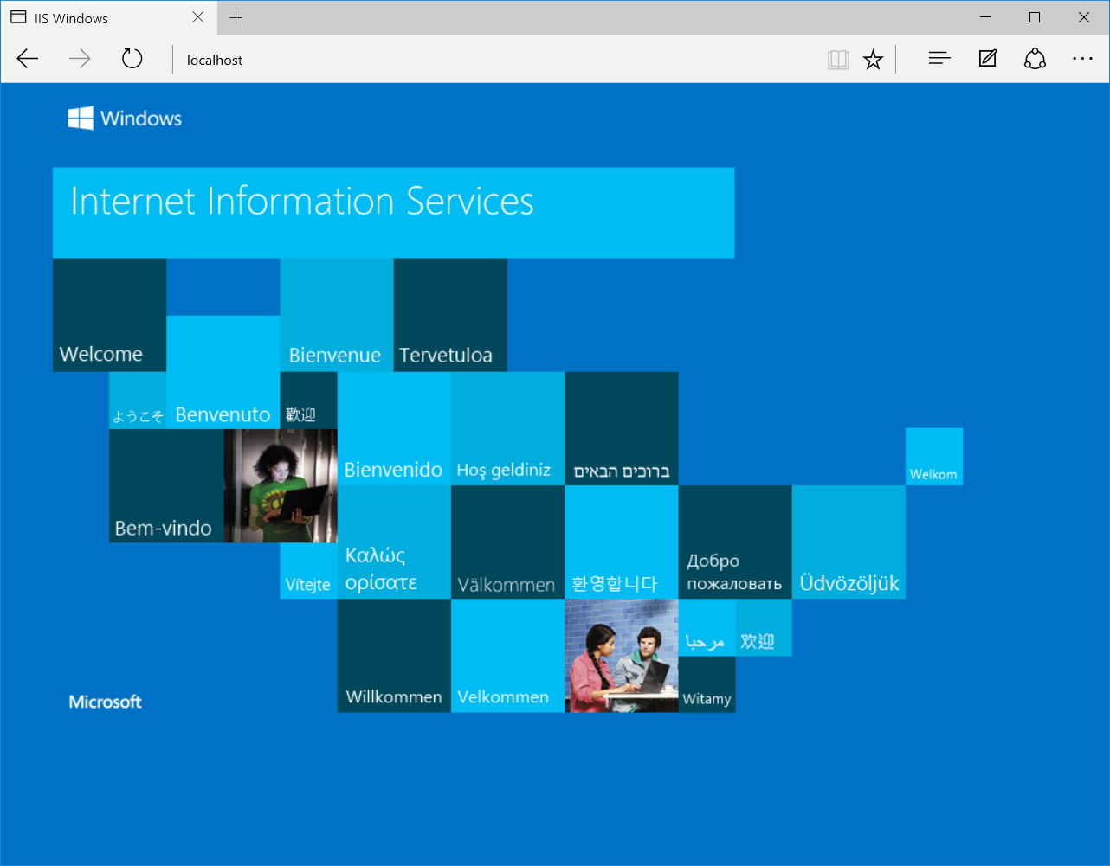

**d) Windows Server 2008 / 2008 R2**

On **Windows Server 2008**, you need to click on Server Manager, then under the “Roles” heading, choose the option to “Add Role” followed by selecting the new role “Web Server / IIS”. Then click “Next” to bring up the role configuration screen:

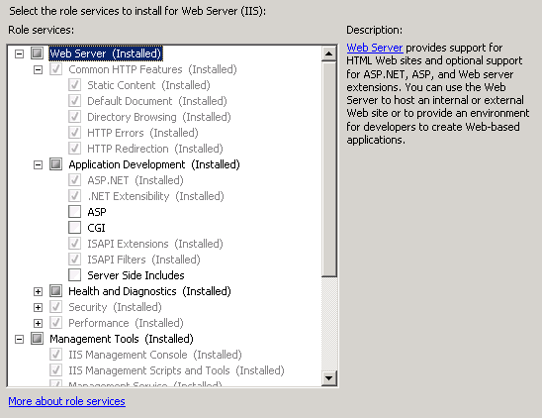

Make sure that the following features are enabled:

* Common HTTP Features
  + Static Content
  + Default Document
  + HTTP Errors
  + HTTP Redirection
* Application Development
  + ASP.NET
  + .NET Extensibility
  + ISAPI Extensions
  + ISAPI Filters
* Management Tools
  + IIS Management Console
  + IIS Management Service

To verify that this IIS is now installed, type [http://localhost](http://localhost/) into the address bar of Internet Explorer on your computer. You should see a screen displaying the initial IIS startup page:



**e) Windows Server 2012, 2016, 2019**

On **Windows Server 2012, 2016, 2019**, you need to click on Server Manager, then under the “Roles” heading, choose the option to “Add Role” followed by selecting the new role “Web Server / IIS”. Then click “Next” to bring up the role configuration screen:

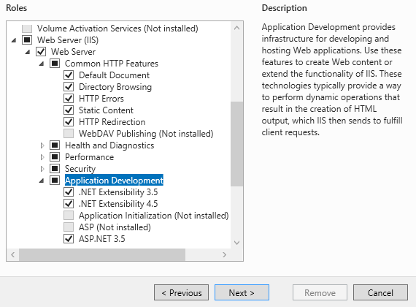

Make sure that the following features are enabled:

* Web Server (IIS)
  + Web Server
    - Common HTTP Features
      * Default Document
      * Directory Browsing
      * HTTP Errors
      * Static Content
      * HTTP Redirection
    - Application Development
      * .NET Extensibility 3.5
      * .NET Extensibility 4.5
      * ASP.NET 3.5
      * ASP.NET 4.5
      * ISAPI Extensions
      * ISAPI Filters
    - Management Tools
      * IIS Management Console
      * IIS Management Service
* .NET Framework 4.5 Features
  + .NET Framework 4.5
  + ASP.NET 4.5
  + WCF Services
    - HTTP Activation
    - TCP Port Sharing

### 2.1.4. Ensure that ASP.NET is installed

Now that you have both IIS and .NET installed, you need to make sure that the Active Server Pages (ASP.NET) components that allow IIS to access the .NET framework have been correctly configured. If you installed .NET *after* IIS then ASP.NET is typically configured for you, but if you installed IIS afterwards, then further manual steps may be necessary.

To verify that ASP.NET has been correctly configured, click on Start > Control Panel > Administrative Tools > Internet Information Services (IIS) Manager to launch the IIS administrative console:

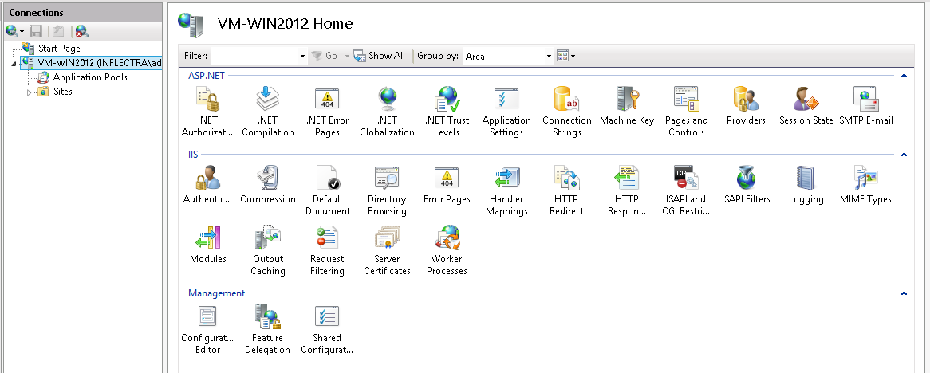

You should see a section called “ASP.NET” occupying the top third of the IIS screen. If not, then you need to go back to section 2.1.4 and make sure that you chose the option to install ASP.NET when installing IIS.

## 2.2. Installing the Software

Now that all the prerequisites have been correctly installed, you are now ready to install SpiraPlan®onto your system. To perform the installation, you will need the installation package downloaded from the Inflectra® website, the name of the organization that the software is licensed to, and the actual license key code which will be available in the customer area of the Inflectra® website.

To start the installation, double-click on the SpiraPlan®installation package (it will have a filename in the form of SpiraTestPlanTeam-vX.X.X.X.exe), and the Windows Installer will display the following dialog box:

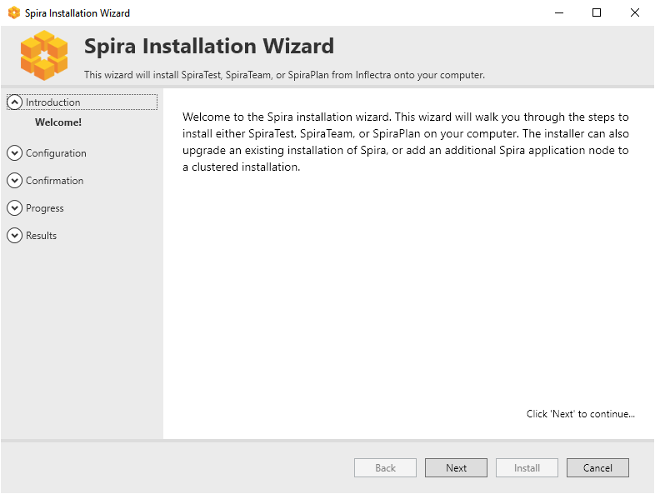

### 2.2.1. Select an Installation Type

Click the “Next” button to start the installation wizard. The wizard will gather information about what you want to do and how you want to do it. Before any changes are made to your system (installing web-server files and database components) you will get a chance to review everything again.

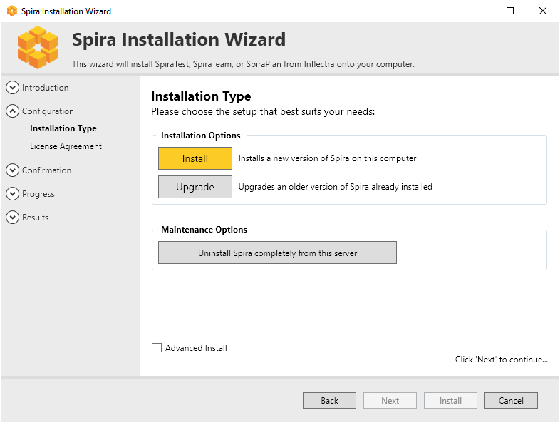

### 2.2.2. Reviewing the License Agreement and Prerequisites

If installing a fresh installation or upgrading, after making your selection the next screen provides a copy of the SpiraPlan®End User License Agreement (EULA). Please read this carefully as it describes the legal contract between you – the user of the software – and Inflectra® Corporation, the developer and publisher. Once you have read the agreement and understood your rights and obligations, select the radio button marked “I accept the terms in the License Agreement” and click the “Next” button.

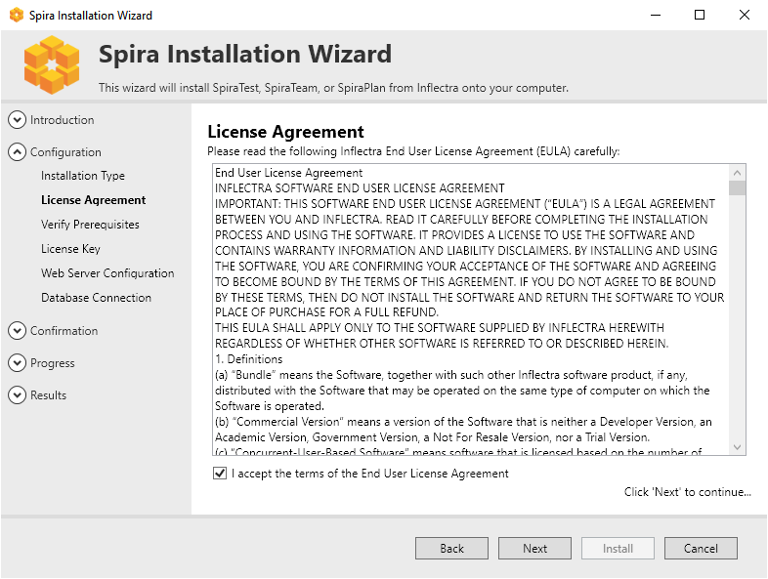

The next page of the wizard will display a list of the required pre-requisites and whether the installer could find them or not. The checks here are not fool-proof (in particular where a question mark is shown) so it is recommended to manually check the prerequisites in full as described above. The system will not require all prerequisites to be met before allowing the installation but may not cause the application to display correctly.

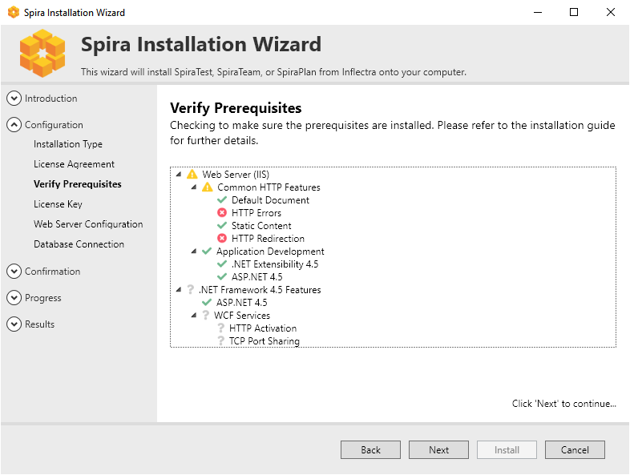

### 2.2.3. License Information

The next stage of the wizard (for installing and upgrading) is entering license information:

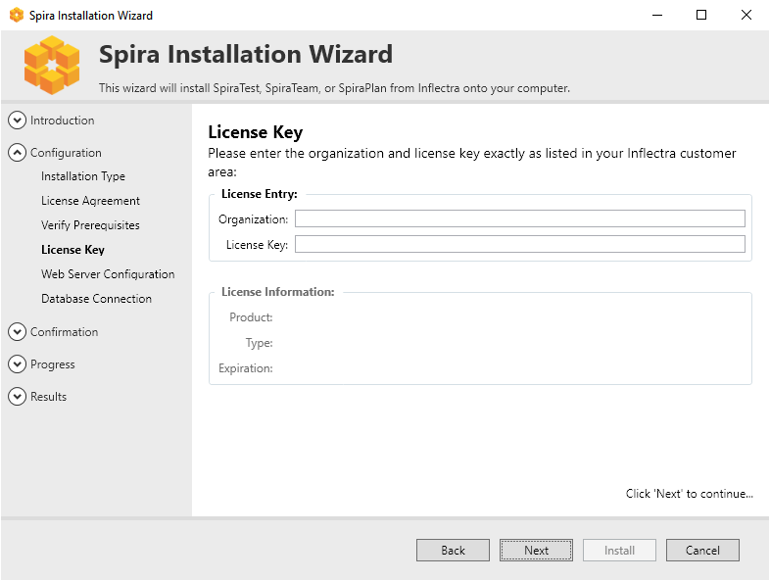

You need to enter the ***organization that was issued the software license***, and the full license key that was provided with the software. The installer will verify the license information as you enter it. If the details entered are valid then the information will be displayed beneath the entry fields. This allows you to check that the correct application and license will be installed. On clicking Next, the installer will warn you of any discrepancies, and will not allow you to proceed until valid information has been provided.

If for any reason you are unable to get the provided license key to work, please contact Inflectra® customer support immediately and they will resolve the issue.

### 2.2.4. Choosing an Installation Location [Advanced only]

If you checked “advanced” at the start of the installation process, you will have the option to choose where the application is installed. **Please note that this is meant for advanced users only**.

You can choose an existing folder or make a new one and select that. By default it is C:\Program Files (x86)\[Application Name]).

### 2.2.5. Web Server Configuration

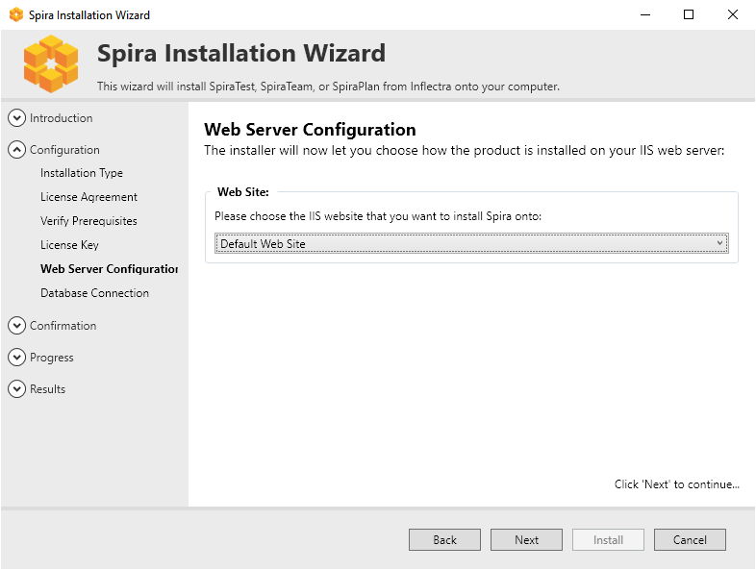

Choose which web site to install Spira int using the available dropdown, which should list all available web sites in IIS on this machine. The Default Web Site will be preselected and is the best option in most circumstances.

**Virtual Directory [advanced only]**

If installing in advanced mode, then you can also on this screen you will able to change the name of the web-site URL that will be user to access the system. By default, users would need to type into their browsers: http://”server name”/[product name]. Should you want to have a different name change the name in the Virtual Directory box, otherwise simply accept the default name and click “Next”. Note: The installer will check to make sure that the name you have chosen is not already in use, and will warn you if it is.

### 2.2.6. Connecting to the Database

SpiraPlan has an application (installed into a default folder on your system), a website (configured above), and a database. The next screen tells the installer how to connect to the database server on your system.

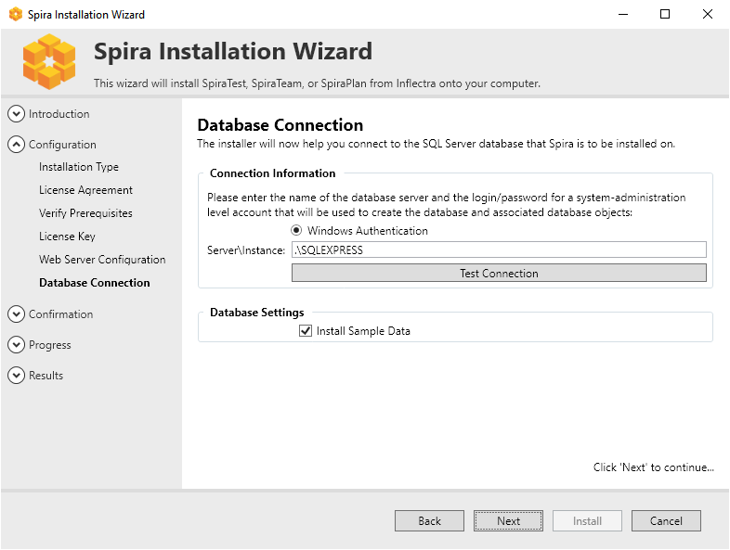

**a) Windows Authentication**

This is the easiest option when the application and database will be residing on the *same* server. It is the only option available for authentication during a standard installation. In this case, choose the “Windows Authentication” option and the Login/Password boxes will be disabled. In this case, the installer will connect to the database using your current Windows login to create the application database objects, and SpiraPlan® will connect to the database during normal operation using either the ASPNET or NETWORK SERVICE Windows accounts (it depends on the version of the operating system).

**b) SQL Server Authentication [advanced only]**

This is the easiest option when the application and databases will be residing on *different* servers across the network. In this case, choose “SQL Server Authentication” and provide a SQL Server Login that has Database Owner (DB-Owner) permissions – e.g. the built in System Administrator (SA) account. The installer will use this DB-Owner account to create the database objects, and SpiraPlan® will use a special login (called SpiraPlan by default) for normal application operations.

**Setting the Correct Server Instance**

In the “Server” box, you need to enter the name of the Microsoft SQL Server instance that is running on your system; the installer will default it to the hostname of the server (which in many cases will be correct). The easiest way to find out the database server name is to open up the SQL Server Administrative console (typically by clicking Start > Programs > Microsoft SQL Server > Enterprise Manager) and look for the name of the server.

For SQL Server 2005/2008 Express edition installations, the Server name is usually the name of your computer followed by “\SQLEXPRESS”, so for example, if your computer is called MyComputer, the server name would be MyComputer\SQLEXPRESS. Omitting the second part (called the instance name) would lead to a “host not found” error.

You can also choose whether to install the sample products or not – typically we recommend installing the sample products for evaluation installations and excluding them for production installs.

### 2.2.7. Completing the Installation

Once you have entered the various pieces of information, click “Next”. The installer will attempt to connect to the database using the provided information, and it will display an error message if any of the information is incorrect. Assuming the information is correct, the following screen will be displayed:

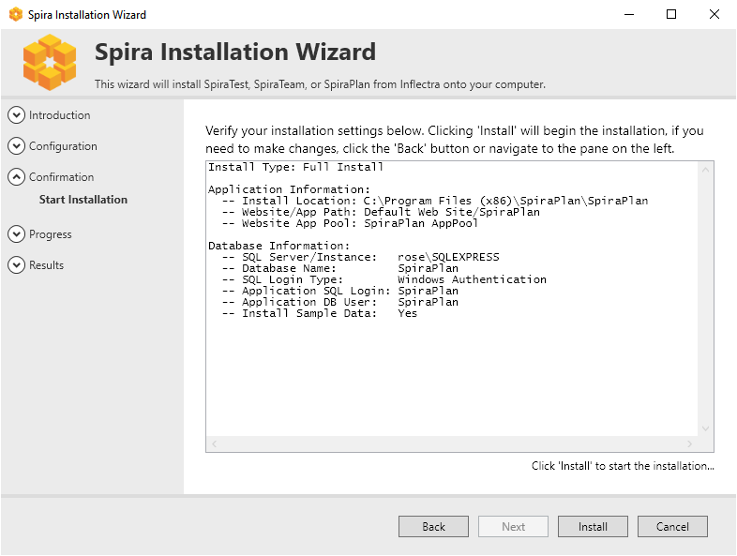

Once you have confirmed that everything is correct, click the **“Install”** button to actually begin the process of installing SpiraPlan®onto your system. The installer will then display a progress bar as the installation proceeds. Once the installation is complete, the installer will provide confirmation, or display information about any problems it encountered.

Click the “Finish” button to complete the installation.

Congratulations! You have successfully installed SpiraPlan®onto your system. If you type <http://localhost/SpiraTeam> into your browser you should see the SpiraPlan®login page, as illustrated in the *SpiraPlan®User Manual*. If for any reason you don’t see the login page, please refer to *Appendix A – Troubleshooting IIS* or contact Inflectra® Technical Support using one of the methods described at our website <http://www.inflectra.com/Support>.

### 2.2.7. Upgrading

Upgrading an existing installation is performed by executing the same

To upgrade an existing installation, execute the same installer, and on the Installation Type screen, select the “Upgrade” button:



You will then be asked to agree to the EULA, it will verify any missing prerequisites in case system requirements have changed, and then ask to verify your License Key. This key should match the new version you are upgrading to, not the existing version installed on the server.

Once that information is verified, you must point the installer to the location of the application. The installer will default to the default installation location and if this is not correct, click the folder icon to select the proper installation location:



After verifying the location, the installer will display the screen that shows the summary of actions to be performed.

In case of an upgrade failure, a backup of the database is made. The location is given on the summary screen, and is usually the default backup directory for SQL Server. To recover your system, all you need to do is restore the backup over top of the existing corrupted database. You can then try the upgrade again.

If problems persist, contact the support department, and they will explain how to retrieve the logs for remediation.

## 2.3. Security Considerations

The Microsoft Internet Information Services (IIS) web-server and SQL Server database are powerful tools to managing web-based applications. However it is important to make sure that they are correctly secured to prevent unauthorized access to applications being hosted on them. This is a fast-changing field and beyond the scope of this guide to address, however we recommend reading the following article for details on how to secure IIS:

<http://www.iis.net/learn/manage/configuring-security>

In addition to the steps outlined in this article, it is important to note that by default, all web pages served by IIS using the HTTP protocol are unencrypted, and as such, the usernames and passwords used by SpiraPlan®to log into the application can be read by network sniffing tools. If you are using SpiraPlan®purely within an intranet environment, this may not be an issue. However, if you are externally hosting SpiraPlan®onto a publicly accessible website, we recommend installing a Secure Sockets Layer (SSL) encryption certificate, and restricting all web-traffic to the secure HTTPS protocol instead.

# 3. System Administration

Now that you have successfully installed SpiraPlan®, this section of the guide outlines how to perform the typical administrative tasks necessary for setting up products and programs in the system, managing users and verifying the license information.

To perform these tasks, you need to login to the system with a user that has some level of “administration” permissions within the system. There are four different sections to administration, and each has its own permission. These sections and their permissions are:

1. **System Administration**: tasks like approving new users, creating new products, changing security settings, or viewing the logs all happen at the system-wide level of administration. There is a special “System Administrator” flag that can be assigned to any user (by an existing system admin only). Any user that has this flag can perform any system administrator task. *Please note that a special “administrator” user is created by the installer. You should initially login to SpiraPlan®with the username administrator, and the password ‘PleaseChange’. Change this password as soon as possible to something that is secure yet memorable by clicking on the “User Profile” link – see the SpiraPlan®User Manual for more details.*
2. **Product Administration:** a product admin can make changes specific to that product and that product only. For instance, they can add or remove users from a product. Once a user is made a product admin, they can perform all the actions in the product administration section. *Each individual product has a defined set of users who are members of that product. Each member is assigned a specific role (many users can share the same role), and a role can be set to be a product admin.* *Please note, that when a system admin creates a product, they are automatically added as “Product Owner*”.
3. **Program Administration:** just like with products, some aspects of a program are managed in the program section of administration. Anyone who is assigned the role of “Program Owner” on a program can perform these administrative functions.
4. **Template Administration:** end usersof the application will work with products and sometimes programs. However, behind the scenes of every product is a template. This template controls the bulk of how that product is configured and will work for the end users. Each product is controlled by one template, though each template can control many products at once. Making a change to a template in template administration will immediately affect all products controlled by that template. Such changes to a template include changing the name of incident types, changing the colors used to indicate requirement priorities, or changing custom properties. *Please note that template admin permissions are managed by the same roles that manage product admin permissions and that apply to members of each product.*

Once you have logged in as an administrator, you can click the “Administration” link which can be found on the right-hand side of the global navigation at the top of any page:

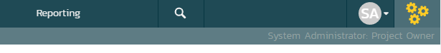

This will display the context aware administration menu popup. This menu will show different sections depending on where you are in the application and your administrative privileges. For example, only system administrators see the “System: Admin Home” section shown at the bottom of the screenshot below.

In the screenshot below you can see that administration links are being shown for three different sections:

1. Library Information System – which is a product
2. The template called Sample Template: Agile (this is the template the controls the above product)
3. System wide administration

This menu only shows the links to one product, one template, or one program at a time (and System Admin all the time to system administrators). Because this user is currently viewing a page in the product ‘Library Information System’, admin items for that product and its template are visible.

You can see that the “Requirements” sub section is highlighted. This is because the user is currently on a requirements page of the ‘Library Information System’ product (either in the main application or in template administration). The highlighting serves no function other than to guide the user to where they may wish to focus.

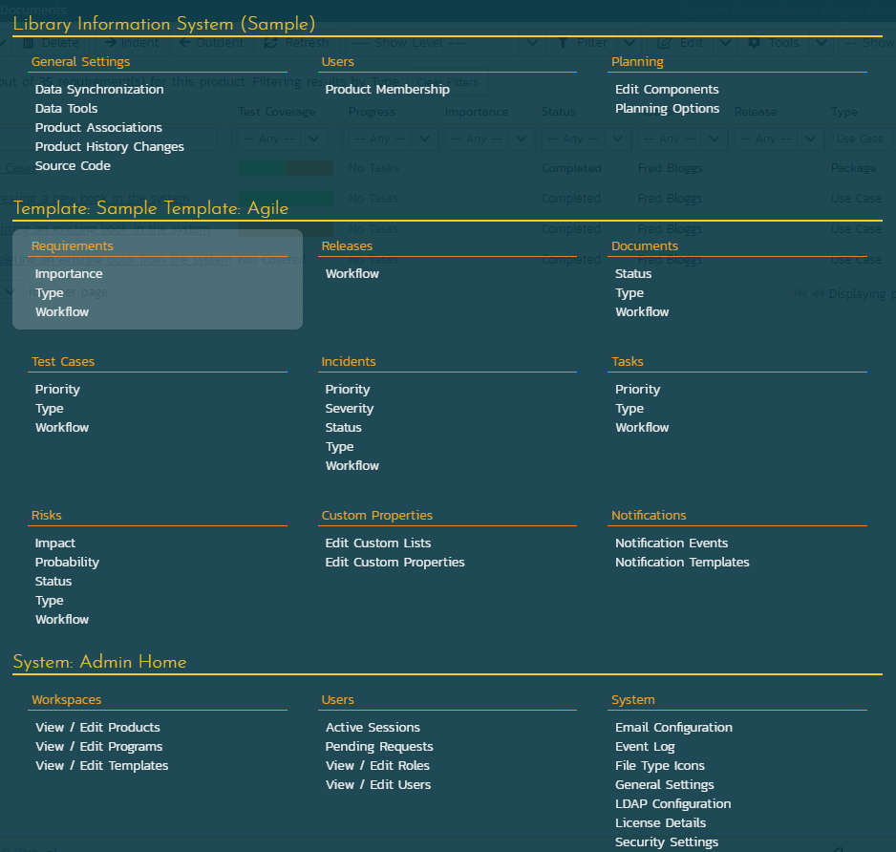

Below is an example of an administration menu where a user is a Program Owner but with no other access to administration. This menu is much barer than the one above, because the administrative options this user has are that much more limited. This user only has admin access to Sample Program One. If they navigate to a different program page or to a product page in the application, they would not see the admin menu at all.

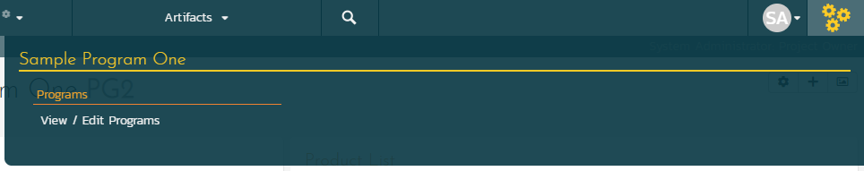

If a user wants to see what, if any, parts of the system they have administrative access to, they can do so at any time. Clicking on the workspace dropdown on the global navigation will show them the list of workspaces they have access to. Below, you can see that products are grouped into programs, and there is a dedicated Templates section at the bottom. Any workspace the user has administrative access to has a superscript gray cog to the right of that workspace’s name.

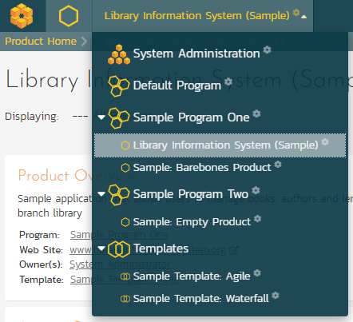

If this user wants to access the admin menu for “Sample Barebones Product”, first that cog tells them they can do so. By clicking on that workspace’s name, they will be switched to that workspace and then they can click on the admin button to get the right menu.

In the screenshot above at the top there is a “System Administration” workspace. This is visible because this user is a system administrator. Clicking this will take the user directly to the System Administration home page.

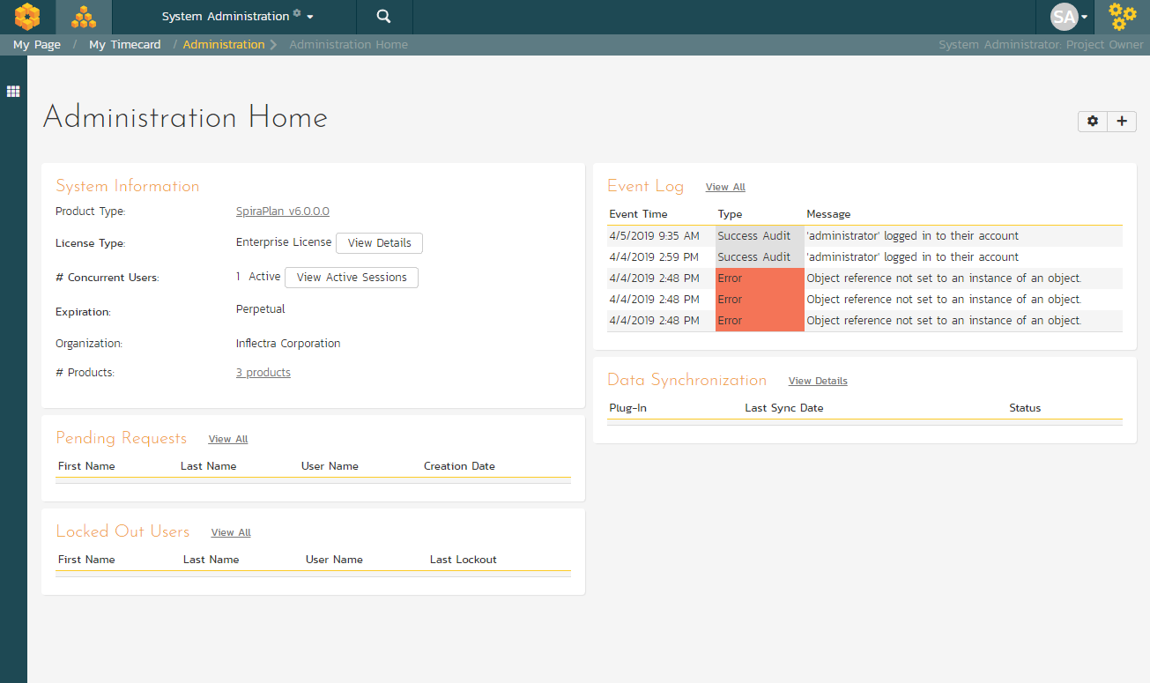

The Administration home page, like all admin pages, is divided into two areas:

1. the skinny left-hand bar. Clicking this will show the context-aware administration menu discussed above
2. the main pane that displays the available options for the selected page.

This home page shows a number of useful widgets with information about the system. You can edit these widgets, their position, and what is shown, using the two buttons in the top right (the cog and the plus).

Product and Template administration home pages also show useful data and links relevant to them. On most admin pages for products and templates the name of the current product or template is shown at the top of the page in a heading. These names are hyperlinks that will open the product or template administration home page.

When you first install the system, we suggest **three main tasks** to perform as the system administrator to get familiar with the basics and to help colleagues start to use the application:

1. Create a new product to use (see XXXX below)
2. Create the users that will be accessing the system (see XXXX below)
3. Add the users as members of the various products (see XXXX below)

These tasks typically need to be performed before any other users can use the system, since there will be no logins or products available other than the sample ones provided during the installation.

The rest of this guide explores each area of administration in order, grouped by administration section.

## 3.1. System: Workspaces

### 3.1.1. View/Edit Products

The following screen is displayed when you choose the “View/Edit Products” link from the administration menu:

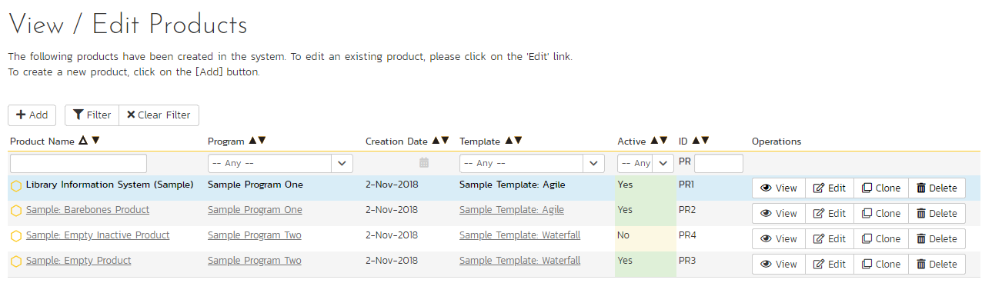

This screen displays the list of products in the system (both inactive and active) together with their program, template, date of creation, and active status. Clicking on either the “View” link in the right-hand column or the name of the product will change the currently selected product to one clicked.

You can filter the list of products by either choosing an active status, program, or entering a portion of the name or date into the appropriate text box. When you click the “Filter” button, the list of products will be filtered by the criteria you entered. You can clear the filter selection by clicking the “Clear Filters” button. To sort the list of products, just click on the appropriate arrow icon located in the header row of each field (one each for ascending / descending) In addition, the list of products is paginated into groups of fifteen (15). You can step through the different pages by clicking the page numbers at the bottom of the product list.

To permanently delete a product, you should click the “Delete” button to the right of the product details. This is irreversible and will delete all the artifacts associated with the product. If you want to temporarily delete a product, set its Active flag to ‘No’ instead. To make a copy of a product to reuse its test cases, releases, test sets and requirements, click the “Copy” link to the right of the product. *Note that this will not make a copy of any historical information, test runs or incidents.*

To add a new product to the system, click the “Add” button at the bottom of the product list, and a new screen will be displayed that allows you to enter the new product information:

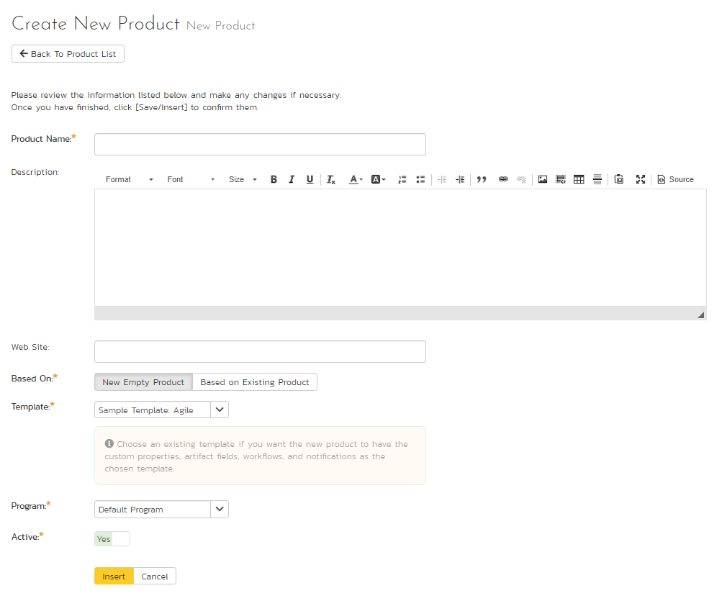

You need to:

* enter a name for the product (which cannot be the same as any already in use);
* select which program it belongs to and optionally enter a detailed description and/or web-site URL;
* you should initially make sure that the product is marked as “Active”;
* decide what to base the product on. It can either be a new empty product, or be based on another product already in the system. Doing the latter will copy across its membership, settings and customizations;
* select a template that will control the product. If you are creating an empty product (not based on an existing one) you can select any template in the system to use for this product, or you can start with a brand new template. If you are creating a product based on an existing one, then by default the template will be the same as the one the existing product uses. You can still create a new template in this case, which will effectively be a clone of the template the existing product uses.

Once you are satisfied with the information, click the “Insert” button to actually create the new product.

In a similar way, to edit the details of an existing product, click the “Edit” button in the right hand column of the product list box, and you will be taken to the following screen that allows you modify the product details:

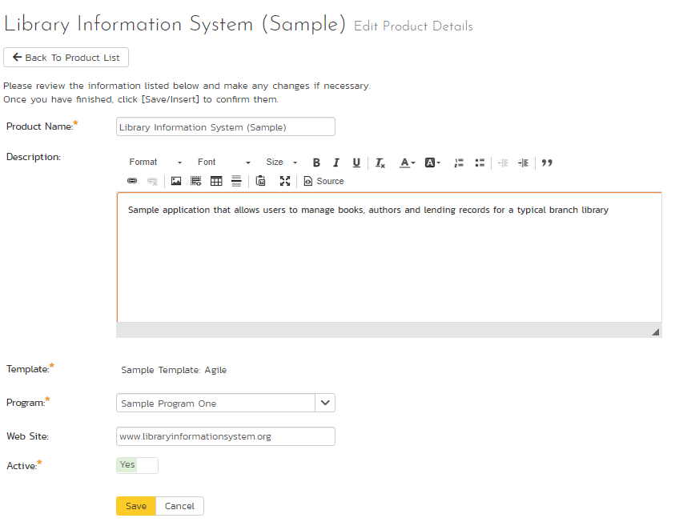

On this screen you can edit the name, description, program, website URL and active status. Once you have made the necessary changes, click the “Save” button to commit them. If you decide that you want to ignore the changes, click the “Cancel” button and the changes will be discarded.

### 3.1.2. View/Edit Programs

The following screen is displayed when you choose the “View/Edit Programs” link from the Administration menu:

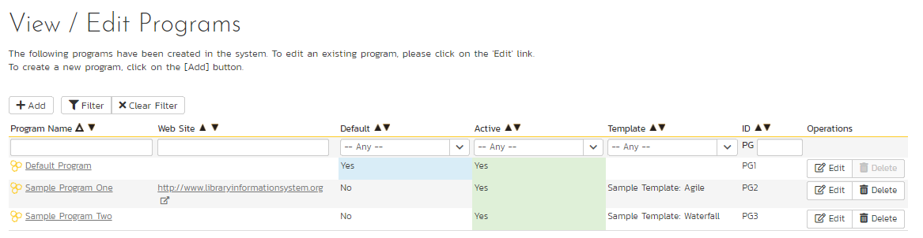

This screen displays the list of programs in the system (both inactive and active) together with their template, web site URL, date of creation and active status. Programs are used to relate products that are in the same department/division/organization or are for a common customer, client, etc. When products are in the same program, a user that is a member of the program can see the special Program Dashboard that displays key metrics from all the products in the program combined. Also, such users will have observer-level access to the contained products without needing to be explicitly added to each product.

You can filter the list of programs by either choosing an active status, or entering a portion of the name, web-site or date into the appropriate text box. When you click the “Filter” button, the list of programs will be filtered by the criteria you entered. You can clear the filter selection by clicking the “Clear Filters” button. To sort the list of programs, just click on the appropriate arrow icon located in the header row of each field (one each for ascending / descending) In addition, the list of programs is paginated into groups of fifteen (15). You can step through the different pages by clicking the page numbers at the bottom of the product list.

To permanently delete a program, you should click the “Delete” button to the right of the program details. Any products contained in the program will not be deleted, but instead just moved to the default program. There has to be at least one program in the system at all times, so the program designated as the ‘default’ one will not be available for deletion.

To add a new program to the system, click the “Add” button at the bottom of the program list, and a new screen will be displayed that allows you to enter the new program information:

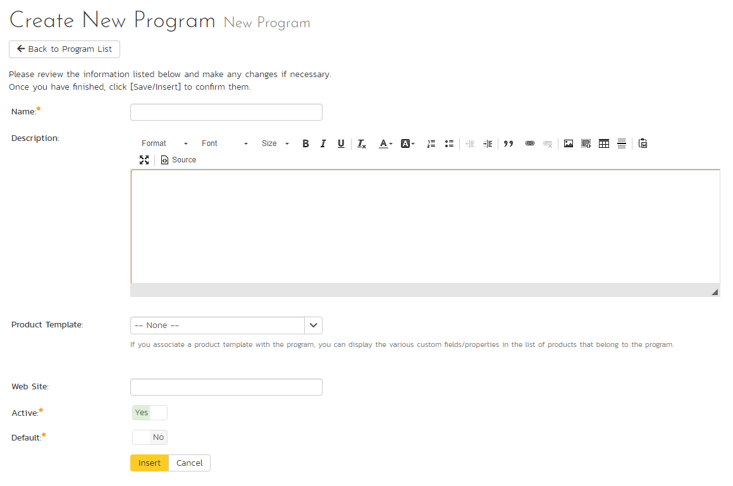

You need to enter:

* a name for the program;
* optionally enter a detailed description and/or web-site URL;
* you should initially make sure that the program is marked as “Active”;
* you can choose to make this program the default one (meaning that it cannot be deleted and products get added to it when their programs are deleted);
* in addition you can optionally choose to associate the program with a product template. The template only controls the products that use it. It does not control the program, but it can affect what data is visible from some of the program pages.

Once you are satisfied with the information, click the “Insert” button to actually create the new program.

In a similar way, to edit the details of an existing program, click the “Edit” button in the right-hand column of the program list box, and you will be taken to the following screen that allows you modify the program details. **Please note that this is the only administrative page in the program administration section.**

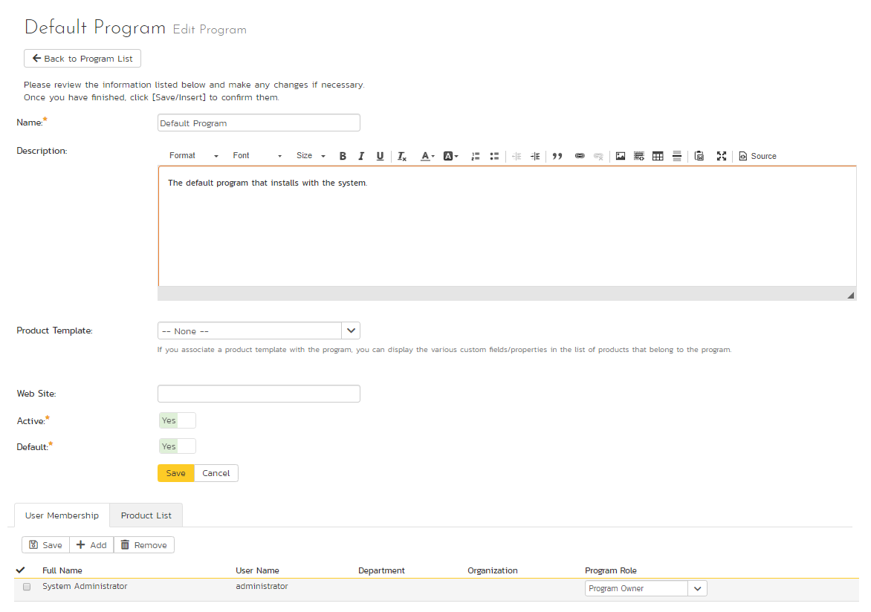

On the top part of this screen you can edit the name, description, website URL, active status and default status. Once you have made the necessary changes, click the “Save” button to commit them. If you decide that you want to ignore the changes, click the “Cancel” button and the changes will be discarded.

In addition, the lower part of the screen allows you to view/edit the users that are members of the program and also see which products are in the program:

a) Program User Membership

This tab allows you to see which users are members of the program and which program role they have:

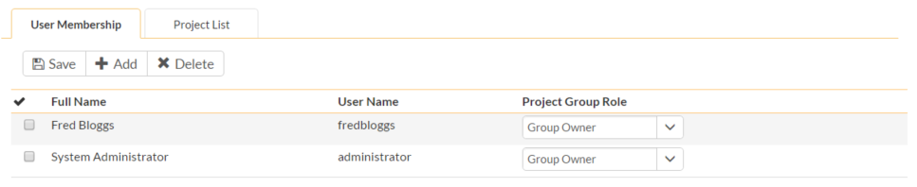

The two program roles are “Executive” and “Program Owner”:

* **Executive** – This role allows the user to see the dashboard for this program, which contains all the key metrics for the contained products displayed in an aggregated manner. Please see the *SpiraPlan User Manual* for more details on this dashboard. In addition, the user is automatically granted ‘observer’ permissions for all the products in the program.
* **Program Owner** – This role consists of all the permissions granted to the “Executive” role above, but in additional allows the user to make changes to the Program itself in the Administration section.

To change the role of an existing program member, just change the role in the drop-down list and click [Save]. To remove a member from the program, just select the appropriate checkboxes and click [Delete]. Finally, to add a new user to the program, click on the [Add] button:

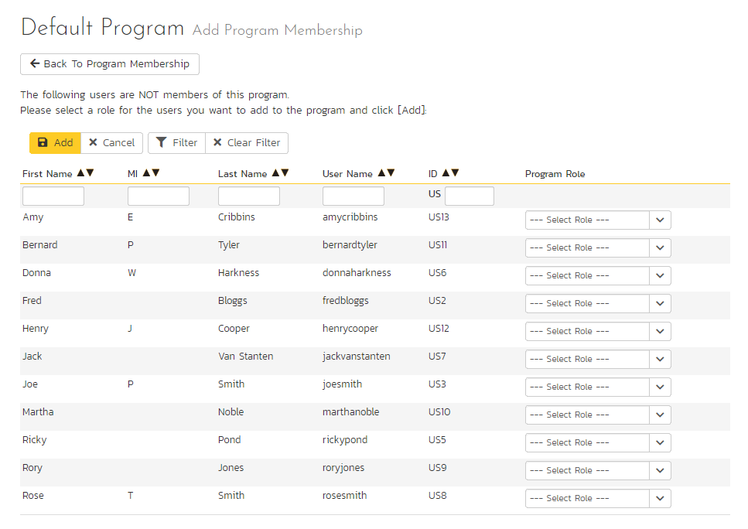

You now should narrow down the list of users by entering filter criteria and clicking [Filter]. Once you have located the appropriate user(s), just select a program role for them from the drop-down list and click [Add] to add them to the program in the specified role.

b) Program Product List

This tab allows you to see the list of products that are contained within the current program. Clicking on the name of the product will take you to the details page for that product:

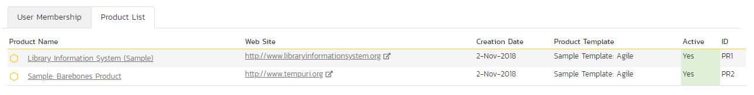

### 3.1.3. View/Edit Templates

The following screen is displayed when you choose the “View/Edit Templates” link from the administration menu:

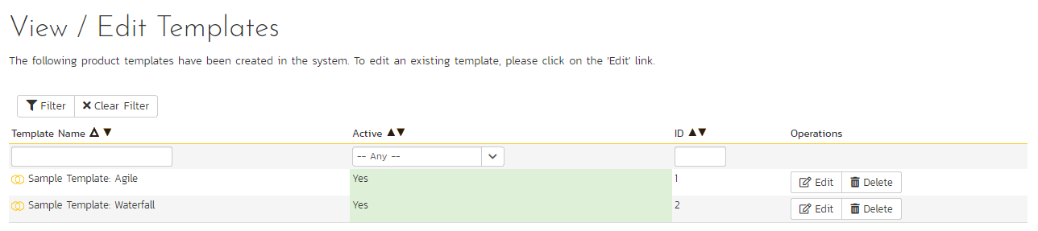

This screen displays the list of templates in the system (both inactive and active) with their active status.

You can filter the list of products by either choosing an active status, ID, or entering a portion of the name into the appropriate text box. When you click the “Filter” button, the list of templates will be filtered by the criteria you entered. You can clear the filter selection by clicking the “Clear Filter” button. To sort the list of templates, click on the appropriate arrow icon located in the header row of each field (one each for ascending / descending).

To permanently delete a template, click the “Delete” button to the right of the template details. This is irreversible. If you want to temporarily delete a product, set its Active flag to ‘No’ instead. Neither of these actions will be possible if any product (active or inactive) is controlled by the template*.*

To add a new template to the system, you need to create a new template when creating a new product (as described in section 3.1.1 above). To edit the details of an existing template, click the “Edit” button in the right hand column of the template list box, and you will be taken to the following screen that allows you modify the template details:

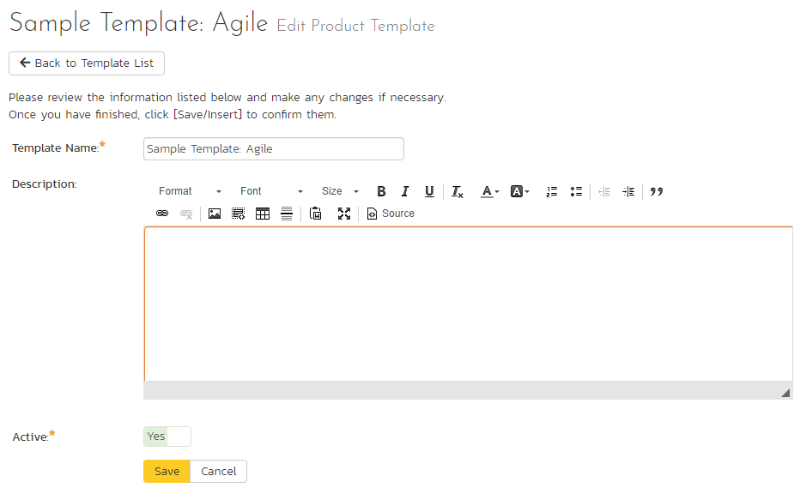

On this screen you can edit the name, description, program, and active status. Once you have made the necessary changes, click the “Save” button to commit them. If you decide that you want to ignore the changes, click the “Cancel” button and the changes will be discarded.

## 3.2. System: Users

### 3.2.1. View / Edit Users

The following screen is displayed when you choose the “View/Edit Users” link from the Administration menu:

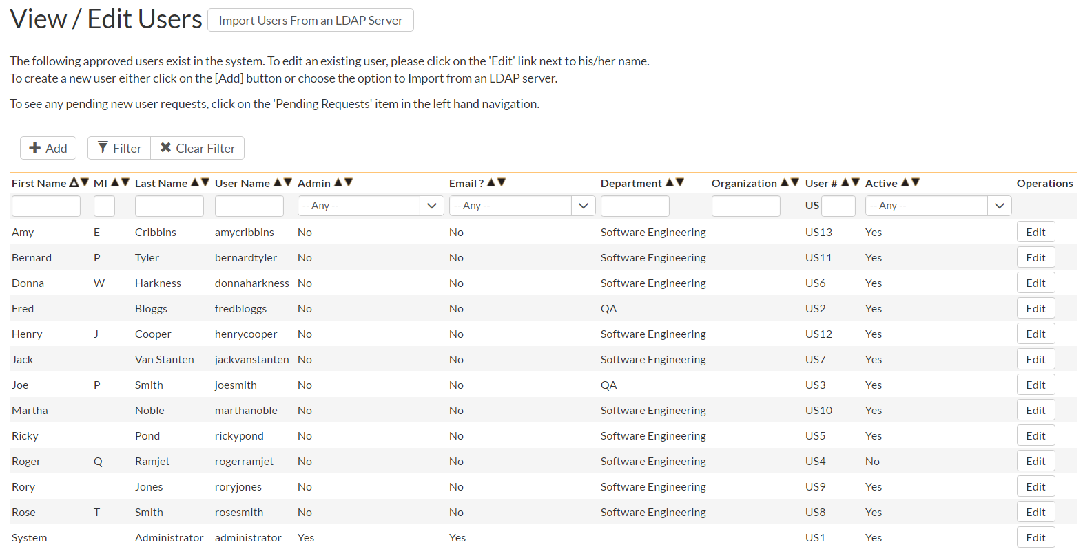

This screen displays the list of users in the system (both inactive and active) together with their first name, middle initial, last name, username (login), administrative permission status and active status.

You can filter the list of users by either choosing an administrative / active status, or entering a portion of the first name, middle initial, last name or username into the appropriate text box. When you click the “Filter” button, the list of users will be filtered by the criteria you entered. You can clear the filter selection by clicking the “Clear Filters” button. To sort the list of users, just click on the appropriate arrow icon located in the header row of each field (one each for ascending / descending). In addition, the list of users is paginated into groups of fifteen (15). You can step through the different pages by clicking the page numbers at the bottom of the user list.

To add a new user to the system, click the “Add” button at the bottom of the user list, and a new screen will be displayed that allows you to enter the new user information:

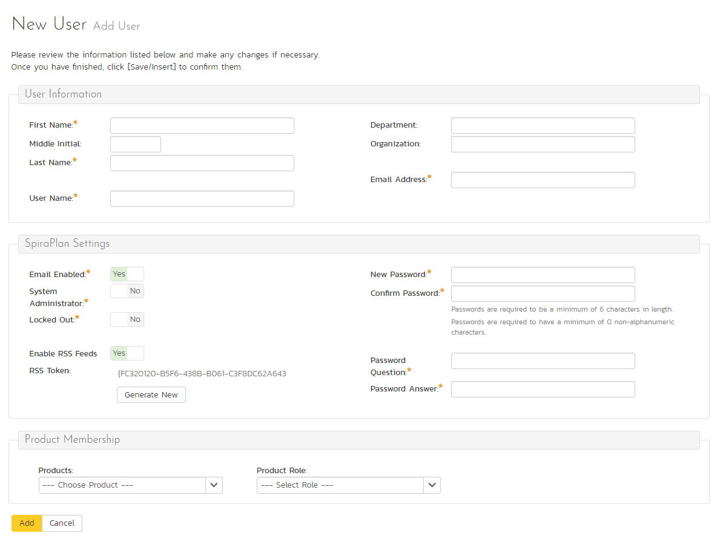

On this screen, you can enter information about the user, such as their name, email address, and department. You can also create their password, password reset question and answer. If you want the user to be able to subscribe to items in the system as RSS feeds, you should also make sure that the “Enable RSS Feeds” checkbox is selected and a GUID token is displayed in the text-box underneath.

When creating a new user, you can also set their role for products. A user can be assigned a role to multiple products at once, by checking the required checkboxes in the dropdown list of products. The same role will be applied across all products.

*Note: If you make a user a System Administrator, it will force that user to always have the ‘Product Owner’ role on all their assigned products, regardless of the chosen role. If you disable this option, they will then revert back to their true role.*

In a similar way, to edit the details of an existing user, click the “Edit” hyperlink in the user list box, and you will be taken to the following screen that allows you modify the user details:

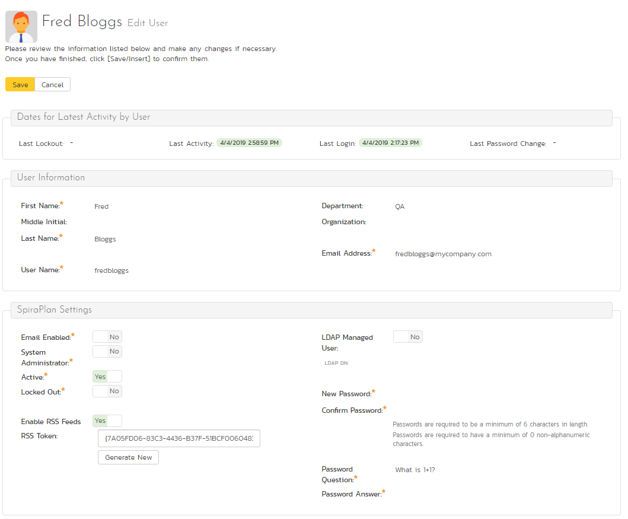

On this screen you can edit the first name, middle initial, last name, username, email address, system administration status and active status. You can also change the user’s password (if the user is managed by SpiraPlan) or LDAP information (if managed by an external LDAP directory server). In LDAP-Managed mode you enter the fully Distinguished Name (DN) for that user in your corporate LDAP server and provide no password. SpiraPlan® will then query your corporate LDAP server for the password information, reducing the number of passwords that a user needs to remember. Please see the sections on *“Importing LDAP Users”* and *“LDAP Configuration”* for more details.

Once you have made the necessary changes, click the “Save” button to commit them. If you decide that you want to ignore the changes, click the “Cancel” button and the changes will be discarded.

At the top of the page you can also see information relating to the activity of the user on the system, such as when they last logged in.

In addition, there are three tabs that allow you to add/remove the user from products, update the data-mapping used when synchronizing artifacts that are assigned or created by the current user, and, where relevant, specify whether the user can access the linked TaraVault™ source code management service.

If you click on the “Product Membership” tab you will be shown a list of products that the user is currently a member of:

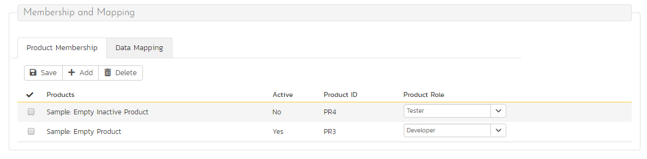

You can change the role that the user has on the various products, by choosing the appropriate role from the drop-down list and then clicking [Save]. To remove the user from a product, select its checkbox and then click [Delete]. To add a user to a new product, click on the [Add] button and then choose the product and associated role from the list of products on the screen that is displayed:

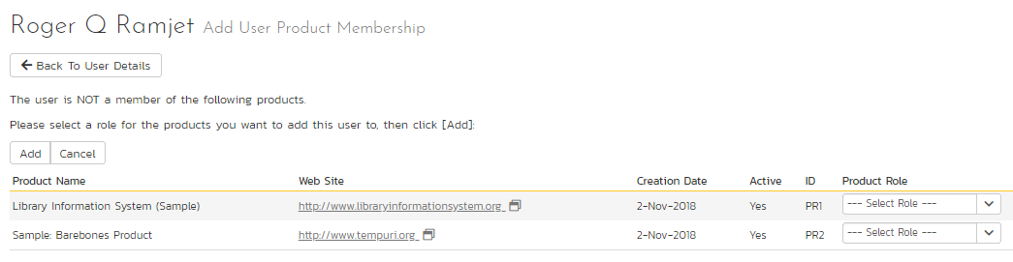

Then click [Add] to add the selected product(s) to the user’s product membership.

To view/change the list of usernames that a user has in an external bug-tracking system, click on the “Data Mapping” tab. This section is used by the SpiraPlan data-synchronization service to map incidents from SpiraPlan to other bug-tracking systems

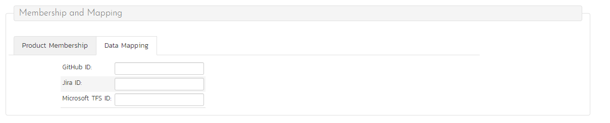

Please see the *SpiraPlan External Bug-Tracking Integration Guide* for more details on using the data-mapping tab.

If you click on the TaraVault membership tab, you can choose whether or not the user has access the linked TaraVault source code repository. This service is only available for hosted/cloud instances of SpiraPlan, and more details can be found in section 3.3.4 of this guide.

### 3.2.1.1. Importing LDAP Users

If your organization already has an LDAP compatible user management system in place (e.g. Windows Active Directory, Novell eDirectory, OpenLDAP, IBM Tivoli, etc.), then instead of having to manually enter users one by one into SpiraPlan®, you can simply import them from your LDAP Server. Before doing this however, you need to first setup the LDAP configuration (see the section on LDAP Configuration below.

Once you have setup your LDAP server configuration in SpiraPlan®, clicking on the “Import Users From and LDAP Server” will bring up the following screen:

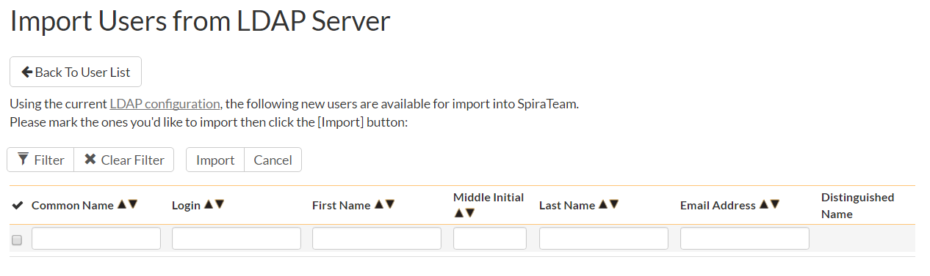

This screen lists all the users available in the LDAP server that have not been already imported into SpiraPlan®. The users are listed by name along with their login, email address and fully distinguished LDAP name (DN). You can narrow down the list by entering partial name matches in any of the fields displayed and clicking [Filter] and/or you can sort the results by clicking on the directional arrows in the field headings.

Select the checkbox of any users you want to import and click “Import” to complete the operation. These users can now login to SpiraPlan® and use their existing LDAP login and password information.

### 3.2.3. Active Sessions

Often an administrator of the system will want to know how many users are currently logged into the system, especially on installations licensed by concurrent-user. Clicking on the ‘Active User Sessions’ administration option will display a list of all the users who currently have active sessions in the system:

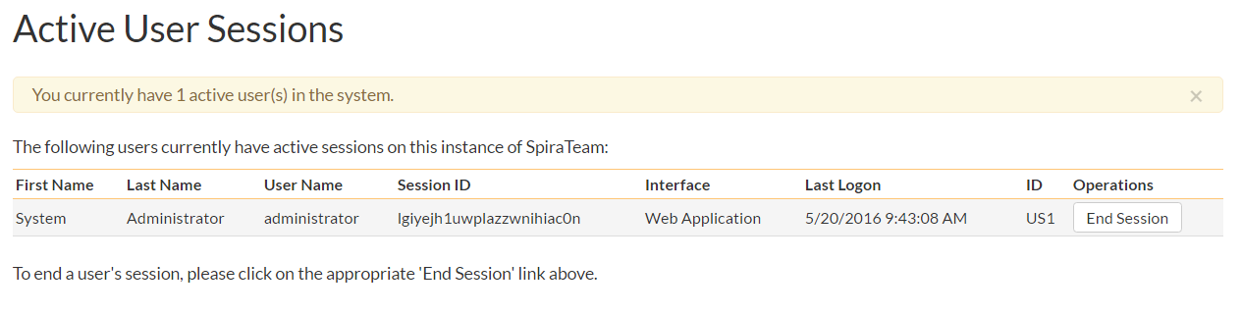

Each user is displayed along with their user ID, whether they’re connected through the application or via a third-party add-on, and the date they last logged-in. The administrator is able to forcibly end a user’s session using the ‘End Session’ link to the right of their name. Clicking this link will result in that user being logged out when they try and perform an operation in the system. **Warning: You should make sure that the user is not actively using the system to prevent any unsaved data being lost**.

### 3.2.4. Pending Requests

If you have enabled the ability for users to register for new SpiraPlan accounts themselves (see section 3.3.6 – Security Settings), clicking on the “Pending Requests” administration option allows you to view a list of all the outstanding requests for new user accounts:

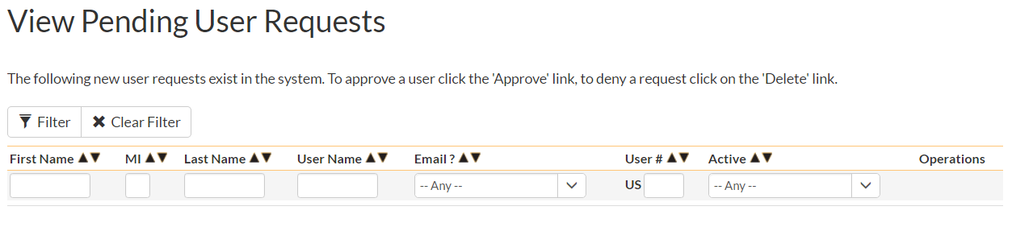

For each pending user request you can choose to either Approve or Deny the request:

* **Approve** – clicking this option will approve the user. They will get an email letting them know that they have been approved and can now log into the system.
* **Delete** – clicking this option will delete the pending user request from the system.

### 3.2.5. View / Edit Roles

There are six (6) default product roles that a user may be assigned to a product with:

* **Product Owner** – the same rights as a Manager, but in addition can access the product administration tools
* **Manager** – can see all screens and add/edit all artifacts, but cannot access product administration tools
* **Developer** – can see all screens, but can only add/edit incidents, tasks and tests and change requirement coverage
* **Tester** – can see all screens, but can only add/edit incidents and execute tests. Note: cannot delete incidents, only a Manager can do that.
* **Observer** – can see all screens, but cannot perform any write operations (insert / update / delete)
* **Incident User** – can only view and edit incidents. This user cannot even see the product’s requirements, tasks, test cases or releases.

Note: The System Administrator (with a user id of 1) is automatically added to every product as a Product Owner, and can never be removed as Product Owner, made inactive or made a different role on the product.

You can make changes to the permissions associated with each of these default roles, and also create as many additional roles as you like. To customize the roles in your installation of SpiraPlan®, click on the “View / Edit Roles” link in the Administration menu:

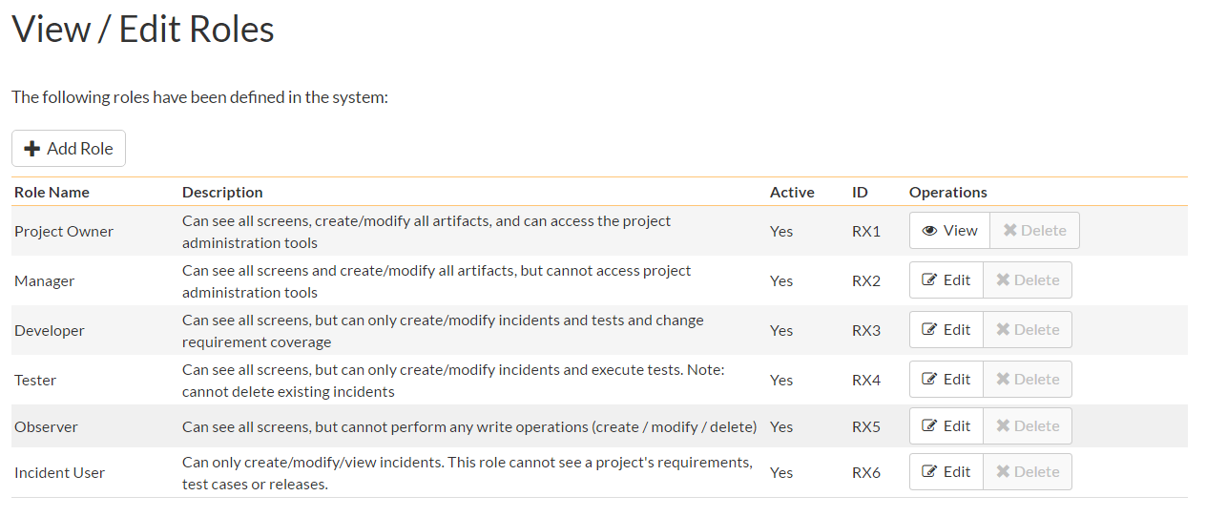

The screen lists all of the roles currently configured in the system (both active and inactive) together with the name, description, and an active flag. You can create new roles by clicking the “Add” button which will create a new default role entry in the list. You can edit the name, description and associated permissions of a role by clicking on the appropriate “Edit” button. You can delete an existing role, by clicking the “Delete” button. Note that you cannot delete any of the default roles, but can instead make them inactive.

Clicking on the edit button will take you to the following screen:

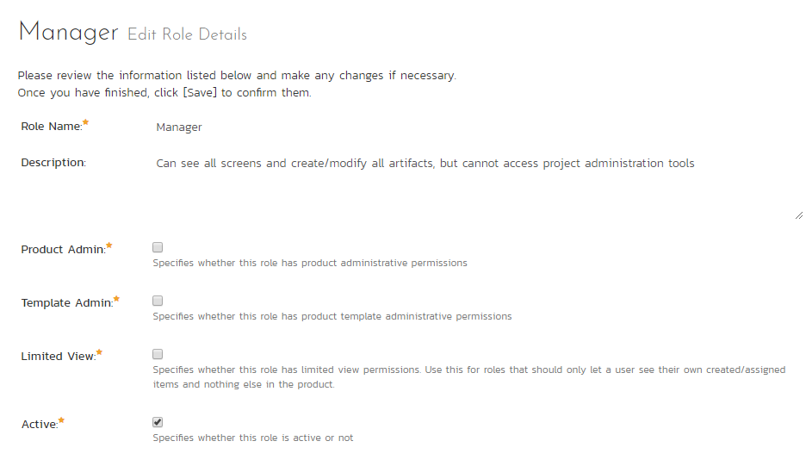

On the top of the screen, you can edit the name, description, product admin, limited view and active flags:

* **Product Admin** – this flag denotes whether this role has administration-level access to the product (for example the product owner role has this set by default)
* **Template Admin** – this flag denotes whether this role has administration-level access to the template that controls this product. You can be a product admin, without also being a template admin. However, you cannot be a template admin, without also being a product admin.
* **Limited View** – this flag denotes that the role has a restricted view of the product, with the user only allowed to see the artifacts that they have either *created* or been *assigned*
* **Active** – This flag denotes if the role is active in the system

Underneath you can specify the various artifact-specific permissions for the role:

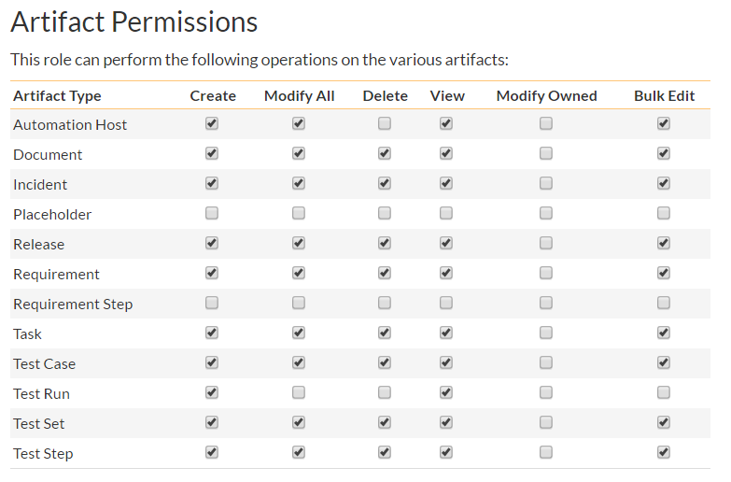

These permission options allow you to specify if a user can **create**, **modify**, **delete** or **view** each of the artifacts in the system. If a user does not have view permissions for the artifact, then the corresponding tab in the system will also be disabled. There are three kinds of Modify permission available:

* **Modify All** – this option specifies that the user can modify all the artifacts of this type in the product (e.g. the user can edit all test cases)
* **Modify Owned** – this option specifies that the user can modify only the artifacts in the product that were either created or assigned to this user (e.g. the user can edit only the requirements they created or have been assigned)
* **Bulk Edit** – this option means that the user can modify items on the artifact list pages and on the various planning boards. This means the user can bypass the workflow restrictions on changing status and the need to enter required fields and electronic signatures. This should be disabled in a system that is being used for a regulated product that requires electronic signatures.

*Note: The permission needed to execute a test case is the “Create + Test Run” permission since that initiates the creation of a new test run.*

In addition, there are some artifact-wide permissions that can be specified for each role:

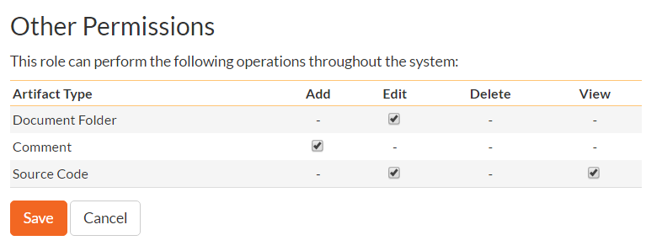

This section lets you specify if the role allows users to add new documents to the product, edit existing documents, delete documents, edit the document folders, and view/edit source code revisions.

## 3.3. System

### 3.3.1. General Settings

The general settings page allows you to configure SpiraPlan® to better match your environment and setup. In the current version, you can specify the default language, or configure the folder used to store document attachments:

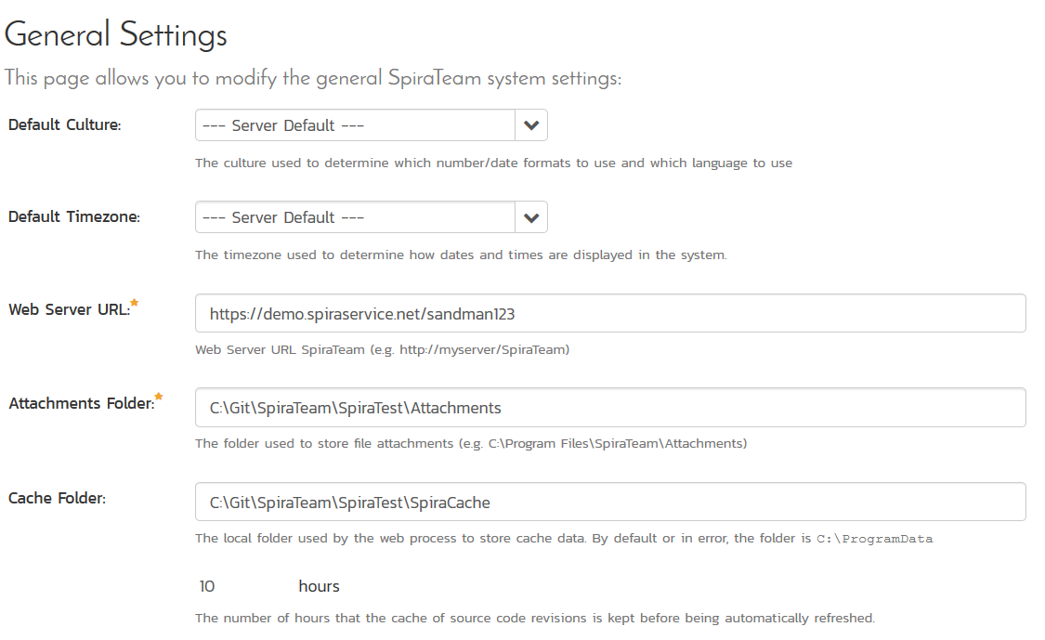

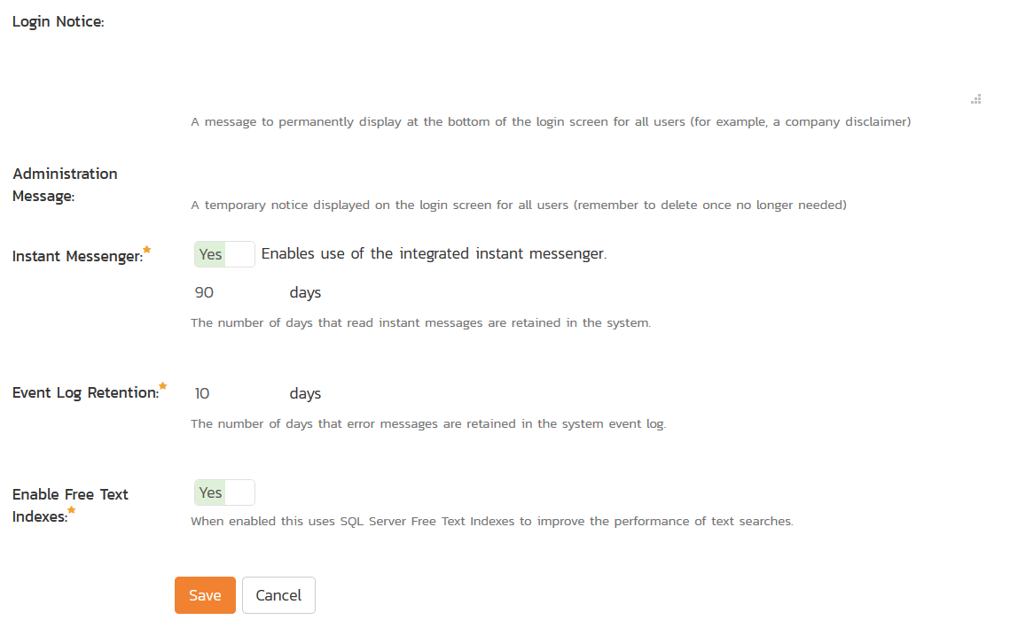

The available settings include:

* **Default Culture** – SpiraPlan can display information in a variety of different languages (assuming that the appropriate language packs have been installed) and number formats. By default, SpiraPlan will use the regional settings (language and number formats) of the operating system it has been installed on. However, you can override this default by choosing the appropriate culture from the list of options displayed in the drop-down list. *Note: The list of culture options does not reflect the available language packs, so in some cases, the setting will only change the number formats.*
* **Default Timezone –** SpiraPlan stores all dates and times internally in Universal Coordinated Time (UTC) and can therefore display dates/times adjusted for different timezones. By default, SpiraPlan will display dates in the timezone specified in the operating system it has been installed on. However, you can override this default by choosing the appropriate display timezone from the list of options displayed in the drop-down list.
* **Web Server URL –** This is the URL that your users use to access the system. Do not put the /Login.aspx or any other page here, as this URL is used to generate links to pages in the application.
* **Attachments Folder** - By default when SpiraPlan® is installed, the document attachments uploaded in the system get stored inside the C:\Program Files\SpiraPlan\Attachments folder located inside the main SpiraPlan® installation root. However you may want to have the documents stored on a remotely mounted drive or on a different hard disk partition. In which case you can simply change the folder pointed to in the text-box illustrated above and then click [Update] to commit the change.
* **Cache Folder** – By default when SpiraPlan needs to store temporary data (generated reports, the version control cache, etc.) it will store them in the C:\ProgramData\Inflectra\Spira folder. Sometimes this folder is not appropriate (e.g. you want them on a different drive that has more space). You can enter in a different folder for temporary storage and SpiraPlan will use that instead.
* **Login Notice** – this can be used system wide to set a message to permanently display at the bottom of the login screen for all users (for example, a company disclaimer).
* **Administration Message** – this can be used by the administrator to display a temporary notice displayed on the login screen for all users. For example it could be used to remind all users that the server will be down for upgrading over the weekend. The administrator should delete the message once it is no longer needed.
* **Instant Messenger** – SpiraPlan and SpiraTeam come with a built-in instant messenger that allows users to communicate with each other in real-time. This can result in higher levels of network traffic and some system administrators may wish to disable this feature. This option lets you disable the integrated instant messenger. In addition, you can specify how long (in days) instant messages are retained in the system.
* **Event Log Retention** – As described in section 3.3.7, SpiraPlan comes with a built-in diagnostic event log. By default the system will only retain the last 30-days of events to avoid wasting storage space. You can adjust the retention period in this section to match your organization’s policies.
* **Enable Free Text Indexes** – This tells SpiraPlan to use SQL Server Free Text Indexing to speed up keyword searches in the Global Search box. You should only have this set to “Yes” if you have the Free Text Indexing featured enabled in SQL Server, otherwise you will cause SpiraPlan to display error messages when users try and use the global search.

### 3.3.2. File Type Icons

The “File Types List” administration page allows you to view all the different filetypes that are recognized by SpiraPlan and add or edit the associated icon, name, description and MIME type:

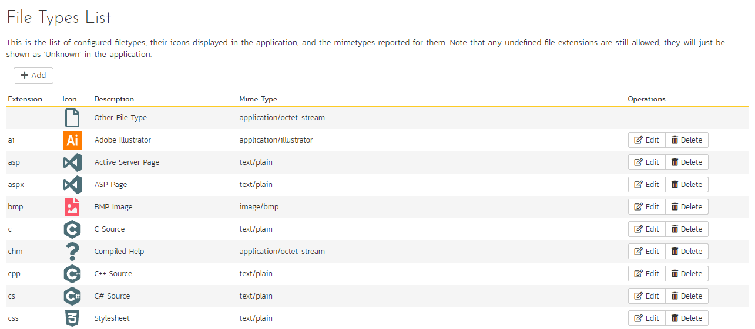

If you click on the “Edit” button next to a filetype, or click on the “Add” button at the bottom of the screen, the system will display the page that lets you add or edit a filetype entry:

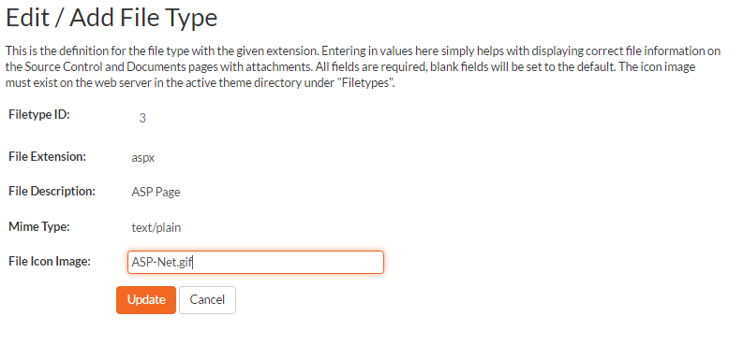

On this page you can enter/edit the file extension that’s used to recognize the type of file uploaded, the description of the file type (displayed in popup tooltips), the MIME type (used to determine how the browser handles the file type) and the path to the icon image. Once you are satisfied with the values, you can click on the “Save” button to confirm the changes.

### 3.3.3. License Details

The license details page displays the information about the installed license for the particular instance of SpiraPlan® being used. This will display less information for hosted customers. The information displayed for self-hosted customers includes: the product name (e.g. SpiraPlan), the license version (e.g. v6.0.0.0), type of license in effect (x-user fixed, x-user concurrent, demonstration, enterprise, etc.), the expiration date (if any) of the license, the organization that the license belongs to, and the number of users concurrently logged-in right now. This last piece of information is useful as it helps administrators track down how many licenses are currently in use.

A sample page is illustrated below:

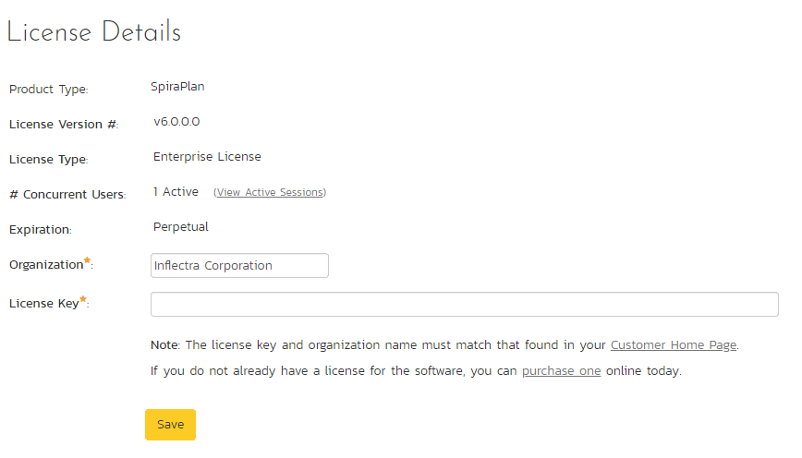

To change the license key used by the system (for example, if to upgrade from Trial edition to Standard edition), you do **not** need to reinstall SpiraPlan®. All you need to do is change the **organization** and **license key** text-boxes to match the license key and organization name found in the customer area of our website (<http://www.inflectra.com/CustomerArea>) and click the “Save” button.

If there is an issue with the license key (e.g. a trial version that is passed its expiration date, or where the license key doesn’t match the organization name) an error will be displayed describing the specific issue with the information you entered. If you are unable to get the system to work with the license key information, please contact Inflectra® customer support at: [support@inflectra.com](mailto:support@inflectra.com).

### 3.3.4. LDAP Configuration

As described previously, you can configure SpiraPlan® to use an external LDAP server for importing new user profiles into the system, and for authenticating users – instead of having to store separate passwords inside SpiraPlan®. However, you need to first configure the LDAP server settings. To do this, click on the “LDAP Configuration” link the Administration navigation:

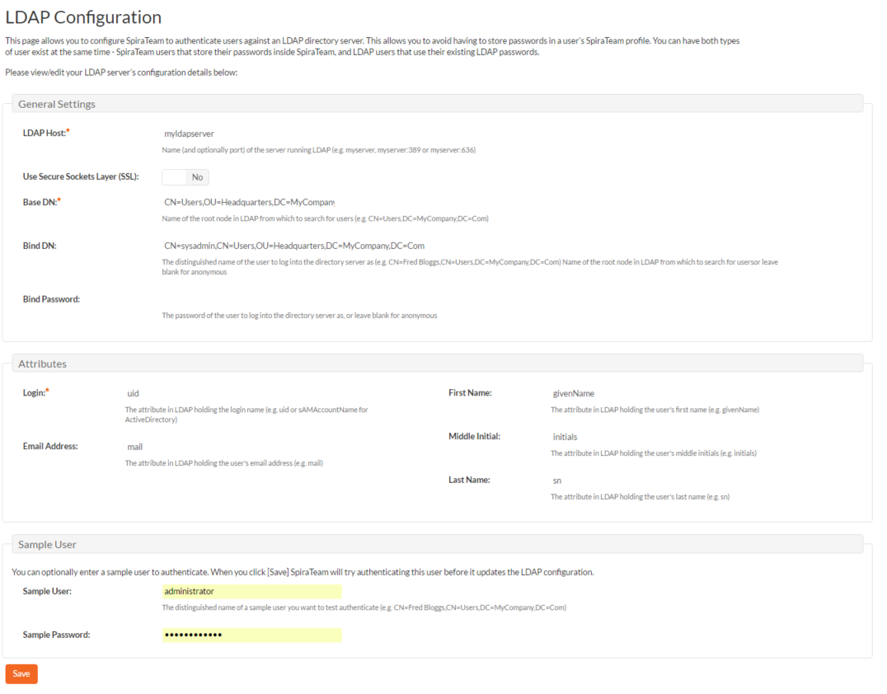

You need to fill out the various configuration settings for your LDAP server, each of which is explained in more detail below:

* **LDAP Host**This should contain the name of the LDAP server that you want SpiraPlan to connect to together with the port number if it’s not the default of 389.
* **Use Secure Sockets Layer (SSL)**You should select this check-box if your LDAP server requires use of the LDAPS secure protocol. Leave unchecked for unencrypted LDAP communication.
* **Base DN**This should be the distinguished name of the object inside your LDAP server that contains the list of user accounts. This varies by the type of LDAP server, please consult your LDAP server documentation for more details.
* **Bind DN**This should be the distinguished name of the user inside your LDAP server that will be used to authenticate against when importing users. If not provided, SpiraPlan® will try and authenticate with the LDAP server anonymously.
* **Bind Password**The is the password of the user specified in the Bind DN field above.
* **Login Attribute**When SpiraPlan® imports users from the LDAP server it needs to know the user attribute inside the LDAP server that it should use to generate the SpiraPlan® user-name. For most LDAP servers the appropriate attribute would be “uid”. However for Windows ActiveDirectory, the attribute “sAMAccountName” should be used instead.
* **First Name Attribute**Providing this optional attribute will allow SpiraPlan® to automatically populate the first name field of the imported user instead of simply using the username as a placeholder.
* **Last Name Attribute**Providing this optional attribute will allow SpiraPlan® to automatically populate the last name field of the imported user instead of simply using the username as a placeholder.
* **Middle Initial Attribute**Providing this optional attribute will allow SpiraPlan® to automatically populate the middle initial field of the imported user instead of simply leaving it blank.
* **Email Address Attribute**Providing this optional attribute will allow SpiraPlan® to automatically populate the email address field of the imported user instead of simply using the username@spiratest.com as a placeholder.
* **Sample User**You can optionally enter a sample user and password to test that the user is correctly authenticated against the server. You can update the LDAP configuration without setting this, but if you do provide a sample user/password, it will not save the configuration unless the authentication succeeds. If you choose to enter it, the user’s name should be the fully-distinguished name of the user (e.g. CN=Sample User, CN=Users, OU=Headquarters, DC=MyCompany, DC=Com).

### 3.3.5. Security Settings

The “Security Settings” administration page lets you specify the various security settings within SpiraPlan to match your organization’s policies and processes:

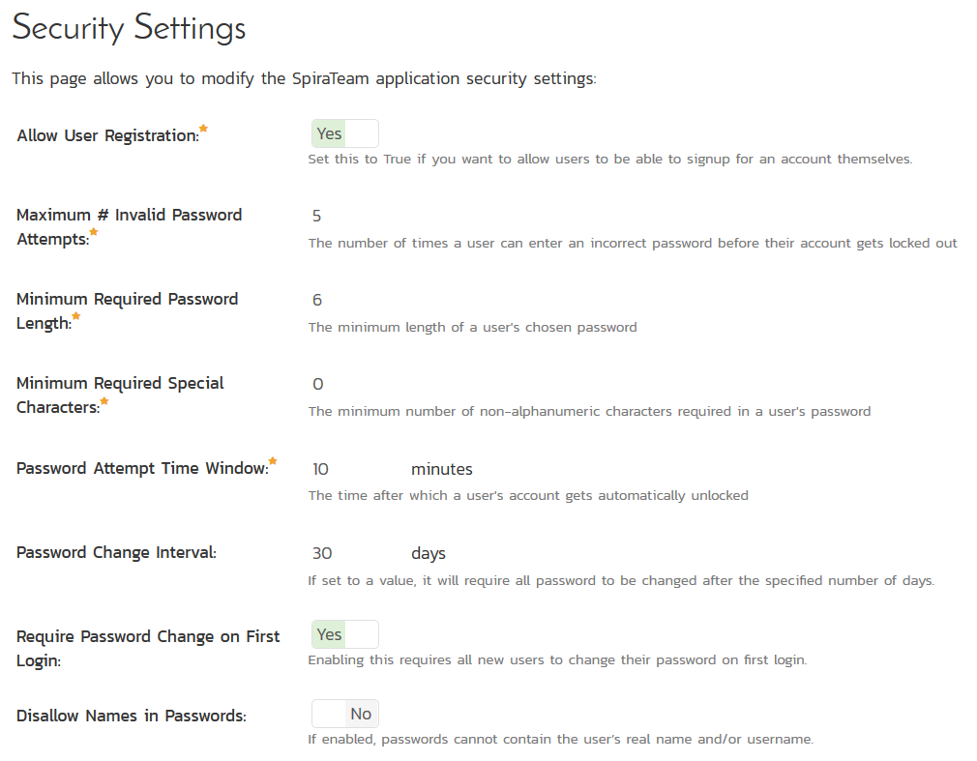

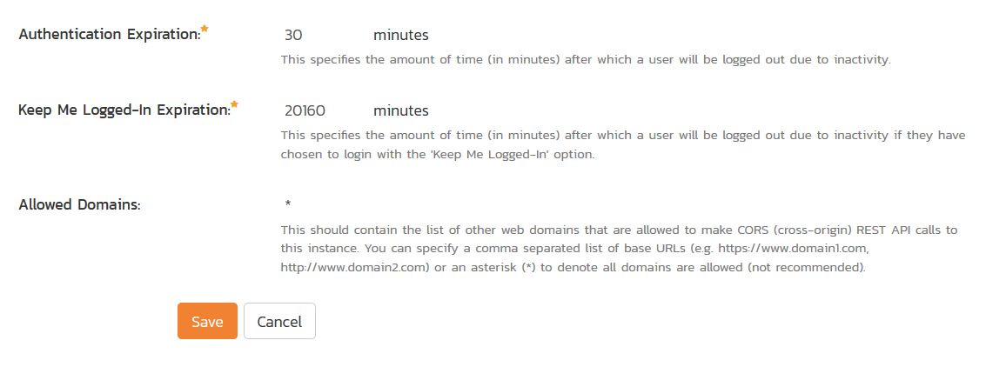

The following settings can be changed within the system, once you are satisfied, click the “Save” button to commit the changes:

* **Allow User Registration** – Set this to “Yes” if you want to allow users to self-register for SpiraPlan accounts (that you can subsequently approve). If you set this to “No”, a system administrator will need to create all user accounts. Also set this to “No” if you plan on using LDAP-based authentication.
* **Maximum # Invalid Password Attempts** – Set this to the number of times a user can enter an incorrect password before their account is temporarily locked out. This is important in preventing ‘brute force’ password hacking attempts.
* **Minimum Required Password Length** – Set this to the minimum length of passwords in the system. Choosing a longer password will make it harder for an unauthorized user to crack a password and gain entry into the system.
* **Minimum Required Special Characters** - Set this to the minimum number of non-alphanumeric characters that will be required for passwords in the system. Choosing more required special characters will make it harder for an unauthorized user to crack a password and gain entry into the system.
* **Password Attempt Time Window** – Set this to the duration (in minutes) after which a user’s account will be automatically unlocked (due to repeated incorrect password attempts).
* **Password Change Interval –** If set to a value, it will require all password to be changed after the specified number of days.
* **Require Password Change on First Login –** Enabling this requires all new users to change their password on first login.
* **Disallow Names in Passwords –** If enabled, passwords cannot contain the user’s real name and/or username.
* **Authentication Expiration** – This specifies the amount of time (in minutes) after which a user will be logged out due to inactivity when they login without choosing the ‘Keep Me Logged-In’ option.
* **Keep Me Logged-In Expiration** - This specifies the amount of time (in minutes) after which a user will be logged out due to inactivity if they have chosen to login with the 'Keep Me Logged-In' option. This should normally be longer than the previous setting.
* **Allowed Domains -** This should contain the list of other web domains that are allowed to make CORS (cross-origin) REST API calls to this instance. You can specify a comma separated list of base URLs (e.g. https://www.domain1.com, http://www.domain2.com) or an asterisk (*) to denote all domains are allowed (not recommended).

### 3.3.6. TaraVault®

*This section refers to the functionality available to hosted/cloud customers of SpiraPlan. If you are using the on-premise version of SpiraPlan, please refer to section* ***3.4.2*** *(Version Control Integration) instead.*

TaraVault® is the hosted source code repository and software configuration management (SCM) system provided by Inflectra. When you signed-up or purchased a subscription to either SpiraPlan or SpiraTeam, it will have come with an entry-level subscription to TaraVault.

When you first click on the Administration > TaraVault administration page, you will see the following screen:

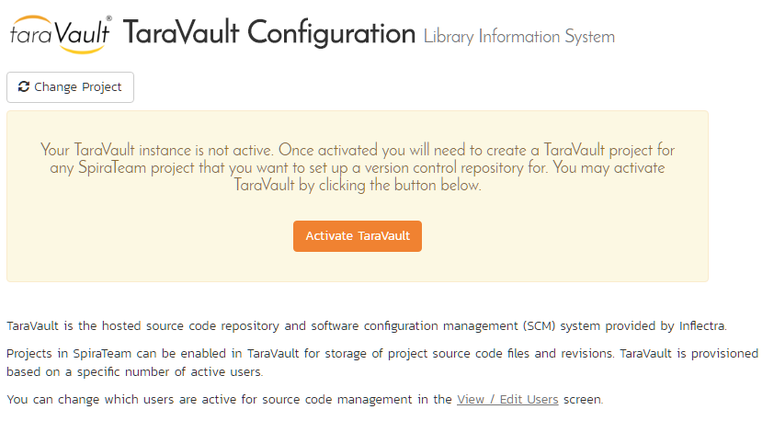

This lets you know that you have not yet activated your TaraVault account with Inflectra. When you click on the [Activate TaraVault] button you will see the following:

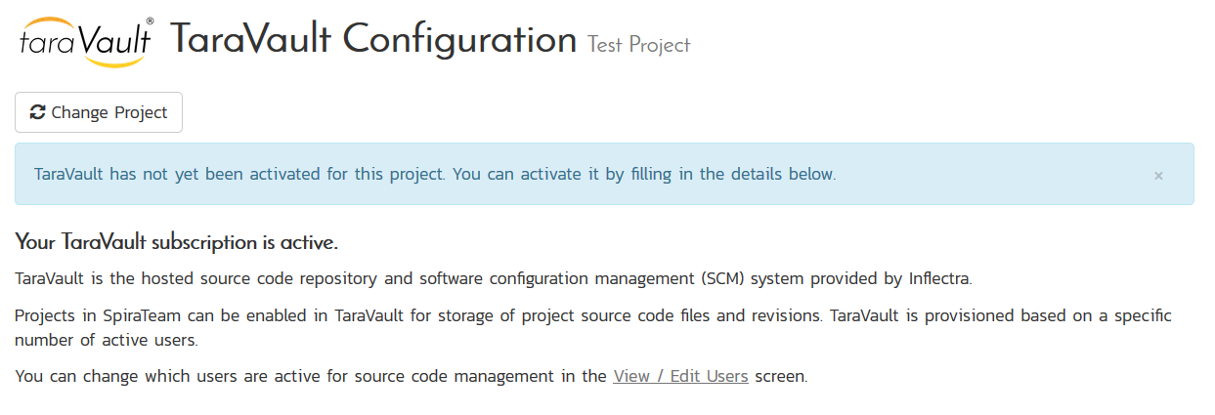

This will let you see how many TaraVault SCM users your subscription allows and also the name of the TaraVault instance that your SpiraPlan instance is associated with.

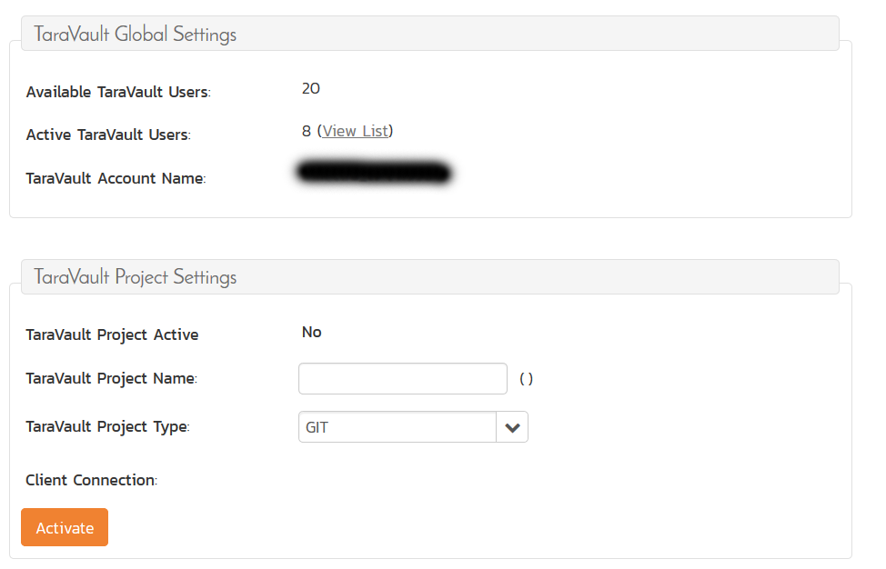

Each product in SpiraPlan has its own corresponding TaraVault product, and each TaraVault product can be configured to use one of the two different SCM providers:

* **Subversion (SVN)** – This is a simple, centralized version control system (VCS) that works best for teams that want to have a centralized SCM environment with only one central instance of the SCM repository. Subversion only allows a single branch to be managed and is generally easier to understand conceptually.
* **Git** – This is a more powerful, distributed version control system (DVCS) that works best for teams that want to have multiple distributed instances of their source code repository. Git offers superior merging and branching functionality to Subversion but is generally more complicated to understand conceptually.

For the current SpiraPlan product you can choose the type of provider you wish to use, enter the name of the TaraVault product and click Activate:

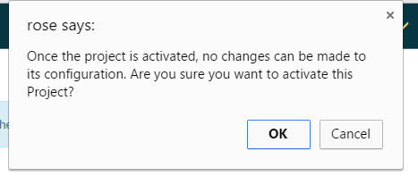

Since you cannot change the type or name of the TaraVault product once activated, please review your entries and click [OK] to confirm the new product activation.

Once the product activation has been completed, the screen will display the following:

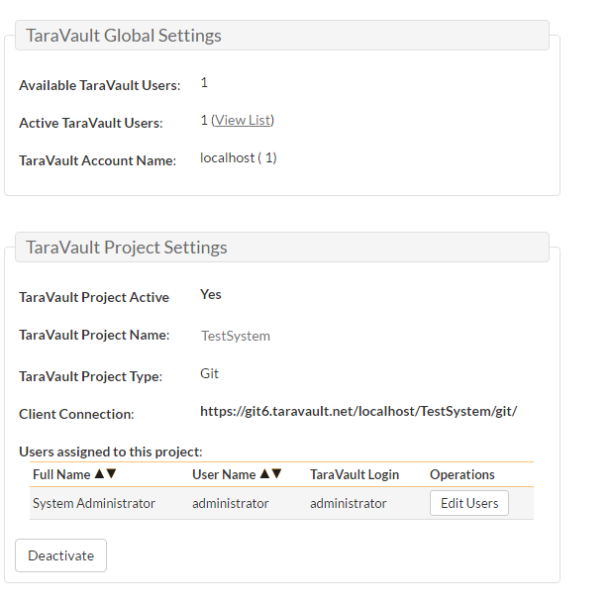

The screen will display the name of the linked TaraVault product as well as the list of TaraVault SCM users that are configured to use this TaraVault product – this list will not necessarily be all of the users in the SpiraPlan product, just those that need to connect to TaraVault to commit source code into the repository.

If you want to deactivate this TaraVault product, click the [Deactivate] button and the product will be removed from TaraVault.

To improve performance, SpiraPlan will cache some of the data it receives from TaraVault. Normally SpiraPlan will know when to update the cached data based on changes made in TaraVault automatically. However sometimes you may wish to flush the cached data completed, to do this, click on the [Clear Cache] button.

To add new SCM users to the TaraVault product, click on the ‘Add Users’ link to add new SCM users to the product.

### 3.3.7. Event Log

The “System Event Log” administration page lets you view all of the errors, warning and other diagnostic messages that have been logged in the system:

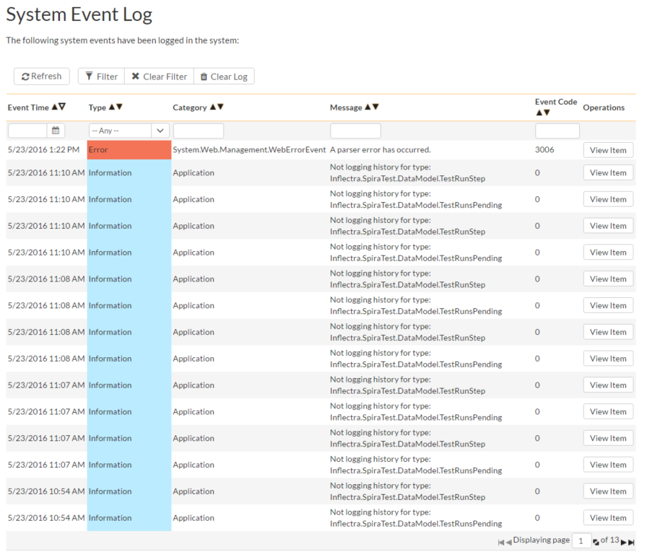

Each event entry is displayed along with the date-time it occurred, the type of event (error, warning, information, success audit, failure audit), category (application, source code provider, data-synchronization) and the short name. To view the full message, click on the “View Item” hyperlink:

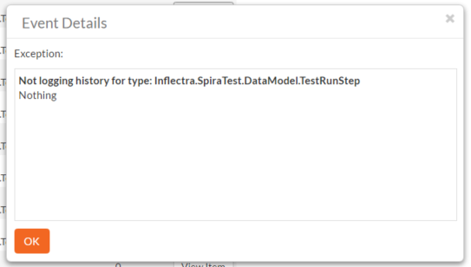

The popup dialog box will display the full error message log and stack trace in a moveable dialog box. This information should be provided to Inflectra customer support if you log a help desk ticket.

### 3.3.8. Testing Settings

Clicking on the “Testing Settings” link brings up a list of options that the administrator can configure regarding testing. Select from the options displayed (as illustrated below) and click “Save” to commit the changes.

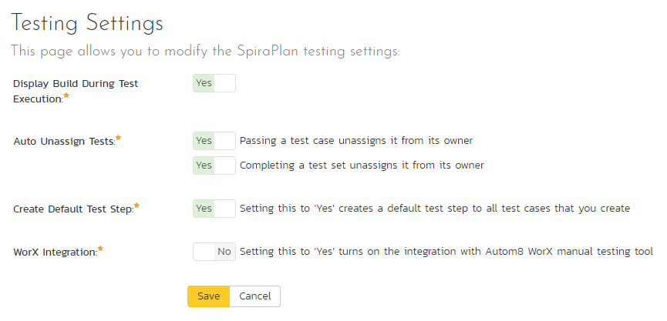

You can enable or disable the following settings:

* **Display Build During Test Execution** – During test execution the system can display a drop-down list of builds associated with the selected release. If you are using SpiraPlan in conjunction with a build server such as Jenkins/Hudson, you should choose “Yes”, otherwise we recommend hiding the list of builds (to avoid confusing your testers) by choosing “No”.
* **Auto Unassign Tests** – When a tester passes an assigned test case or all the test cases in an assigned test set the system by default will automatically un-assign the test case / test set from the user. To prevent this from happening, change either setting to “No”.
* **Auto create a test step** - Automatically creating a default test step on the creation of any test case
* **Worx Integration** – Integrating with the Worx desktop application

### 3.3.9 Email Configuration

The Email Configuration page is split into two sections. The first section covers email notification details, and the second section configures how email from the application is sent.

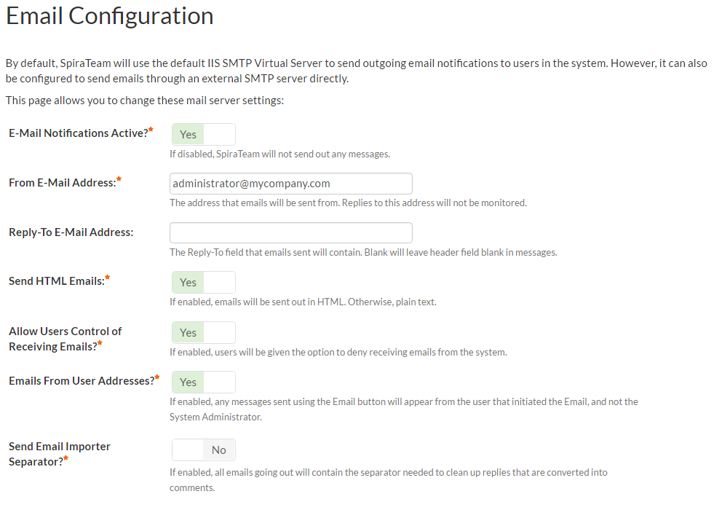

* **Email Notifications Active?** – Defaults to Yes. If changed to No, the system will not send out any emails, regardless of other settings. Note that this means that new user requests will not get sent either.
* **From Email Address –** This is the email address specified in the ‘From:’ field of email notifications sent from the application.
* **Reply-To Email Address –** This is the address specified in the ‘ReplyTo:’ field for notification emails sent from the application.
* **Send HTML Emails?** – Defaults to Yes. This option specifies whether HTML or Plain-Text emails are sent from the system.
* **Allow Users Control of Receiving Emails?** – Defaults to Yes. This specifies whether or not a user can modify their profile to not receive any emails from the system. If set to no, users’ preference will be enabled and locked out.

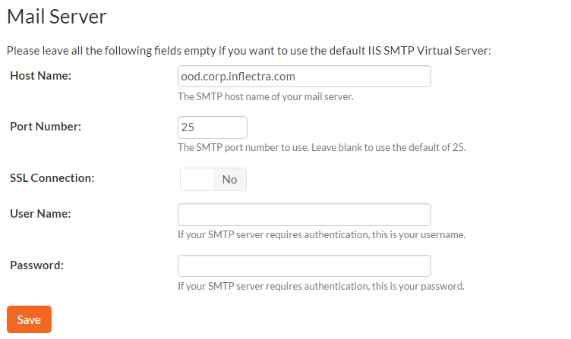

To use the internal IIS’s default virtual SMTP server, leave all fields blank. The virtual server must then be configured to use proper SMTP server and network configuration. If you want the application to contact an SMTP server directly, use the following fields:

* **Host Name –** This is the SMTP server to connect to.
* **Port Number –** This is the port number to use, blank uses the default port 25.
* **SSL Connection –** Whether or not to use an SSL connection with the server. Be sure that the SMTP server’s SSL certificate is trusted on the application server.
* **User Name –** When using an authentication method, this is the username to log in as.
* **Password –** When using an authentication method, this is the password to use.

Example settings for connecting to Gmail/Google Mail for sending notifications:

* **Host Name:** smtp.gmail.com
* **Port Number:** 587
* **SSL Connection:** Yes
* **User Name:** “account”@gmail.com
* **Password:** “account password”

## 3.4. System: Integration

### 3.4.1. Data Synchronization

SpiraPlan® is capable of synchronizing its data with a variety of other systems, including but not limited to requirements management systems and standalone bug-tracking tools. The various integration plug-ins for SpiraPlan® and the steps for configuring the data-synchronization settings are described in the *SpiraTest External Bug-Tracking Integration Guide*.

If you are synchronizing data between SpiraPlan® and one of these other systems, you can click on the ‘Data Synchronization’ administration page at any time and view a list of all the data-synchronizations taking place, together with the status and date/time of last synchronization:

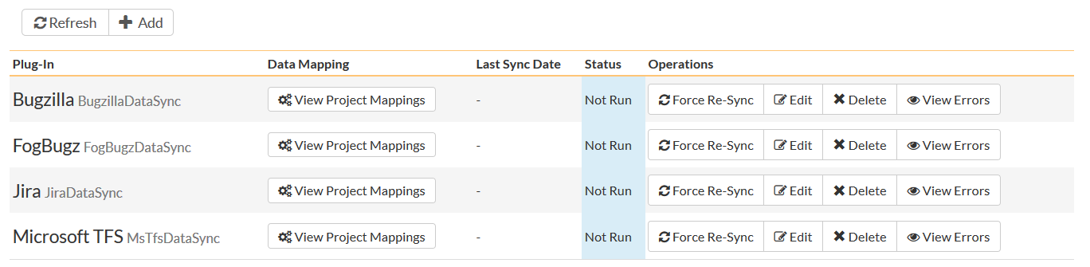

In the example above, we have four plug-ins active, with incidents being exported into JIRA, Bugzilla, FogBugz and Microsoft Team Foundation Server. The data of last sync and the status indicate if there are problems with the plug-in.

The ‘Refresh’ button allows you to refresh the status of the page to ensure that you are seeing the most up to date information. In certain circumstances you may want to reset the date of last sync and force a particular plug-in to examine all the records in the system to see if any were not synchronized - clicking on the ‘Force Complete Re-Sync’ button will achieve this. The recommended procedure for forcing a re-sync is to temporarily stop the SpiraPlan Data-Sync background Windows service, click the button to reset the last-sync date, and then start the service. This will ensure that the resetting doesn’t happen mid-sync.

### 3.4.2. Version Control Integration (On-Premise Customers Only)

*This section refers to the functionality available to on-premise customers of SpiraPlan. If you are using the cloud / hosted version of SpiraPlan, please refer to section* ***3.3.6.*** *(TaraVault Configuration) instead.*

SpiraPlan® is capable of integrating with a variety of Version Control (VC) / Software Configuration Management (SCM) tools such as Git, Subversion, CVS and TFS. This allows you to browse the source code repositories using the SpiraPlan web interface, and more importantly link revisions in these tools to artifacts in SpiraPlan. This provides the end-to-end traceability from code commits/check-ins to the tasks, incidents and requirements that necessitated the code change.

The information on using the various version control providers for SpiraPlan® and the steps for configuring the provider-specific settings are described in the *SpiraPlan/Team Version Control Integration Guide*.

To configure a version control provider, you need to click on the Administration > Integration > Version Control link in the Administration navigation to bring up the list of configured version control providers:

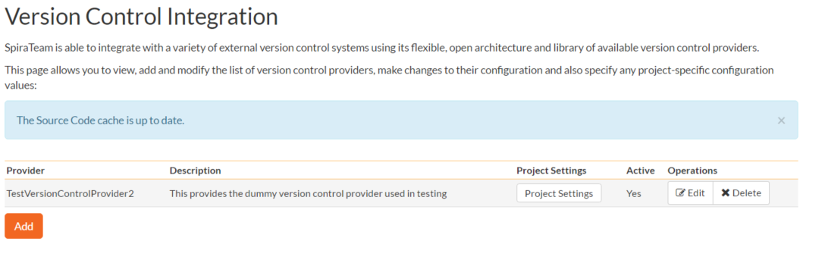

By default the only provider listed will be the TestVersionControlProvider which is used for demonstration purposes only, and can be deleted from a production system by clicking on the “Delete” button to the right of it.

To add a new version control provider, click the “Add” button to enter the Plug-in details page. The fields required are as follows:  
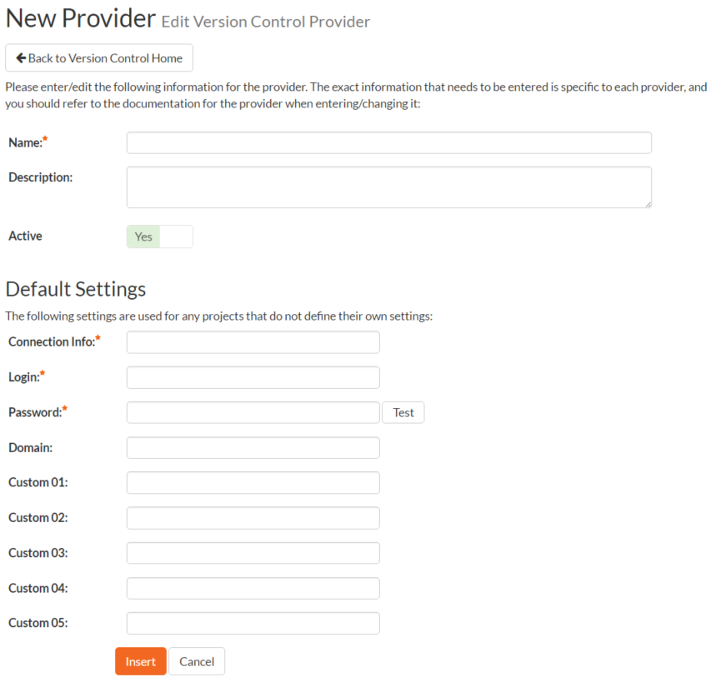

* **Name**: The name of the version control provider that you’re adding. This needs to match the name of the Plug-in DLL file that you’re using (see the *SpiraPlan/Team Version Control Integration Guide* for more details on your specific tool)
* **Description**: The description is for your use only, and does not affect operation of the plug-in.
* **Active**: If checked, the plug-in is active and able to be used for any product.
* **Connection Info**: This field holds the root of the repository for any product accessing the plug-in, unless overridden in the Product Settings. Use the syntax that is described for your tool in the *SpiraPlan/Team Version Control Integration Guide)*
* **Login / Password**: The user id and the password of the user to use while accessing and retrieving information from the version control system.
* **Other Fields**: The other fields (Domain, Custom1 – Custom5) are provider-specific and will be described in the appropriate section of the *SpiraPlan/Team Version Control Integration Guide.*

When finished, click the “Insert” button and you will be taken back to the Version Control integration list page, with new provider listed as an available plug-in:

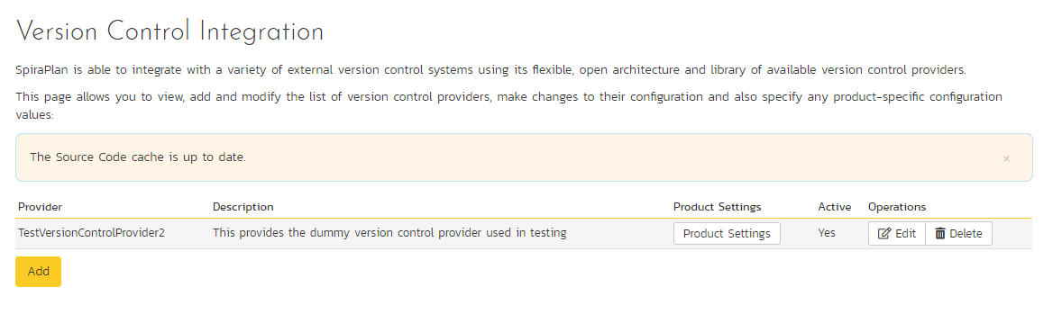

To edit the settings for an existing version control provider, click on the “Edit” button next to the name of the provider and you will be able to edit the same settings that were shown above when you first created it.

Now, you may want to change some of the settings on a per-product basis. For example you may have different repositories that you want to link to each product. You still enter the base settings for the provider as illustrated above, but then you can override specific settings for each product.

To do this, click on the “Product Settings” button next to the provider in question, which will take you to the screen discussed in 3.6.4. below.

### 3.4.3. Test Automation

SpiraPlan® can be used to manage the development, scheduling and execution of automated unit, functional and load tests written using a variety of test automation engines (e.g. HP QuickTest Pro, SmarteScript, TestComplete, etc.). This section allows you to configure the different engines that are available in your environment so that the testers know which tools they can use to schedule tests with.

The information on using the various test automation engines for SpiraPlan® and the steps for configuring the engine-specific settings are described in the *SpiraTest/Team RemoteLaunch Automated Testing Integration Guide*.

To configure a test automation engine, you need to click on the Administration > Integration > Test Automation link in the Administration navigation to bring up the list of configured test automation engines:

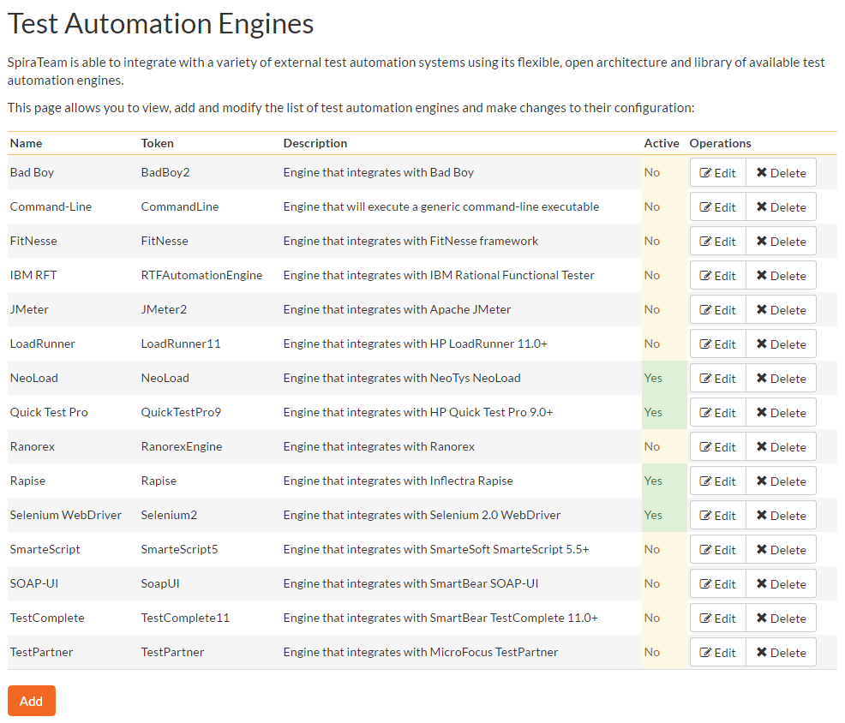

To add a new test automation engine, click the “Add” button to enter the Automation Engine details page. The fields required are as follows:

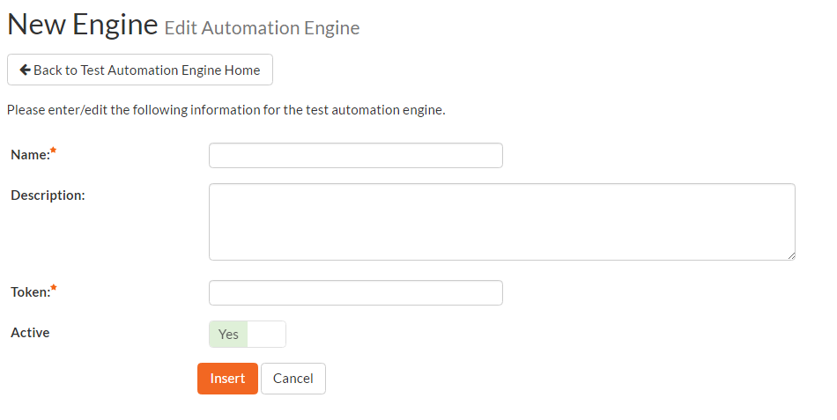

* **Name**: The name of the test automation engine that you’re adding. This can be set to any name of your choice that would make sense to your users.
* **Description**: The description is used for any comments or additional information that you need to use to describe the automation engine.
* **Active**: If checked, the automation engine is active and able to be used in any product.
* **Token:** This needs to match the name of the Automation Engine DLL file that you’re using (see the *SpiraTest/Team Automated Testing Integration Guide* for more details on your specific tool) for the specific automation engine.

When finished, click the “Insert” button and you will be taken back to the test automation engine list page, with new automation engine listed.

To edit the settings for an existing test automation engine, just click on the “Edit” link next to the name of the engine and you will be able to edit the same settings that were shown above when you first created it.

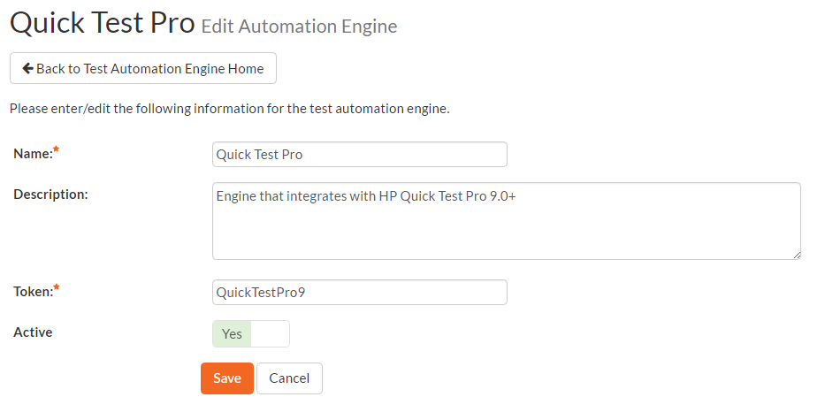

Once you have made the appropriate changes, click the [Save] button to commit them.

You are now ready to use SpiraPlan® in conjunction with the test automation engine you added. For details on how to use the test automation features of SpiraPlan, please refer to the *SpiraPlan® User Manual*.

## 3.5. System: Reporting

SpiraPlan has a powerful set of reports and charts available out of the box that cover most product’s needs. However, there is often a need to be able to generate custom reports and graphs that are specific to your organization. In this section, you can create custom graphs and reports for your users to use.

### 3.5.1. Edit Reports

The “Edit Reports” administration page lets you create custom reports in the system that your users can run in the various products they have access to. Note that the report definitions themselves are global to the system and therefore available in all products.

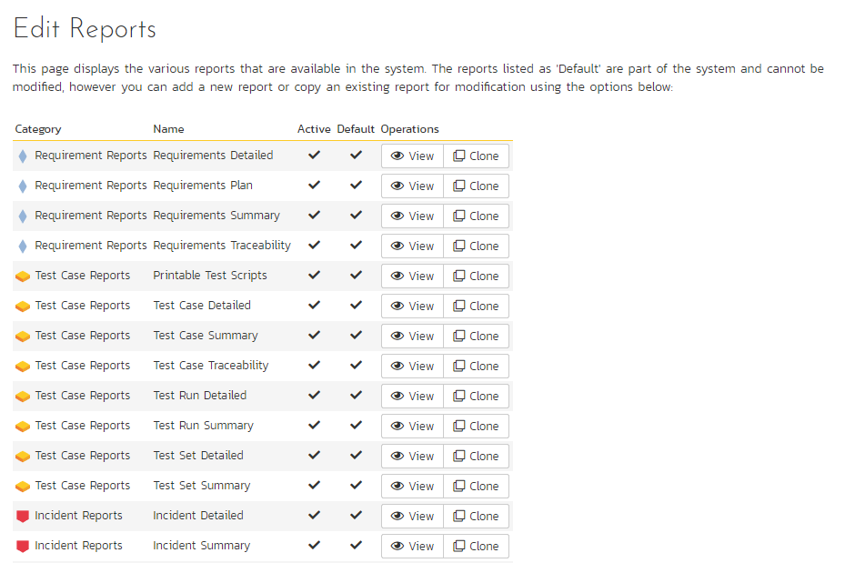

The list of report definitions contains both the standard (default) reports that ship with the system and any custom reports that you have defined. However, any of the reports listed with the “Default” option checked will not be editable. So, if you want to modify one of the built-in reports to make it better suit your needs, you should instead click on the “Clone” button next to the report and make a copy of the report that you can then modify. You can view any of the default reports by clicking on the associated “View” button.

To edit an existing non-default report, click on the “Edit” button. To add a new report from scratch, click on the “Add New Report” option at the bottom of the list. Either of these will take you to the Report editing screen:

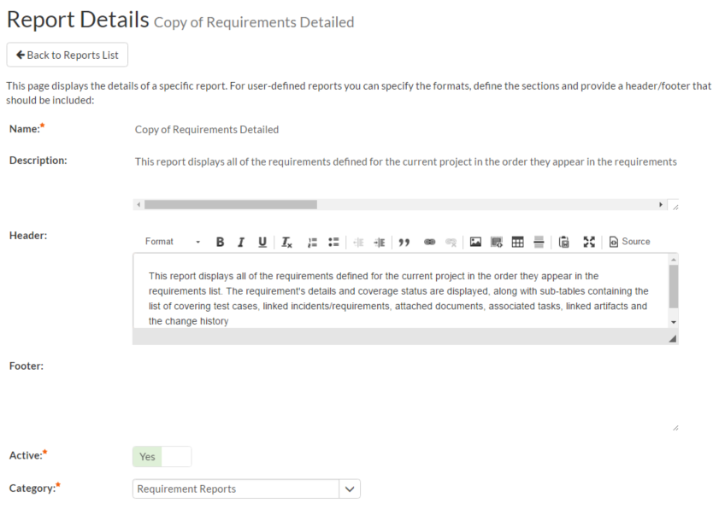

The top-half of this screen (illustrated above) lets you specify the name of the report, the long description (displayed in tooltips but not in the report itself) and a rich-text footer and header. The header and footer will be displayed at the top and bottom of the generated report.

In addition, you can specify whether the report is active (and therefore can be used in the SpiraPlan reports center) and which report category heading the report will appear in. This is also used to determine which role(s) are able to run the report (e.g. a user that has permissions to view requirements will be able to run all reports listed under the “Requirement Reports” category).

The lower-half of the screen displays the list of formats, standard sections and custom sections that make up the report:

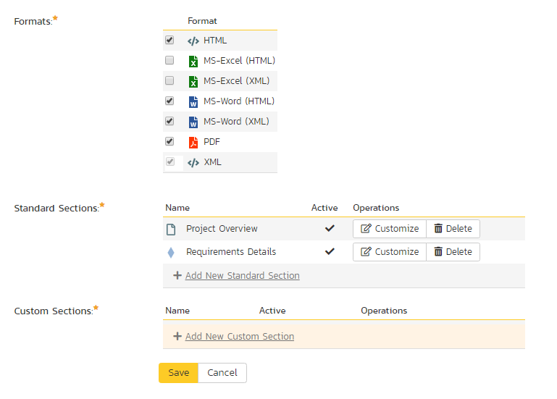

The list of formats is fixed in the system, you can simply choose which formats this specific report will be available in. The reporting engine will take care of converting your report into the target format, you just need to specify which type(s) are applicable.

a) Standard Sections

The list of **standard sections** contains a list of the various pre-defined report sections that are to be included in the report. A standard section consists of a set of nested queries and embedded elements that will return back data. For example, the “Requirements Details” section consists of a list of all the requirements in a product, together with the associated test cases, tasks, custom properties, attachments, discussions, change history, source code revisions and other related items.

With a standard section, you cannot change the underlying data query, but you can change the header, footer and XSLT template used to format the results:

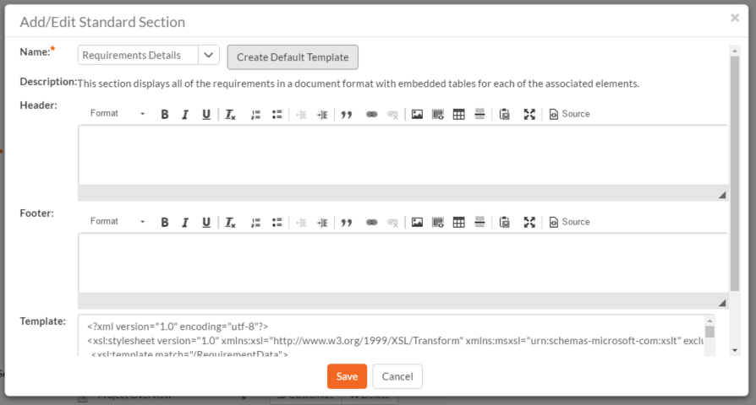

When you either click on “Add New Standard Section” or the “Customize“ link next to an existing standard section, the popup dialog illustrated above will be displayed. On this page you can change the following fields:

* **Name –** Choose the name of the standard report section you want to use from the dropdown list. Changing the name of the section will automatically update the Description field below.
* **Description** – This is the description of the report section, it is not displayed in the final report.
* **Header** – This is the header that will be displayed *before* the dynamic data retrieved as part of the report section. You can enter in formatted rich text in this field.
* **Footer** – This is the footer that will be displayed *after* the dynamic data retrieved as part of the report section. You can enter in formatted rich text in this field.
* **Template** – This is the eXtensible Markup Language Stylesheet Transform (XSLT) used to transform the raw XML data from the report query into the final HTML display format. When you choose/change the name dropdown list, clicking on the “Create Default Template” will populate this field with the default template used to render the data.

When you first create a new standard report section, we recommend using the option to “Create Default Template”. This will then allow you to run the report in the main reports center and have all the available data fields displayed in the standard format. If you would like to customize the content of the section, you have several options:

* **Customize Header/Footer** – if you want to keep the data and layout as-is, you can simply add a custom header and footer to add organization specific information into the report.
* **Customize the Data/Layout** – if you want to customize how the data is displayed and formatted, you will need to edit the XSLT Template. You can learn more about XSLT at the W3Schools website (<http://www.w3schools.com/xsl>). However, the recommended approach is to first run the “Raw XML” format report from the main SpiraPlan reports center. An example XML report is partially shown below:

“?xml version="1.0" encoding="UTF-8" standalone="yes"?”

“Report”

“Title”

Requirements Detailed Report

“/Title”

“ProductData”

“Product”

“ProjectId”1”/ProjectId”

“ProjectGroupId”2”/ProjectGroupId”

“Name”Library Information System”/Name”

“Description”Sample application that allows users to manage books, authors and lending records for a typical branch library”/Description”

“Website”www.libraryinformationsystem.org”/Website”

“CreationDate”2005-11-30T19:00:00”/CreationDate”

“ActiveYn”Y”/ActiveYn”

“WorkingHours”8”/WorkingHours”

“WorkingDays”5”/WorkingDays”

“NonWorkingHours”0”/NonWorkingHours”

“TimeTrackIncidentsYn”Y”/TimeTrackIncidentsYn”

“TimeTrackTasksYn”Y”/TimeTrackTasksYn”

“EffortIncidentsYn”Y”/EffortIncidentsYn”

“EffortTasksYn”Y”/EffortTasksYn”

“TasksAutoCreateYn”Y”/TasksAutoCreateYn”

“ReqDefaultEffort”480”/ReqDefaultEffort”

“TaskDefaultEffort”360”/TaskDefaultEffort”

“ProductGroupName”Internal Products”/ProductGroupName”

“/Product”

“/ProductData”

“RequirementData”

“Requirement”

“RequirementId”1”/RequirementId”

“ProjectId”1”/ProjectId”

“ScopeLevelId”3”/ScopeLevelId”

“AuthorId”2”/AuthorId”

“Name”Functional System Requirements”/Name”

“CreationDate”2003-11-30T19:00:00”/CreationDate”

“LastUpdateDate”2003-11-30T19:00:00”/LastUpdateDate”

“IndentLevel”AAA”/IndentLevel”

“ExpandedYn”Y”/ExpandedYn”

“VisibleYn”Y”/VisibleYn”

“SummaryYn”Y”/SummaryYn”

“AttachmentsYn”N”/AttachmentsYn”

“CoverageCountTotal”21”/CoverageCountTotal”

“CoverageCountPassed”10”/CoverageCountPassed”

“CoverageCountFailed”3”/CoverageCountFailed”

“CoverageCountCaution”1”/CoverageCountCaution”

“CoverageCountBlocked”1”/CoverageCountBlocked”

“PlannedEffort”8700”/PlannedEffort”

“TaskEstimatedEffort”11400”/TaskEstimatedEffort”

“TaskActualEffort”7570”/TaskActualEffort”

“TaskProductedEffort”3855”/TaskProductedEffort”

“TaskRemainingEffort”11485”/TaskRemainingEffort”

“TaskCount”42”/TaskCount”

“TaskPercentOnTime”59”/TaskPercentOnTime”

“TaskPercentLateFinish”6”/TaskPercentLateFinish”

“TaskPercentNotStart”7”/TaskPercentNotStart”

“TaskPercentLateStart”28”/TaskPercentLateStart”

“ScopeLevelName”In Progress”/ScopeLevelName”

“AuthorName”Fred Bloggs”/AuthorName”

“HasDiscussionChanged”false”/HasDiscussionChanged”

“IsDeleted”false”/IsDeleted”

“CustomProperties”

“CustomProperty”

“Alias”URL”/Alias”

“Name”Custom_01”/Name”

“Type”Text”/Type”

“/CustomProperty”

“CustomProperty”

“Alias”Difficulty”/Alias”

“Name”Custom_02”/Name”

“Type”List”/Type”

“/CustomProperty”

“CustomProperty”

“Alias”Requirement Type”/Alias”

“Name”Custom_03”/Name”

“Type”List”/Type”

“/CustomProperty”

“CustomProperty”

“Alias”Notes”/Alias”

“Name”Custom_04”/Name”

“Type”Text”/Type”

“/CustomProperty”

“CustomProperty”

“Alias”Review Date”/Alias”

“Name”Custom_05”/Name”

“Type”Date”/Type”

“/CustomProperty”

“CustomProperty”

“Alias”Decimal”/Alias”

“Name”Custom_06”/Name”

“Type”Decimal”/Type”

“/CustomProperty”

“/CustomProperties”

“Discussions /”

“TestCases /”

“Tasks /”

“Attachments /”

“History”

“HistoryChangeSetType”

“ChangeTypeId”1”/ChangeTypeId”

“ChangeTypeName”Modified”/ChangeTypeName”

“/HistoryChangeSetType”

“HistoryChangeSetType”

“ChangeTypeId”2”/ChangeTypeId”

“ChangeTypeName”Deleted”/ChangeTypeName”

“/HistoryChangeSetType”

“HistoryChangeSetType”

“ChangeTypeId”3”/ChangeTypeId”

“ChangeTypeName”Added”/ChangeTypeName”

“/HistoryChangeSetType”

“HistoryChangeSetType”

“ChangeTypeId”4”/ChangeTypeId”

“ChangeTypeName”Purged”/ChangeTypeName”

“/HistoryChangeSetType”

“HistoryChangeSetType”

“ChangeTypeId”5”/ChangeTypeId”

“ChangeTypeName”Rollback”/ChangeTypeName”

“/HistoryChangeSetType”

“HistoryChangeSetType”

“ChangeTypeId”6”/ChangeTypeId”

“ChangeTypeName”Undelete”/ChangeTypeName”

“/HistoryChangeSetType”

“HistoryChangeSetType”

“ChangeTypeId”7”/ChangeTypeId”

“ChangeTypeName”Imported”/ChangeTypeName”

“/HistoryChangeSetType”

“HistoryChangeSetType”

“ChangeTypeId”8”/ChangeTypeId”

“ChangeTypeName”Exported”/ChangeTypeName”

“/HistoryChangeSetType”

“/History”

“Requirements /”

“Incidents /”

“SourceCodeRevisions /”

“/Requirement”

“/RequirementData”

“/Report”

This XML data is then converted by the XSLT template into HTML format so that it can be included into the final generated report. An example fragment of the XSLT template looks like:

“?xml version="1.0" encoding="utf-8"?”

“xsl:stylesheet version="1.0" xmlns:xsl="http://www.w3.org/1999/XSL/Transform" xmlns:msxsl="urn:schemas-microsoft-com:xslt" exclude-result-prefixes="msxsl"“

“xsl:template match="/RequirementData"“

“xsl:for-each select="Requirement"“

“div”

“xsl:attribute name="style"“

padding-left: “xsl:value-of select="string-length(IndentLevel)*2"/”px;

“/xsl:attribute”

“xsl:if test="SummaryYn='Y'"“

“div class="Title2"“

RQ:”xsl:value-of select="RequirementId"/” - “xsl:value-of select="Name"/”

“/div”

“div class="Description"“

“xsl:value-of select="Description" disable-output-escaping="yes"/”

“/div”

“br /”

“/xsl:if”

“xsl:if test="SummaryYn='N'"“

“xsl:attribute name="style"“

padding-left: “xsl:value-of select="string-length(IndentLevel)*2"/”px;

“/xsl:attribute”

“div class="Title3"“

RQ:”xsl:value-of select="RequirementId"/” - “xsl:value-of select="Name"/”

“/div”

“p”

“xsl:value-of select="Description" disable-output-escaping="yes"/”

“/p”

“/xsl:if”

“/div”

“/xsl:for-each”

“/xsl:template”

So using a combination of XSLT and the Raw XML report format, you can generate a customized view of the standard report section that will be included in the final report.

Sometimes, however you want to be able to create a completely custom report that includes customized data as well as a custom format. In which case you need to use a **custom report section** instead.

b) Custom Section

Back on the main report details page, if you click on “Add New Custom Section”, the following dialog box will be displayed:

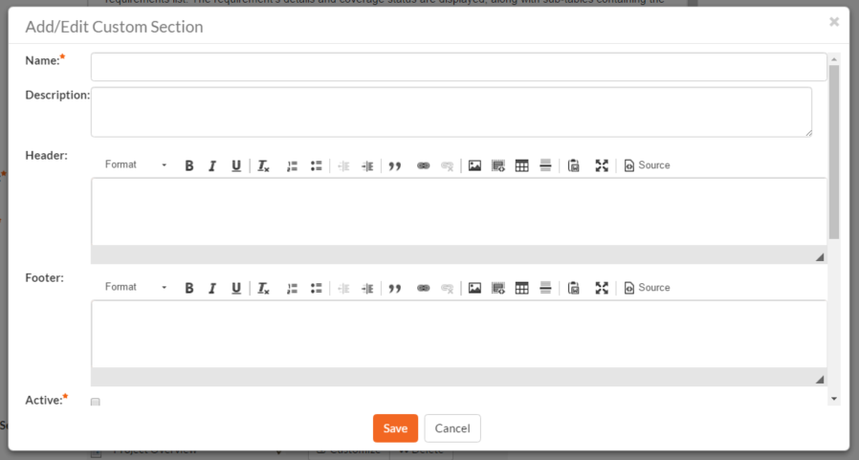

On this page you can enter / change the following fields:

* **Name –** Enter the name of the new custom report section that you will be adding to the report. This is not displayed in the final report
* **Description** – This is the description of the custom section, it is not displayed in the final report.
* **Header** – This is the header that will be displayed *before* the dynamic data retrieved as part of the report section. You can enter in formatted rich text in this field.
* **Footer** – This is the footer that will be displayed *after* the dynamic data retrieved as part of the report section. You can enter in formatted rich text in this field.
* **Active** – You should make sure this checkbox is checked if you want the custom section to appear in the final report.

Further down on the page you can actually enter the custom query and associated XSLT template:

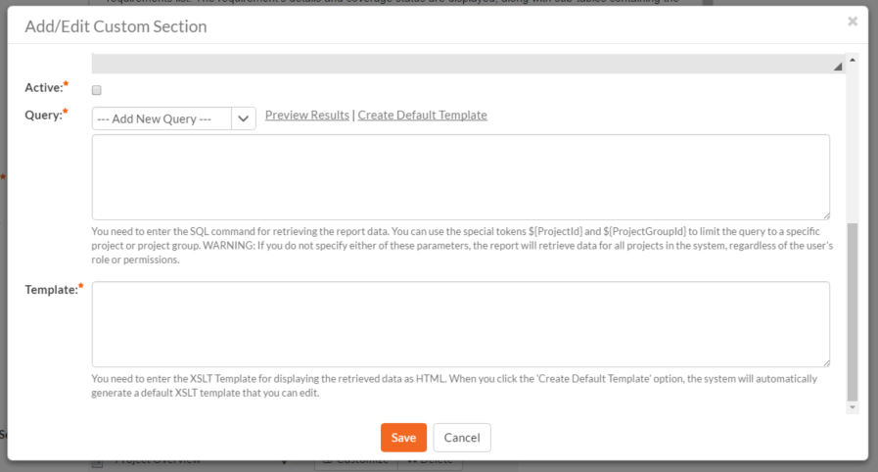

On this page you need to first choose the appropriate **reportable entity** from the dropdown list. In the example illustrated above, we have selected the “Requirements” reportable entity. This will automatically populate the following query in the **Query** editor:

select value R from SpiraTestEntities.R_Requirements as R where R.PROJECT_ID = ${ProjectId}

This query tells SpiraPlan to select all of the rows in the R_Requirements collection that are in the current product and include all of the columns in the final report. This generally will result in more columns than is desirable, so you should click on the “Preview Results” option to view a list of the various columns and the sample data. That will help you decide which columns are important for your report. You can then adjust the query to only include those columns:

select R.REQUIREMENT_ID, R.NAME from SpiraTestEntities.R_Requirements as R where R.PROJECT_ID = ${ProjectId}

In this modified query, we have replaced the keyword **value** with the specific column names. When you use the “Preview Results” option on this query, you will only see the two desired columns:

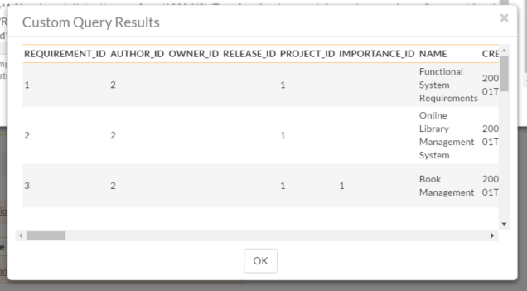

Once you have verified that the data being returned matches your requirements, click on the “Create Default Template” option and SpiraPlan will automatically generate a new XSLT template that displays just these columns in a nice table format:

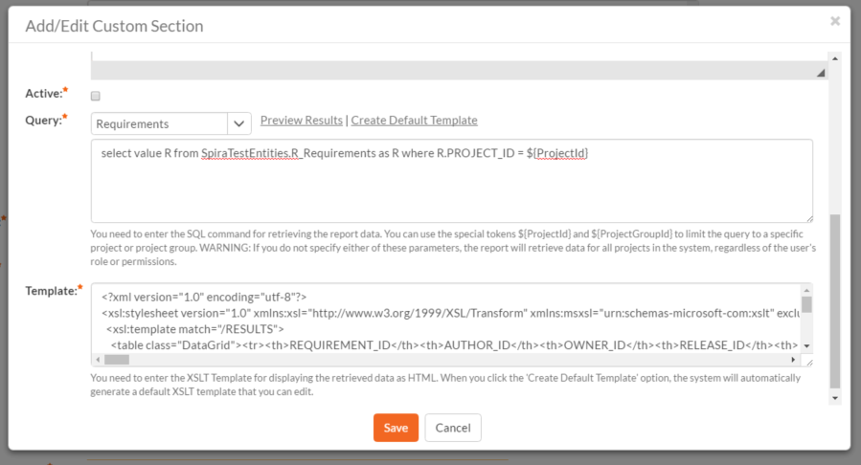

You can now click the [Save] button to save your changes to the report.

You may have noticed that we had a special token in the query **${ProjectId}**, this token will be evaluated during the generation of the report and ensures that only items in the current product are included. If you want to include all the items in a specific Program, you should instead use the token **${ProjectGroupId}**. If you don’t use either token, the report will include all the items in the entire system, across all products and groups.

For example:

* select value R from SpiraTestEntities.R_Requirements as R where R.PROJECT_ID = ${ProjectId}  
  **will display all the requirements in the specific product**
* select value R from SpiraTestEntities.R_Requirements as R where R.PROJECT_GROUP_ID = ${ProjectGroupId}  
  **will display all the requirements in the specific program**
* select value R from SpiraTestEntities.R_Requirements as R  
  **will display all the requirements in the entire system**

For more information on creating custom report queries, please refer to the knowledge base articles on the Inflectra customer support website: <http://www.inflectra.com/Support>.

*Warning: If you create a report that doesn’t have either ${ProjectId} or ${ProjectGroupId} in the WHERE clause you could end up displaying data to a user that shouldn’t have permission to see that data.*

### 3.5.2. Edit Graphs

The “Edit Graphs” administration page lets you create custom graphs and charts in the system that your users can run in the various products they have access to. Note that the graph definitions themselves are global to the system and therefore available in all products.

When you click on the ‘Edit Graphs’ menu option, the system will display a list of any existing custom graphs that have been already defined (it will not list the standard graphs that come with the system):

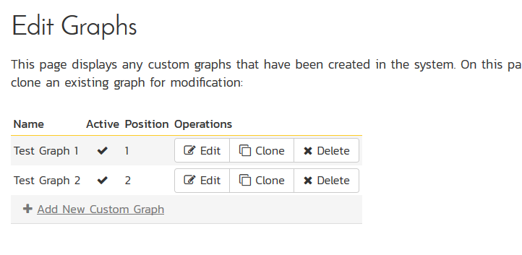

To add a new graph, click on the ‘**Add New Custom Graph**’ option in the bottom of the table:

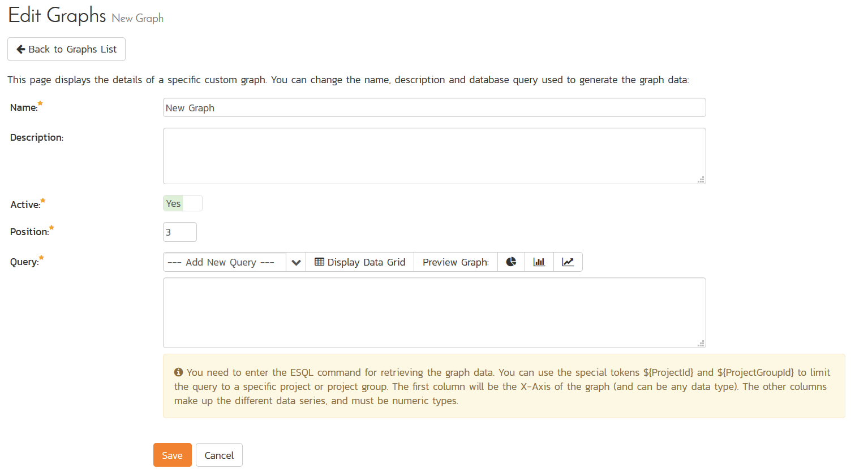

This is the same screen you will see if you click on the **Edit** button for an existing graph. In addition, the graph list page has the following additional operations:

* **Clone** – this will make a copy of the graph with ‘- Copy’ appended to the name
* **Delete** – this will permanently delete the selected custom graph.

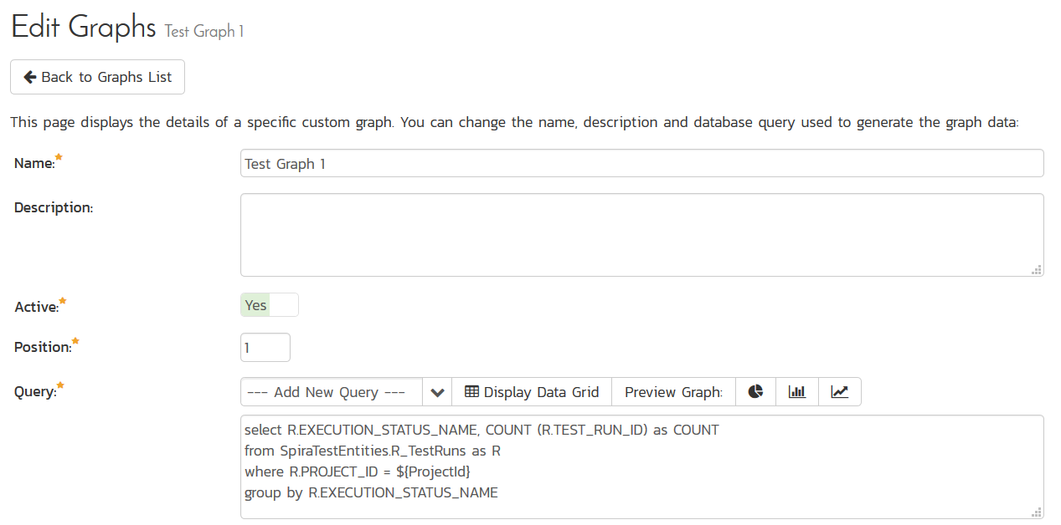

On the graph editing page, you can enter the following fields:

* **Name** – This is the short name of the graph that will be displayed to users when they choose to display a custom graph.
* **Description** – This is the longer description of the graph, and should be used to explain what the data in the graph shows, what the purpose of the graph is and how the data should be interpreted. This is what the user will see when they click on the help link on the graph.
* **Active** – If you set this to “No”, the graph will not be accessible by end users
* **Position** – use this to specify the relative position of the graph in the list of custom graphs.
* **Query** – this is where you enter the actual query used to generate the graph data. We shall discuss this below.

Entering the Query

We recommend that you first choose the appropriate **reportable entity** from the dropdown list. In the example illustrated above, we have selected the “Test Runs” reportable entity.

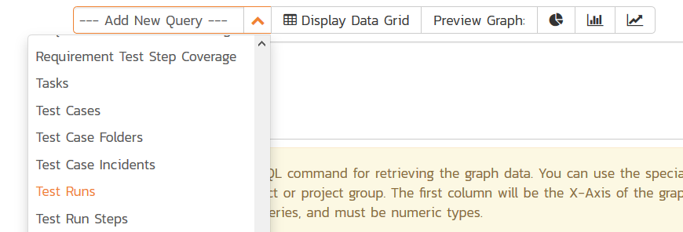

This will automatically populate the following query in the **Query** editor:

select value R from SpiraTestEntities.R_TestRuns as R where R.PROJECT_ID = ${ProjectId}

This query tells SpiraPlan to select all of the rows in the R_TestRuns collection that are in the current product and include all of the columns in the final report. You cannot graph non-numeric columns, so usually we’d recommend clicking **Display Data Grid** to see all of the columns that you can use in the graph:

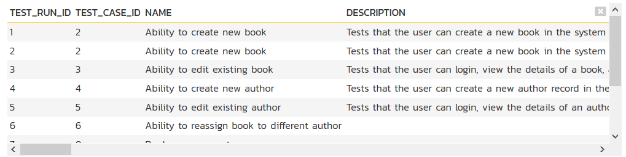

This will help you decide which columns are important for your graph. You can then adjust the query to only include those columns:

select R.EXECUTION_STATUS_NAME, COUNT (R.TEST_RUN_ID) as COUNT

from SpiraTestEntities.R_TestRuns as R

where R.PROJECT_ID = ${ProjectId}

group by R.EXECUTION_STATUS_NAME

In this modified query, we have replaced the keyword **value** with the specific column names. We have also added an aggregation function called **COUNT** to count the number of test runs and group by the execution status name column. SpiraPlan uses a modified SQL language called Entity SQL. For more information on creating custom graph queries, please refer to the knowledge base articles on the Inflectra customer support website: <http://www.inflectra.com/Support>.

When you click **Display Data Grid**, you will now see:

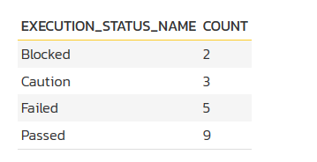

The graphing module requires that the first column be the list of categories to display on the x-axis of the graph. It can be any format (text, numeric, dates, etc.). The remaining columns have to be numeric and will be used to display the different data ranges. The column name will be used to display the data range. For donut graphs, only one data range is supported, for line/bar charts, you can have multiple ranges.

You can see how the graph looks in the three different styles (donuts, bar, line):

a) Donut Graph

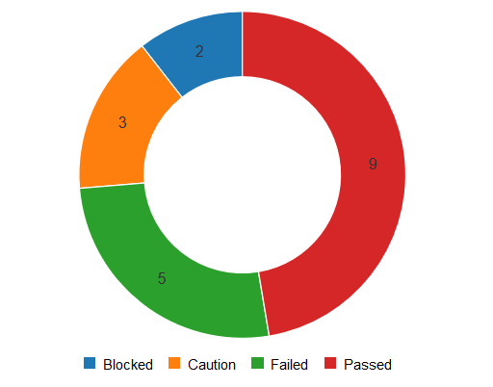

b) Bar Graph

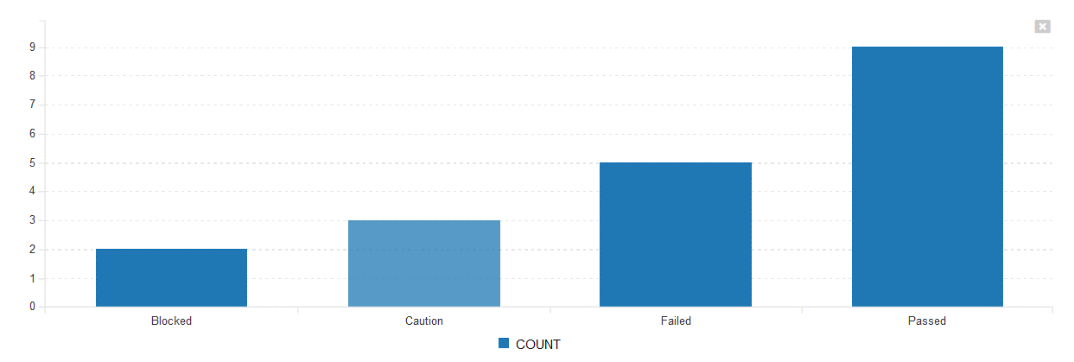

c) Line Graph

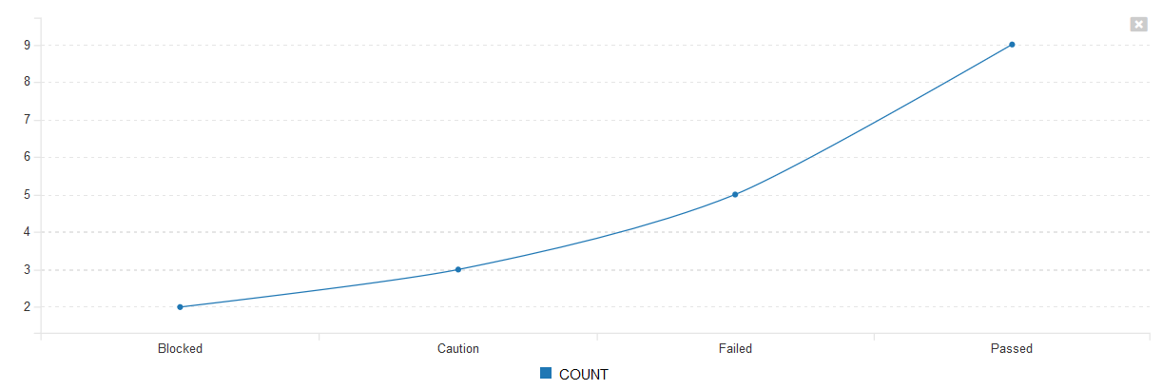

Once you are happy with your custom graph, click the **Save** button to commit the changes. If the Active flag is set to “Yes” then the graph will be available for end users to use.

*Warning: If you create a graph that doesn’t have either ${ProjectId} or ${ProjectGroupId} in the WHERE clause you could end up displaying data to a user that shouldn’t have permission to see that data.*

## 3.6. Product: General Settings

### 3.6.1. Product History Changes

This page displays a list, by default in chronological order, of changes made to items within the selected product.

At this time, only changes made to Requirements, Tasks, Incidents, Test Cases, Test Steps, Test Sets, Releases, and Automation Hosts are recorded. Certain changes are to these artifacts are not recorded, such as location changes (indenting, outdenting), and comment additions.

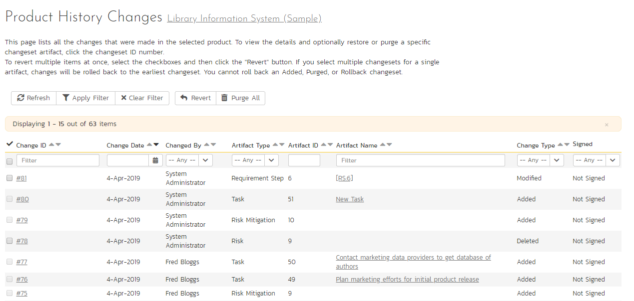

There are a handful of change types recorded and displayed here:

* **Modified**: The most common, this means that one or more fields in this artifact were changed. Note that if a standard field and a custom field were changed at the same time, it will generate two separate entries, one for the standard fields, one for the custom fields.
* **Added**: This means that this artifact was added, created in the system, either by using the New menu option or by copying. Pasting an item that was cut will not result in an Added entry being created.
* **Rollback**: This items means that the artifact was rolled back to a specific event in the history.
* **Deleted**: This entry is created when an artifact is deleted from the system.
* **Undelete**: This entry is created when an artifact was deleted and then undeleted, making it live in the system again.
* **Purged**: This entry is created (and all other history items are removed) when a deleted artifact is purged from the system. Purged items are removed from the database, and cannot be recovered.

***Note***: When upgrading from a version before v3.1, each individual field changed will be considered a unique change, due to how previous versions recorded history. However, as soon as the application is upgraded, simultaneous changes will be grouped together based on their last-update date.

This screen allows the administrator several options:

* *Viewing Details*: The detail screen for each change set can be viewed by clicking on the change ID #. This will take you to the history details screen, described below.
* *Revert*: This button will roll back all items in the list that are checked. You must have at least one row checked to revert. See the section on reverting below.
* *Purge All*: This button will permanently purge all deleted items from the database. Once items are purged, they cannot be restored.

#### 3.6.1.1. History Details Screen

The history details screen displays information on the selected change set:

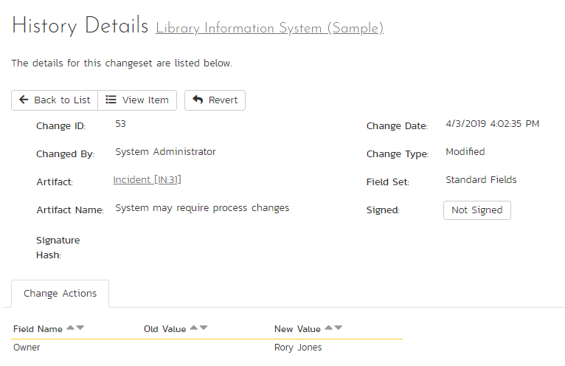

The History Details screen will show basic information as well as fields that were changed in this change set. Shown here is the Change ID, the date and time that the change was made, the user that made the change, the change type, the artifact affected, and the set of fields affected.

If a set of fields were affected (Standard or Custom), then the list of fields will be listed below. In the example above, the change was a Modification, and 5 fields were changed. In other change types, no fields will be displayed.

If the artifact is still available in the system, you can click the Artifact or click the ‘View Item’ button in the toolbar to view the item as it is currently. However, if the item has been deleted, a warning label will be displayed (as above in the example screenshot), the View Item links will be disabled, and a new option, “Purge” will appear on the toolbar.

#### 3.6.1.2 Purging Items

Items that have been deleted by any user still remain in the database, but do not affect statistics or reports, and do not show up in reports and cannot be viewed. The artifacts are still in the database, however, and can be restored by clicking on the Restore button in the toolbar.

Purging an individual item can only be done while viewing one of its history detail screens. Once an item is purged, you will be taken back to the history list screen. All the previous history items for the artifact will be removed, and replaced with a single “Purged” history item.

Items that are purged cannot be restored into the database, as unique identifiers will be wiped from the database, so be sure that you are sure you want to purge an item before doing so.

You can purge all items in the product at once by clicking the “Purge All” button located on the History List page. This will take some time depending on how many deleted items are in your database, and it is recommended that the database files be compressed in SQL Management Studio afterwards to free up space and compress clustered indexes.

#### 3.6.1.3 Reverting Items

Reverting an artifact will attempt to reset all fields back to the selected change set, reverting all changes made after the selected change set as well. In certain cases, the artifact will not be able to be reverted – cases like this could be caused by other items having been deleted or purged. (For example, if Requirement #1 was linked to Release #4, and that Release does not exist anymore.) In cases like this, no fields will be reverted and the artifact will remain unchanged.

Reverting an item will cause it to be undeleted if it has been deleted.

You can revert multiple items from the History List page – however, the only items that can be reverted back are Deletes and Modifications. All other types will be ignored. When selecting multiple items, you can select more than a single change set for a specific artifact, the artifact will be rolled back to the earliest change set selected.

### 3.6.2. Product Associations

By default, all products in SpiraPlan are completely self-contained. Artifacts in one product can only be linked or associated with artifacts in the same product. However, for some customers, they need a way to share artifacts between products. This administration screen lets the product admin specify which other products can access artifacts in the current product:

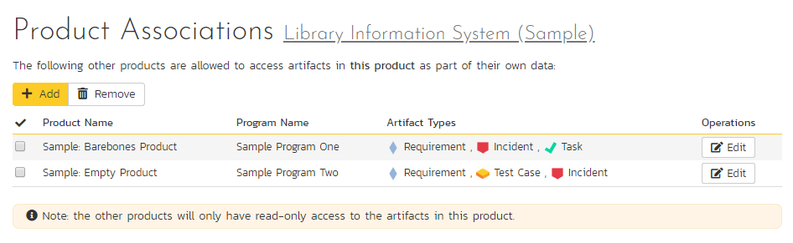

Note: When you share artifacts from the current product to another product, the permissions in the other product will determine which users can see the items, so you need to make sure that is acceptable before enabling the sharing.

To share artifacts with another product, click on the ‘Add’ button in the toolbar:

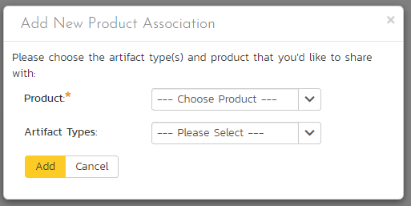

Select the name of the product you want to share with and choose which artifact(s) you want to share with this product:

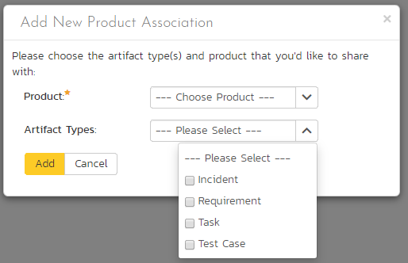

When you click the ‘Add’ button, SpiraPlan will add the new product association to the list.

You can change the product association (for example to change which artifacts are shared) by clicking on the ‘Edit’ button to the right. This updates the association list.

To remove an association, simply select its checkbox and click ‘Remove’.

### 3.6.3. Product Data Tools

This page contains several different data management tools that can be used to identify certain data issues in the system and correct them. There are two main sections to this page – Data Caching and Indentation Hierarchy:

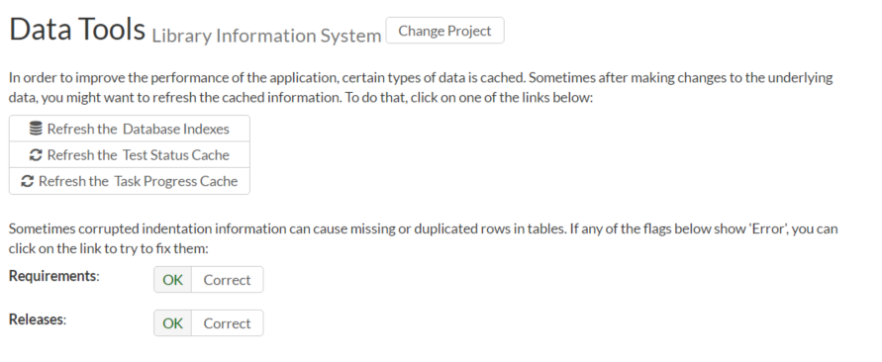

a) Database Indexes

In order to improve the performance of SpiraPlan®, it can be beneficial to refresh the database indexes. Clicking the “Refresh” button illustrated above will refresh all relevant database indexes across all SpiraPlan products. If for any reason performance seems to be slower than usual after a large import of data (for instance from Excel, or using the product migration tool) or after a recent database upgrade, you should consider refreshing the indexes. Depending on the size of the database, this could take some time. Please keep the web page open throughout the process to ensure it can complete successfully.

b) Data Caching

In order to improve the performance of SpiraPlan®, certain types of product data are cached. If for any reason you make changes to test cases, test runs or tasks in the system through the database, you may need to update the cached values for test execution status and task progress that are displayed on the requirements and releases pages. To refresh the execution status or task progress data, click on the appropriate “Refresh” button illustrated above.

c) Indentation Hierarchy

The Requirement and Releases pages use an “Indent” system for managing the hierarchy of information. This allows requirements and test cases to be nested under parent items and be rapidly searched and filtered on. Sometimes if a move/copy operation is interrupted (due to a network outage, etc.) the hierarchy may get corrupted. If so, you’ll see a red Error message instead of the Green OK. If that happens, just click on the appropriate “Correct” button and the system will correct the indent levels for you.

### 3.6.4. Source Code

Clicking on the Source Code link in the administration menu will, if a source code provider has been set up by a system administrator, show a screen like the one below.

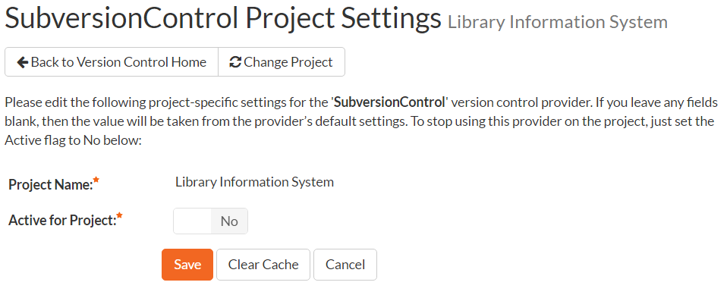

The first thing you need to do (regardless of whether you’ll be overriding any of the settings) is to make the provider active for the current product. To do this, change the toggle to “Yes” and click [Save]:

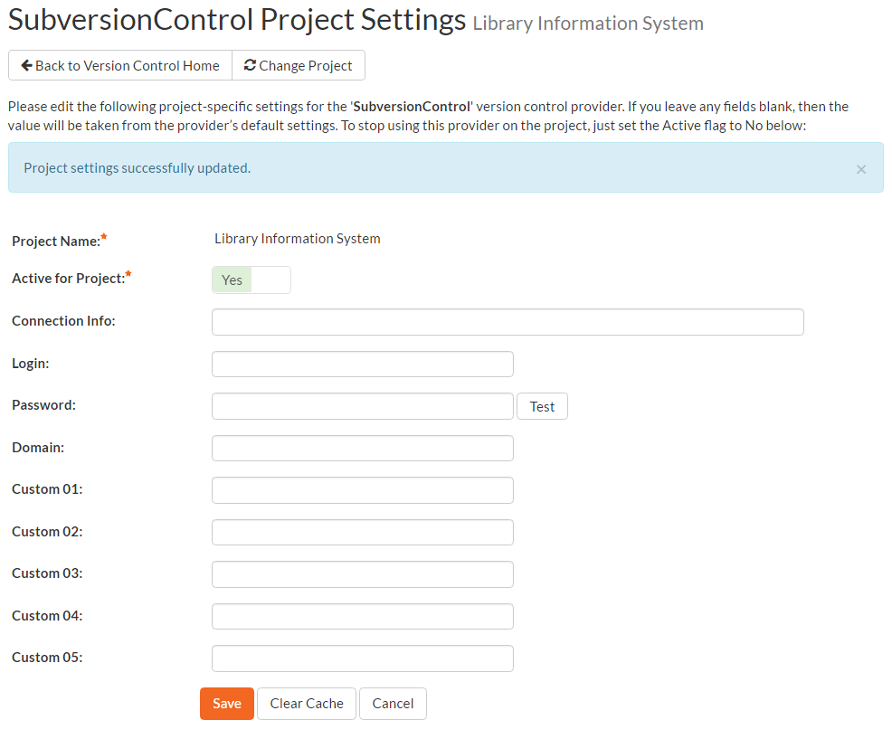

Now you can decide whether you want to override any of the default settings for this product. Any field left blank will automatically get its settings from the default values entered earlier. In the example above, we have specified a product-specific repository path, login and password. Once you have correctly configured the product, click [Save] to commit the changes.

To improve performance, SpiraPlan will cache some of the data it receives from the version control provider. Normally SpiraPlan will know when to update the cached data based on changes made in the version control system automatically. However sometimes you may wish to flush the cached data completed, to do this, click on the [Clear Cache] button.

You are now ready to use SpiraPlan® in conjunction with the version control tool you selected. For details on how to use the Source Code integration features of SpiraPlan, please refer to the *SpiraPlan® User Manual*.

## 3.7. Product: Users

### 3.7.1. Product Membership

The following screen is displayed when you choose the “Product Membership” link from the Administration menu:

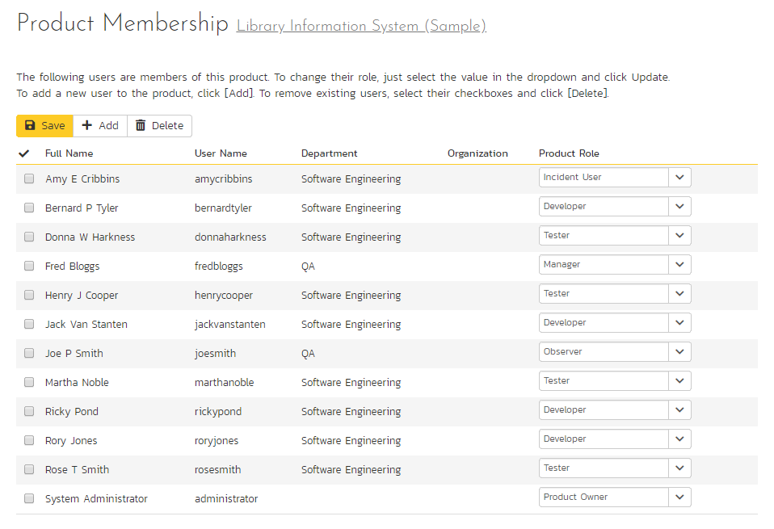

This screen displays the name of the current product together with a list of all the users who are currently members of the product along with their currently assigned product role. If you want to modify the membership for a different product, click the “Change Product” button to be taken back to View/Edit Products screen where you can select a different product.

To modify the role of a user assigned to the product, change the role for that user’s entry in the drop-down menu and click the “Save” button. To remove a user from the product, check the box to the left of the user’s name and click the “Delete” button. Note that this only removes them from the product, not the entire system. Roles are discussed in more detail in 3.2.5. above.

To add a user to the product, so that can access its information, click the “Add” button and you will be taken to the following screen that lists all the users in the system that are not currently members of the product:

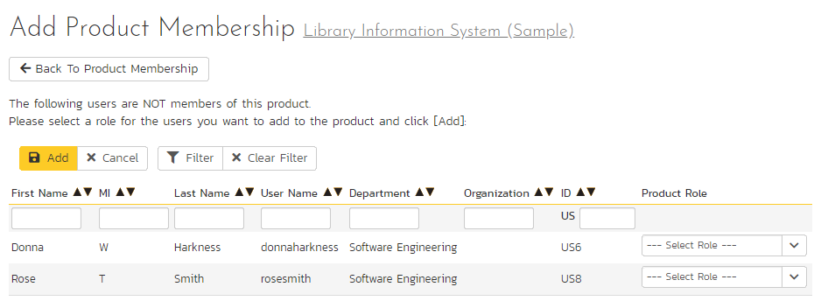

You now should narrow down the list of users by entering filter criteria and clicking [Filter]; you can also sort the results to make viewing easier. Once you have located the appropriate user(s), just select a product role for them from the drop-down list and click [Add] to add them to the product in the specified role.

## 3.8. Product: Planning

### 3.8.1. Edit Components

SpiraPlan lets you define a list of Components for each product. These components represent the main functional areas of the system and artifacts can be associated with each of the defined components.

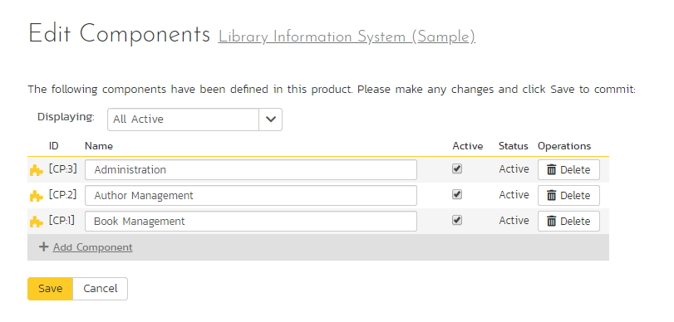

This page lets you display the list of components based on three predefined filters:

* **All Active** – This displays only the components that are listed as Active = Yes. Only active components will be displayed inside the main application.
* **All But Deleted** – This displays all the components (active and inactive) except those that have been deleted.
* **All** – This displays all the components (active, inactive, and deleted).

From this page you can click on the ‘Add Component’ option to add a new component in the list:

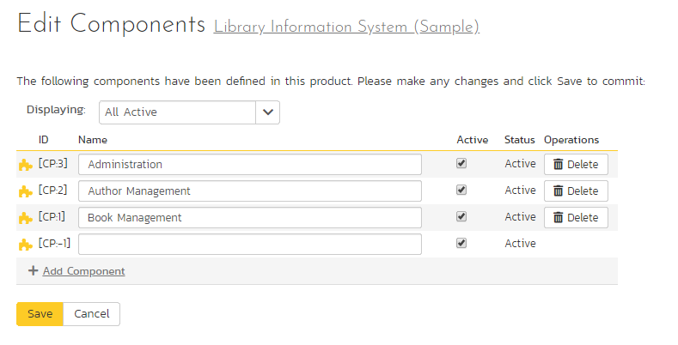

After entering the name of the new component and choosing its Active status, click on ‘Save’ to commit the new item. To edit an existing component, edit its name and Active status and click ‘Save’. To delete a component, click the ‘Delete’ option next to its name. Once deleted, an item can be undeleted by changing the display to ‘All’ and then clicking ‘Undelete’.

### 3.8.2. Planning Options

The Planning Options page lets you configure the schedule and calendar options for the various product estimation and planning modules. The settings are specific to each product:

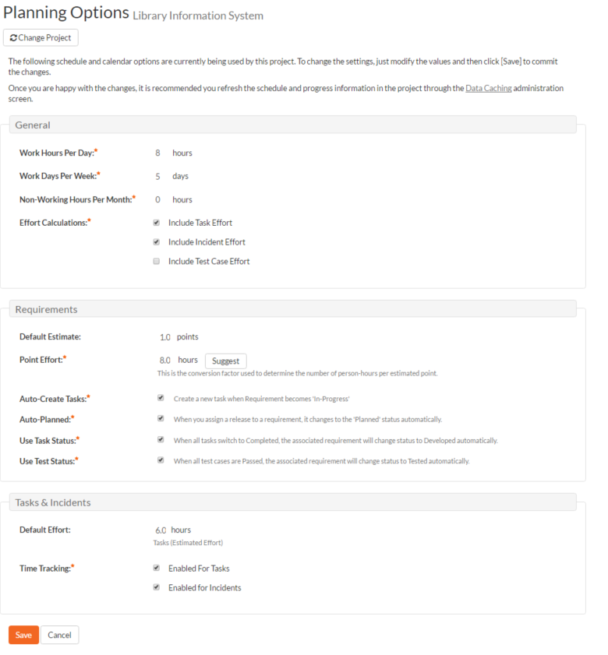

This page allows you to make changes to the following settings:

**General**

* **Work Hours Per Day** – this setting allow you to specify how many work hours should be used when converting an effort calculation from hours to calendar days. For example a 12 hour task will occupy two days if you set the working hours per day to 6 hours, whereas the same task will occupy 1 ½ days only if you set the working hours per day to 8 hours.
* **Work Days Per Week** – this setting allows you to specify how many days in the week are *typically* worked on the product. By default the system assumes a 5-day (Mon-Fri) working week, but if your organization works Saturdays (for example), you may want to switch to a 6-day working week. If you want to use partial days, then just round up to the nearest day and add non-working hours (see below) to compensate.
* **Non-Working Hours Per Month** – this setting allows to specify how many non-working hours *typically* need to be accounted for. This is useful if you want to have a working week that contains a fractional number of days or if you have recurring activities that need to be removed from each month. *Note that if you have specific holidays, vacation days that need to be accounted for, it is better to use the Release/Iteration non-working time feature instead.*
* **Effort Calculations** – When calculating how much effort has been scheduled in a release or iteration, the system will aggregate the individual effort values (both estimated and actual) for all the task, incident and test cases artifacts associated with the release/iteration. This setting allows you to specify if you want only task, incident, or test case effort values to be included in the release/iteration total. This is useful if your product management methodology requires that incident or test case effort values be excluded from the total.

**Requirements**

* **Default Estimate** – Normally when you create a new Requirement in the system it will be given an empty initial estimate (in points). However if many requirements are typically a standard size, then as a time-saver, the system will let you specify a default estimate value that will be used when a new requirement is created.
* **Point Effort** – When requirements are added to the Planning Board or Iteration planning screen, they will have an initial effort (in hours) that is used until tasks are added (see Auto-Create Tasks option). This field contains the standard conversion factor used to convert points into hours based on the current team velocity (how much time it takes on average to accomplish one story point). As the product progresses, the team velocity will change, so you can click on the [Suggest] button to have the system calculate how many hours each existing story point has taken to implement in the product and provide that as a recommendation:  
    
  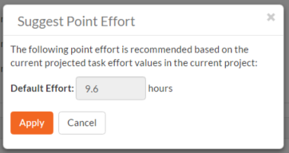
* **Auto-Create Tasks** – When you change the status of a Requirement in the system to “In-Progress” the system will automatically add a default Task to that requirement if no tasks already exist. This is a useful shortcut that makes planning with requirements easier in the case when the requirements are of a size where they don’t need to be formally decomposed into multiple developer tasks. However if you don’t want the system to automatically create tasks in, you can deselect the option for the current product and it will turn off the feature.
* **Auto-Planned** – When this option is enabled, if you assign a release/iteration to a requirement, and the requirement is not already in the ‘Planned’ status, the system will automatically switch the status of the requirement to ‘Planned’.
* **Use Task Status** – When this option is enabled, if you add any tasks to a requirement, the status of the requirement will be automatically governed by the aggregate status of the associated tasks.
* **Use Test Status** - When this option is enabled, if you associate any test cases to a requirement, the status of the requirement will be automatically switched from ‘Developed’ to ‘Tested’ when all the associated test cases are passed.

**Task & Incidents**

* **Default Effort** – Normally when you create a new Task in the system it will be given an empty initial estimated effort. However if many tasks are typically a standard size, then as a time-saver, the system will let you specify a default estimated effort that will be used when a new task is created.
* **Time Tracking** – SpiraPlan® has an integrated time tracking system that allows the easy entry of the hours spent on all assigned incidents and tasks in one place (see the *SpiraPlan User Manual* for more details on this feature). This setting allows administrators to specify if they want the integrated time tracking features enabled for both incidents or tasks (or neither).

## 3.9. Template: Requirements

This section contains administrative options that are specific to the requirements functionality in the system.

### 3.9.1. Importance

The following screen is displayed when you choose the “Importance” link from the Requirements section of the administration menu:

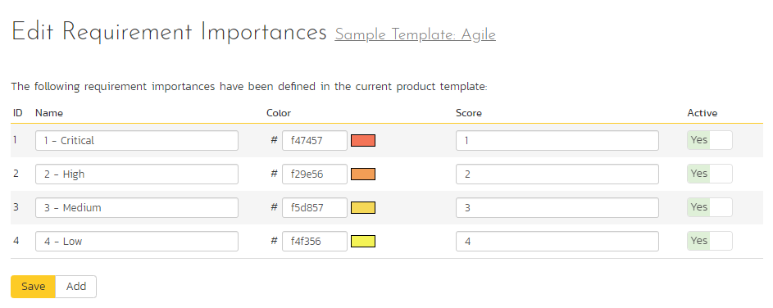

The screen displays a list of all the defined requirement importances for the current template. By default the screen will be populated with the standard SpiraPlan® requirement importances. To edit an existing requirement importance, change the name, color, score (this is used for ranking the different items – the item with the lowest score will appear at the top of dropdown lists in the application), and/or change the active flag then click “Save”.

Note that you can either enter the hexadecimal RRGGBB code for the color or use the pop-up color picker.

You can’t delete an existing requirement importance, but to prevent it appearing in any drop-down-lists, change its active flag to “No” and click “Save”. To add a new requirement importance, click the “Add” button and a new row will be added to the list which you can now edit.

### 3.9.2. Types

The following screen is displayed when you choose the “Types” link from the Requirements section of the administration menu:

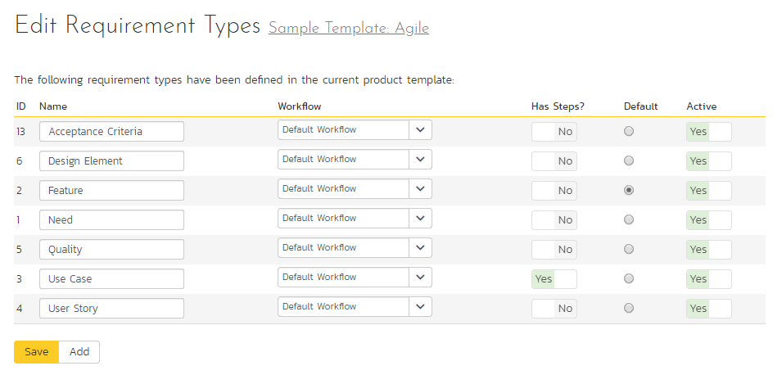

The screen displays a list of all the defined requirement types for the current template. By default the screen will be populated with the standard SpiraPlan® requirement types. To edit an existing requirement type, change the name, associated workflow, issue check-box, risk check-box, set a default type and/or change the active flag then click “Save”.

You can’t delete an existing requirement type, but to prevent it appearing in any drop-down-lists, change its active flag to “No” and click “Save”. To add a new requirement type, click the “Add” button and a new row will be added to the list which you can now edit.

The associated workflow drop-down list allows you to specify which workflow the requirement type will follow. This is a very powerful feature since it allows you to configure different workflows for different requirement types; i.e. a User Story may follow a simpler review process than a Feature or Use Case requirement.

The Has Steps check-box allows you to specify if the requirement type should be able to contain scenario steps (as is typical with use cases).

The default radio button allows you to specify which requirement type should be the default for newly created requirements. This is the type that a new requirement will be set to unless changed by the creator of the requirement. Note that you must have at least one active requirement type, and you cannot set an inactive type as the default.

### 3.9.3. Workflows

Clicking on the “Workflow” link under the Requirements heading, brings up the list of defined requirement workflows for the current template. A workflow is a predefined sequence of requirement statuses linked together by “workflow transitions” to enable a newly created requirement to be reviewed, prioritized, assigned, developed and tested, as well as to handle exception cases such as the case of a rejected or obsolete requirement. The workflow list screen for the sample template is illustrated below:

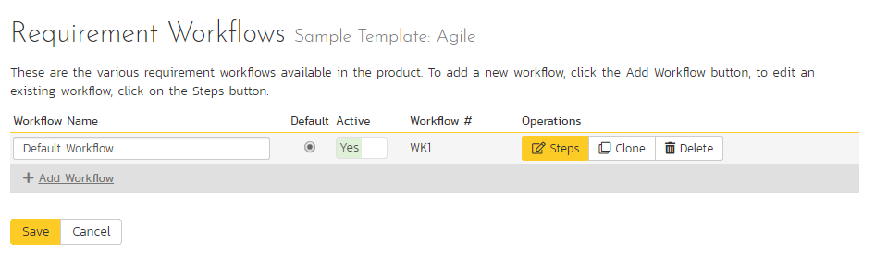

You can have as many workflows as you like in a template, but only one can be marked as the default. Each requirement type must be assigned to a workflow. To modify the name, default flag, and/or active flag of an existing workflow, change the values in the appropriate text-box, radio-button, or drop-down list and click the “Save” button. To add a new workflow, click the ‘Add Workflow’ link and a new workflow will be created with the standard SpiraPlan® steps and transitions.

Note: You cannot make a workflow inactive that is currently linked to a requirement type. This is important as all requirement types need to be linked to an active workflow at all times.

#### 3.9.3.1. Edit Workflow Details

Clicking on the ‘Steps’ button of a workflow brings up the following screen that lists all the workflow steps and workflow transitions that comprise the workflow:

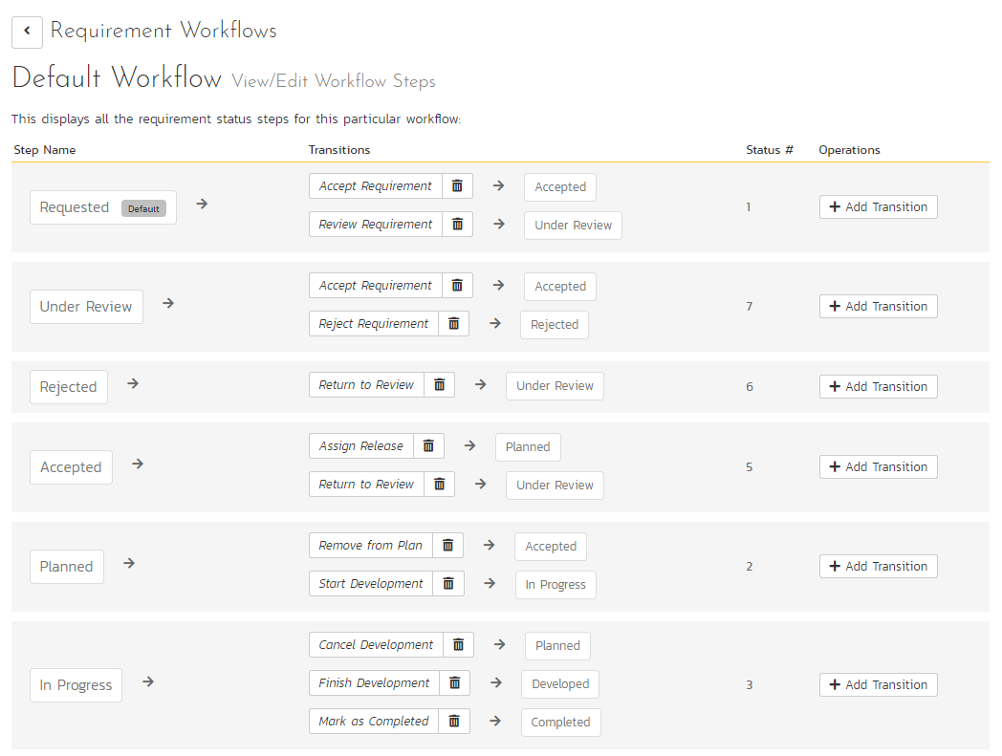

This page lists in the left-most column all the various requirement statuses defined in the system. The next column lists all the possible transitions that can occur *from that status*. In addition, with each transition is listed the name of the resulting *destination status* that the transition leads to. E.g. from the Requested status, depending on your role (see later) the user can move the requirement to either Accepted or Under Review, depending on which transition the user takes.

Clicking on the name of a step or transition takes you to the appropriate details page (see below) where you can set the properties of the step or transition respectively. To delete an existing transition, click the ‘x button after the transition name, and to add a new transition, click the ‘Add Transition’ button in the Operations column.

#### 3.9.3.2. Edit Workflow Transition

When you click on the transition name link from the previous screen, you are taken to the workflow transition details screen:

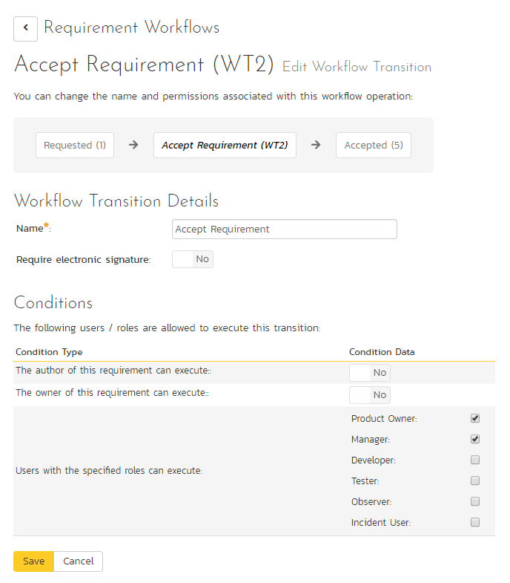

The top part of the screen is the “workflow browser” which illustrates how the transition relates to the workflow as a whole. It displays the current transition in the middle, with the originating and destination steps listed to either side. Clicking on either requirement status name will take you to the appropriate workflow step details page. This allows you to click through the whole workflow from start to finish without having to return to the workflow details page.

This part of the screen lets you change the name of the transition. If a digital signature from the user is required to authorize and record the transition, set the toggle to yes for “Require Electronic Signature”.

In addition, each transition has a series of conditions which need to be satisfied for a user to actually execute the transition (i.e. move the requirement from the originating status to the destination status):

The conditions section allows you to set three types of user role:

* The author of the requirement can be allowed to execute the transition. For example, when a requirement is marked as Completed, the author might be allowed to move it to Obsolete when it’s no longer applicable.
* The owner of the requirement can be allowed to execute the transition. For example, when a requirement is marked as Under Review, the assigned owner should be the only one who’s allowed to move it to Accepted.
* A user with a specified role can be allowed to execute the transition regardless of whether they are the author or owner. For example a user with role “Manager” might want the power to close all requirements regardless of ownership status.

You can set any of these conditions by changing the drop-down list and/or check-boxes and clicking the appropriate “Save” button.

#### 3.9.3.3. Edit Workflow Step

When you click on the requirement status name link from either of the previous screens, you are taken to the workflow step details screen:

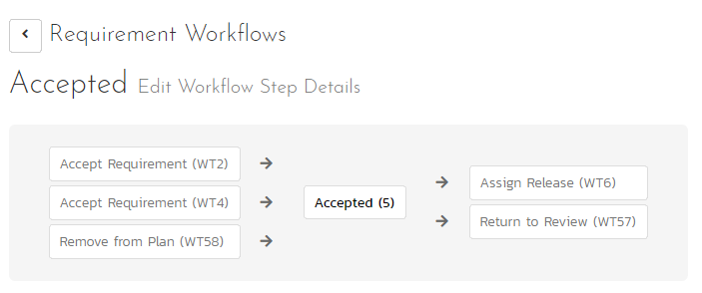

The top part of the screen is the “workflow browser” which illustrates how the step relates to the workflow as a whole. It displays the current requirement status in the middle, with the possible originating and destination transitions listed to either side. Clicking on either workflow transition name will take you to the appropriate workflow transition details page. This allows you to click through the whole workflow from start to finish without having to return to the workflow details page.

This page allows you to define the behavior of the various requirement fields (i.e. those that are a standard part of SpiraPlan® such as Importance):

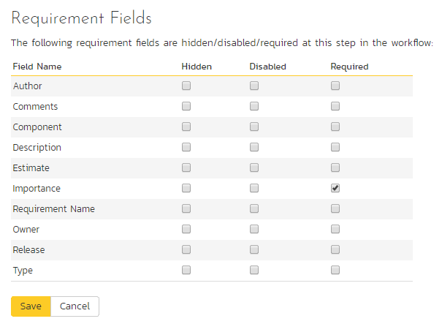

This page also allows you to define the behavior of the various requirement custom properties for this particular step in the workflow:

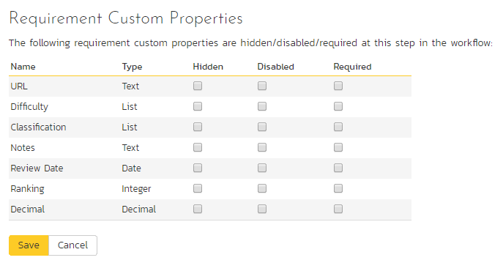

You can set each of the fields/custom properties as being:

* **Hidden** – The field / custom property will not be displayed when the requirement is in this status
* **Disabled** – The field / custom property will be displayed, but will be greyed-out and read-only
* **Required** – The field / custom property will be required when the requirement is in this status

Note that you cannot set a field/property as being required and either disabled or hidden since this would prevent a user from ever updating the requirement. For example, when a requirement is in the Requested status, you might make the owner field hidden (since the author shouldn’t need to know who will ultimately own it), when it gets to the Accepted status, you might make the field enabled, and when it gets to the In Progress status, you might make it enabled and required. This allows you to tailor the information gathered to the appropriate place in the workflow.

To actually make these changes, all you need to do is select the appropriate checkboxes in the list of fields and custom properties and click the corresponding “Save” button.

## 3.10. Template: Releases

### 3.10.1. Release Workflows

Clicking on the “Release Workflows” link under the Planning heading, brings up the list of defined release workflows for the current template. A workflow is a predefined sequence of release statuses linked together by “workflow transitions” to enable a newly created release to be reviewed, prioritized, assigned, developed and tested, as well as to handle exception cases such as the case of a cancelled or deferred release. The workflow list screen for the sample template is illustrated below:

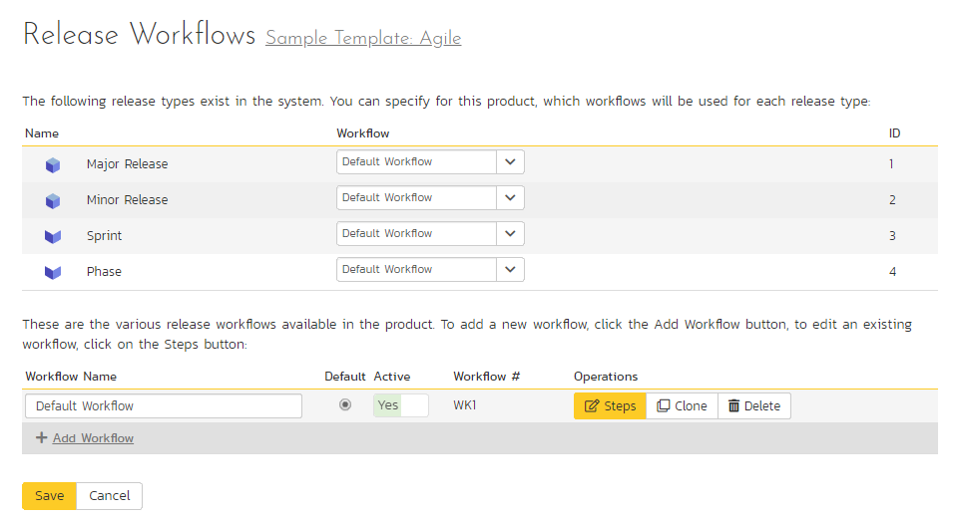

The screen displays a list of all the standard release types in the system. The associated workflow drop-down list allows you to specify which workflow the release type will follow. This is a very powerful feature since it allows you to configure different workflows for different release types; i.e. a Major release may follow a different process than an iteration.

You can have as many workflows as you like in a template, but only one can be marked as the default. Each release type must be assigned to a workflow. To modify the name, default flag, and/or active flag of an existing workflow, change the values in the appropriate text-box, radio-button, or drop-down list and click the “Save” button. To add a new workflow, click the ‘Add Workflow’ link and a new workflow will be created with the standard SpiraPlan® steps and transitions.

Note: You can only assign an active workflow to a release type, and similarly you cannot make a workflow inactive that is currently linked to a release type. This is important as all release types need to be linked to an active workflow at all times.

#### 3.10.1.1. Edit Workflow Details

Clicking on the ‘Steps’ hyperlink of a workflow brings up the following screen that lists all the workflow steps and workflow transitions that comprise the workflow:

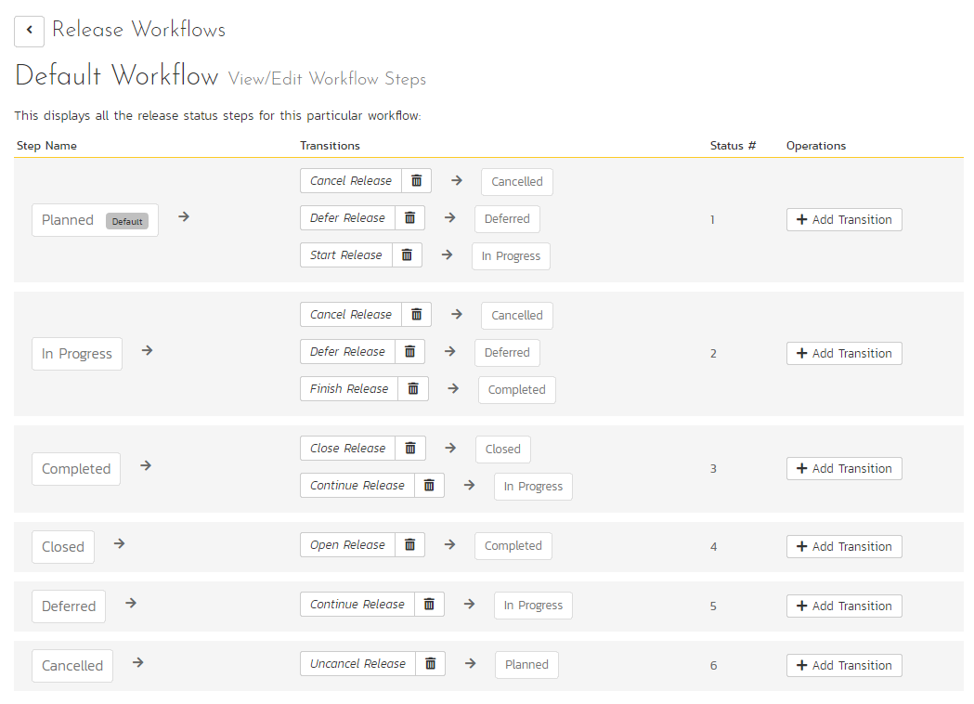

This page lists in the left-most column all the various release statuses defined in the system. The next column lists all the possible transitions that can occur *from that status*. In addition, with each transition is listed the name of the resulting *destination status* that the transition leads to. E.g. from the Planned status, depending on your role (see later) the user can move the release to either Cancelled, Deferred, or In Progress, depending on which transition the user takes.

Clicking on the name of a step or transition takes you to the appropriate details page (see below) where you can set the properties of the step or transition respectively. To delete an existing transition, click the ‘x button after the transition name, and to add a new transition, click the ‘Add Transition’ button in the Operations column.

#### 3.10.1.2. Edit Workflow Transition

When you click on the transition name link from the previous screen, you are taken to the workflow transition details screen:

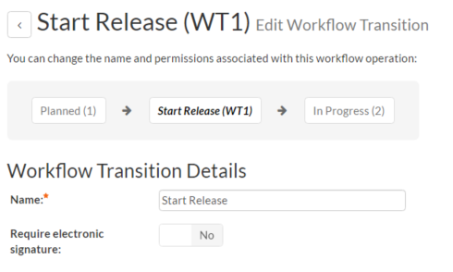

The top part of the screen is the “workflow browser” which illustrates how the transition relates to the workflow as a whole. It displays the current transition in the middle, with the originating and destination steps listed to either side. Clicking on either task status name will take you to the appropriate workflow step details page. This allows you to click through the whole workflow from start to finish without having to return to the workflow details page.

This part of the screen lets you change the name of the transition. If a digital signature from the user is required to authorize and record the transition, set the toggle to yes for “Require Electronic Signature”.

In addition, each transition has a series of conditions which need to be satisfied for a user to actually execute the transition (i.e. move the release from the originating status to the destination status):

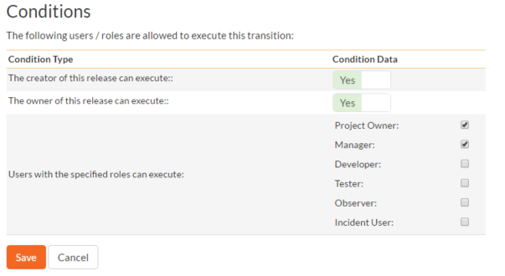

The conditions section allows you to set three types of user role:

* The author of the release can be allowed to execute the transition. For example, when a release is marked as Completed, the author might be allowed to move it to In Progress if there is still work remaining.
* The owner of the release can be allowed to execute the transition. For example, when a release is marked as In Progress, the assigned owner should be the only one who’s allowed to move it to Competed.
* A user with a specified role can be allowed to execute the transition regardless of whether they are the author or owner. For example a user with role “Manager” might want the power to defer all releases regardless of ownership status.

You can set any of these conditions by changing the drop-down list and/or check-boxes and clicking the appropriate “Save” button.

#### 3.10.1.3. Edit Workflow Step

When you click on the release status name link from either of the previous screens, you are taken to the workflow step details screen:

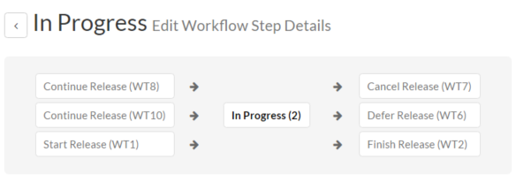

The top part of the screen is the “workflow browser” which illustrates how the step relates to the workflow as a whole. It displays the current release status in the middle, with the possible originating and destination transitions listed to either side. Clicking on either workflow transition name will take you to the appropriate workflow transition details page. This allows you to click through the whole workflow from start to finish without having to return to the workflow details page.

This page allows you to define the behavior of the various release fields (i.e. those that are a standard part of SpiraPlan® such as Priority):

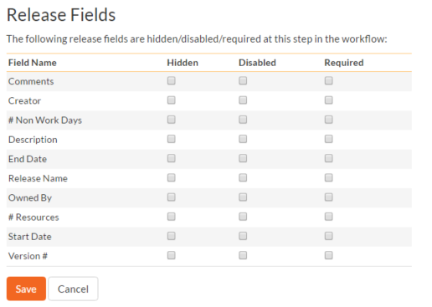

This page also allows you to define the behavior of the various release custom properties for this particular step in the workflow:

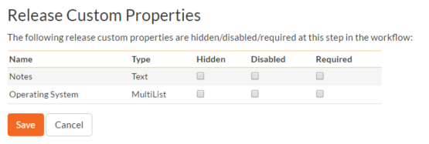

You can set each of the fields/custom properties as being:

* **Hidden** – The field / custom property will not be displayed when the release is in this status
* **Disabled** – The field / custom property will be displayed, but will be greyed-out and read-only
* **Required** – The field / custom property will be required when the release is in this status

Note that you cannot set a field/property as being required and either disabled or hidden since this would prevent a user from ever updating the release. For example, when a release is in the Planned status, you might make the owner field hidden (since the author shouldn’t need to know who will ultimately own it), when it gets to the In Progress status, you might make the field enabled and required, and when it gets to the Completed status, you might make it disabled. This allows you to tailor the information gathered to the appropriate place in the workflow.

To actually make these changes, all you need to do is select the appropriate checkboxes in the list of fields and custom properties and click the corresponding “Save” button.

## 3.11. Template: Documents

SpiraPlan® includes a built-in web-based document management system that allows you to upload and share documents between product team members. These documents are stored in folders, categorized by a series of user-defined meta-tags and can also be associated with other artifacts in the system (e.g. requirements, incidents, etc.).

The set of administrative options located under the “Documents” heading allow the Template Owner to configure how the documents are organized in their particular template.

### 3.11.1. Document Types

When users upload documents into a SpiraPlan product, they are required to specify the type of document that is being uploaded. The list of document types is configurable by the Template Owner for each individual template.

When you click on Documents “Types”, you can edit the list of types available:

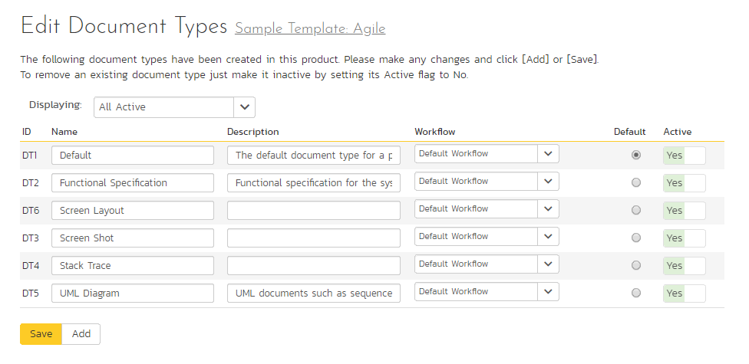

By default, each template will be created with a single document type called ‘Default’. You can add additional document types and/or change the name of the ones already created. If you decide that you no longer want to use a specific document type, you can set its active flag to “No”.

The only requirement is that each template needs to have at least one active document type available, and that there is one active type designated as the default type. The default type is the option that will be initially selected when a user uploads a file / URL to the template’s product(s).

### 3.11.2. Document Statuses

The following screen is displayed when you choose the “Statuses” link from the Documents section of the administration menu:

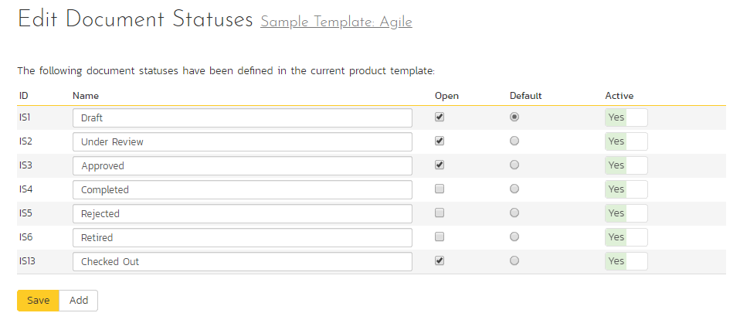

The screen displays a list of all the defined document statuses for the current template. By default, the screen will be populated with the standard SpiraPlan® document statuses. To edit an existing document status, change the name, open check-box, set it as the default status and/or change the active flag then click “Save”.

You can’t delete an existing document status, but to prevent it appearing in any drop-down-lists, change its active flag to “No” and click “Save”. To add a new document status, click the “Add” button and a new row will be added to the list which you can now edit.

The open check-box allow you to specify if the document status should be considered open or not, which means it is would be eligible for display in the various sections of the user’s home page and the product home page that list open document. The default radio button allows you to specify which document status should be the default for newly created documents. This is the status that a new document will be set to when first created, and acts as the first step in the document workflow. Note that you must have at least one active incident status, and you cannot set a document status as the default.

### 3.11.3. Document Workflows

Clicking on the “Workflows” link in the Administration menu Documents section brings up the list of defined document workflows for the current template. A workflow is a predefined sequence of document statuses linked together by “workflow transitions” to enable a newly created document to be reviewed, prioritized, assigned, resolved and closed, as well as to checking documents in and out of the system. The workflow list screen for a sample template is illustrated below:

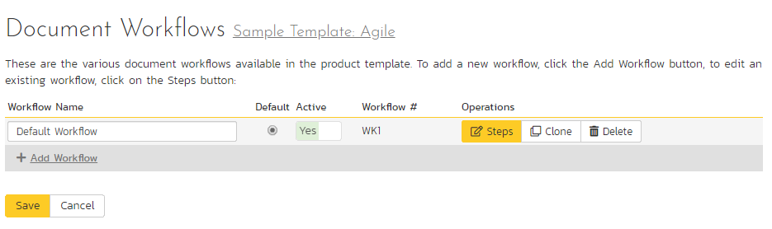

To modify the name, default status, notify and/or active flags, change the values in the appropriate text-box, radio-button, check-box or drop-down list and click the “Save” button. To add a new workflow, click the “Add” button and a new workflow will be created with the standard SpiraPlan® steps and transitions.

You can have as many document workflows as you like in a template, but only one can be marked as the default. Each document type is assigned to a workflow; this allows you to have different document types follow different paths from creation of closure. However, when a new document type is created, it will be initially associated with the template’s default workflow.

Note: You can only assign an active workflow to a document type, and similarly you cannot make a workflow inactive that is currently linked to a document type. This is important as all document types need to be linked to an active workflow at all times.

#### 3.11.3.1. Workflow Details

Clicking on the “Steps” button of a workflow brings up the following screen that lists all the workflow steps and workflow transitions that comprise the workflow:

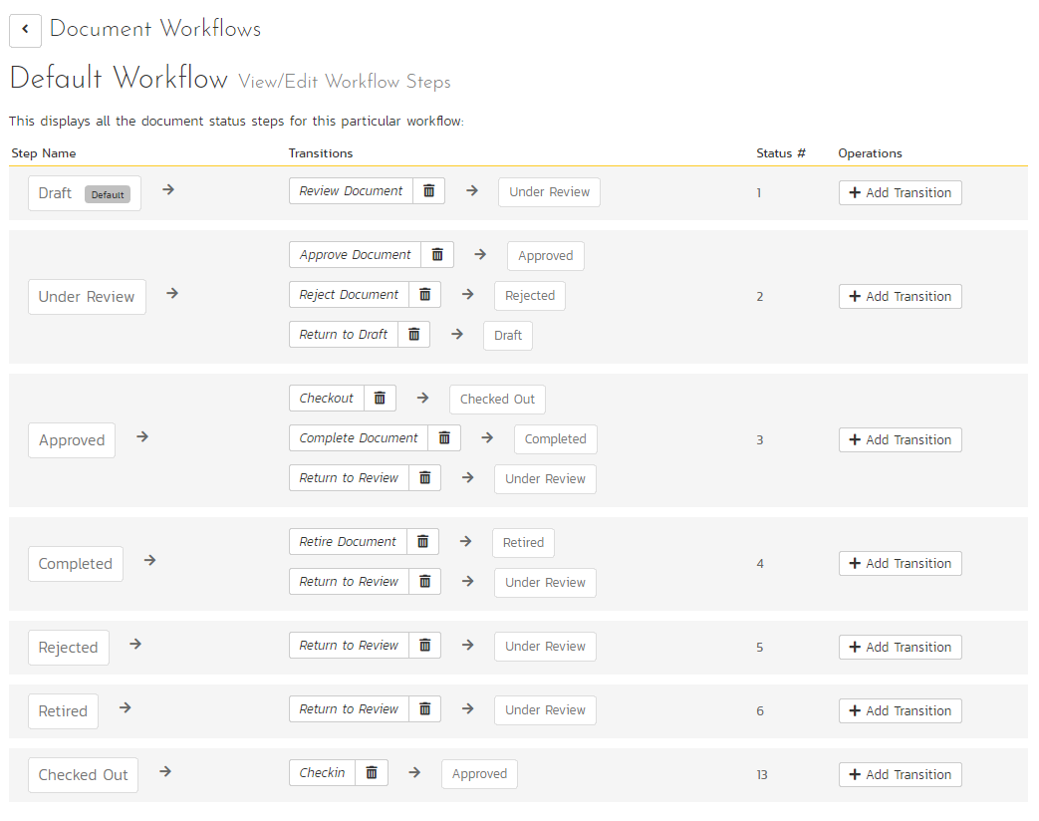

This page lists in the left-most column all the various document statuses defined for the template. The next column lists all the possible transitions that can occur *from that status*. In addition, to the right of each transition is the name of the resulting *destination status* that the transition leads to. E.g. from the Under Review status, depending on your role (see later) you can move the document to either Approved, Rejected or Draft depending on which transition the user takes.

Clicking on the name of a step or transition takes you to the appropriate details page (see below) where you can set the properties of the step or transition respectively. To delete an existing transition, click the “x” button after the transition name, and to add a new transition, click the “Add Transition” button in the Operations column.

#### 3.11.3.2. Edit Workflow Transition

When you click on the transition name link from the previous screen, you are taken to the workflow transition details screen:

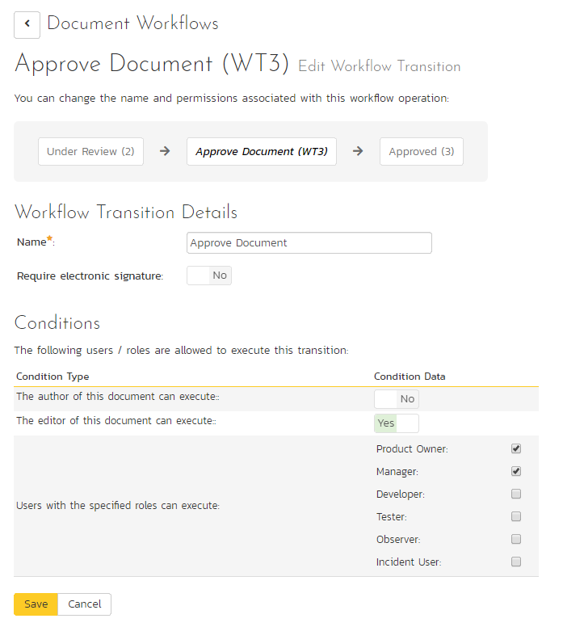

The top part of the screen is the “workflow browser” which illustrates how the transition relates to the workflow as a whole. It displays the current transition in the middle, with the originating and destination steps listed to either side. Clicking on either document status name will take you to the appropriate workflow step details page. This allows you to click through the whole workflow from start to finish without having to return to the workflow details page.

If a digital signature from the user is required to authorize and record the transition, set the toggle to yes for “Require Electronic Signature”.

Each transition has a series of conditions which need to be satisfied for a user to actually execute the transition (i.e. move the document from the originating status to the destination status).

#### 3.11.3.3. Edit Workflow Step

When you click on the document status name link from either of the previous screens, you are taken to the workflow step details screen:

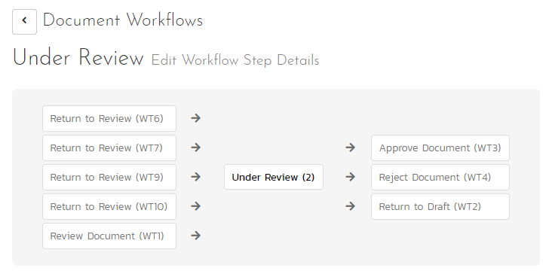

The top part of the screen is the “workflow browser” which illustrates how the step relates to the workflow as a whole. It displays the current document status in the middle, with the possible originating and destination transitions listed to either side. Clicking on either workflow transition name will take you to the appropriate workflow transition details page. This allows you to click through the whole workflow from start to finish without having to return to the workflow details page.

This page allows you to define the behavior of the various document fields (i.e. those that are a standard part of SpiraPlan® such as Type):

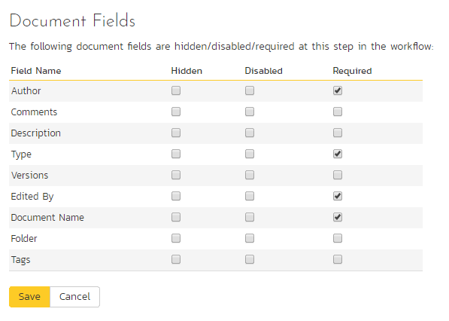

This page also allows you to define the behavior of the various document custom properties for this particular step in the workflow:

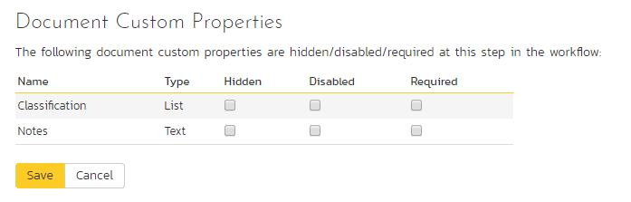

You can set each of the fields/custom properties as being:

* **Hidden** – The field / custom property will not be displayed when the document is in this status
* **Disabled** – The field / custom property will be displayed, but will be greyed-out and read-only
* **Required** – The field / custom property will be required when the document is in this status

Note that you cannot set a field/property as being required and either disabled or hidden since this would prevent a user from ever updating the document.

After you have made the changes, click the “Save” button.

## 3.12. Template: Test Cases

This section contains administrative options that are specific to the testing functionality in the system.

### 3.12.1. Priority

The following screen is displayed when you choose the “Priority” link from the Test Cases section of the administration menu:

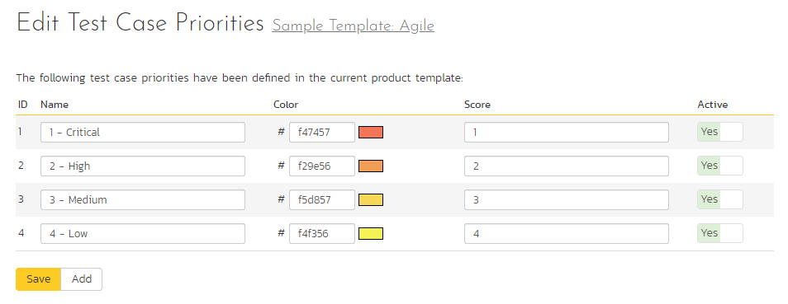

The screen displays a list of all the defined test case priorities for the current template. By default, the screen will be populated with the standard SpiraPlan® test case priorities. To edit an existing test case priority, change the name, color, score (this is used for ranking the different items – the item with the lowest score will appear at the top of dropdown lists in the application), and/or change the active flag then click “Save”.

Note that you can either enter the hexadecimal RRGGBB code for the color or use the pop-up color picker.

You can’t delete an existing test case priority, but to prevent it appearing in any drop-down-lists, change its active flag to “No” and click “Save”. To add a new test case priority, click the “Add” button and a new row will be added to the list which you can now edit.

### 3.12.2. Types

The following screen is displayed when you choose the “Types” link from the Test Cases section of the administration menu:

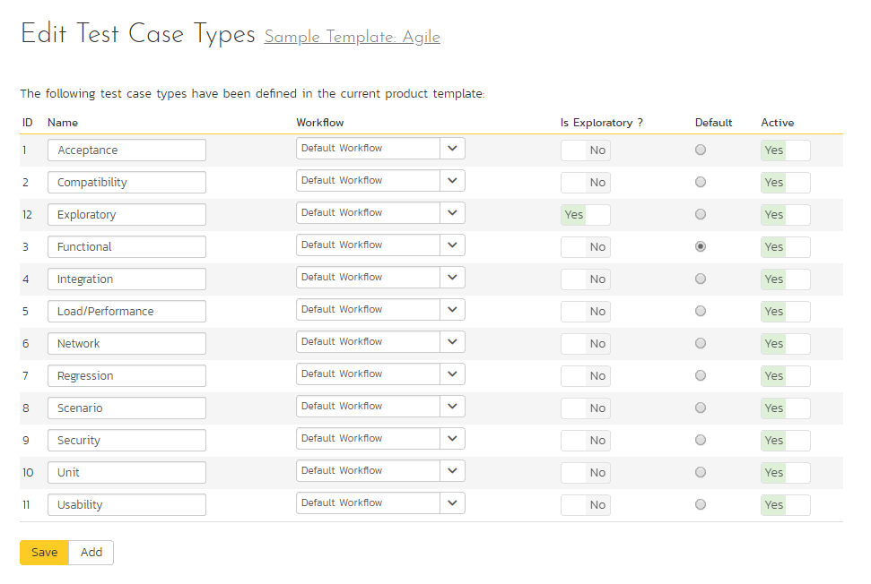

The screen displays a list of all the defined test case types for the current template. By default, the screen will be populated with the standard SpiraPlan® test case types. To edit an existing test case type, change the name, associated workflow, issue check-box, risk check-box, set a default type and/or change the active flag then click “Save”.

You can’t delete an existing test case type, but to prevent it appearing in any drop-down-lists, change its active flag to “No” and click “Save”. To add a new test case type, click the “Add” button and a new row will be added to the list which you can now edit.

The associated workflow drop-down list allows you to specify which workflow the test case type will follow. This is a very powerful feature since it allows you to configure different workflows for different test case types; i.e. a User Story may follow a simpler review process than a Feature or Use Case test case.

The Is Exploratory check-box allows you to specify if the test case type should be able to be executed in exploratory mode (which allows more editing of the test case and its steps during execution). Note that this mode is only available to users with a certain permission level and when executing an individual test case.

The default radio button allows you to specify which test case type should be the default for newly created test cases. This is the type that a new test case will be set to unless changed by the creator of the test case. Note that you must have at least one active test case type, and you cannot set an inactive type as the default.

### 3.12.3. Test Case Workflows

Clicking on the “Workflows” link under the Test Cases section, brings up the list of defined test case workflows for the current template. A workflow is a predefined sequence of test cases statuses linked together by “workflow transitions” to enable a newly created test case to be reviewed, prioritized, assigned, and tested, as well as to handle exception cases such as the case of a rejected or obsolete test case. The workflow list screen for the sample template is illustrated below:

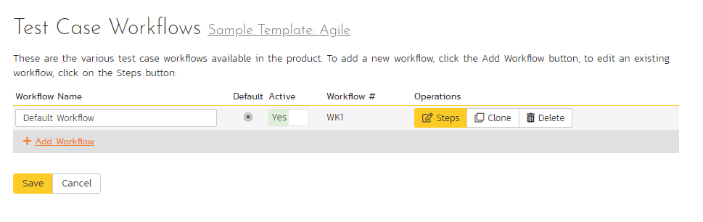

You can have as many workflows as you like in a template, but only one can be marked as the default. Each test case type must be assigned to a workflow. To modify the name, default flag, and/or active flag of an existing workflow, change the values in the appropriate text-box, radio-button, or drop-down list and click the “Save” button. To add a new workflow, click the ‘Add Workflow’ link and a new workflow will be created with the standard SpiraPlan® steps and transitions.

Note: You can only assign an active workflow to a test case type, and similarly you cannot make a workflow inactive that is currently linked to a test case type. This is important as all test case types need to be linked to an active workflow at all times.

#### 3.12.3.1. Edit Workflow Details

Clicking on the ‘Steps’ button of a workflow brings up the following screen that lists all the workflow steps and workflow transitions that comprise the workflow:

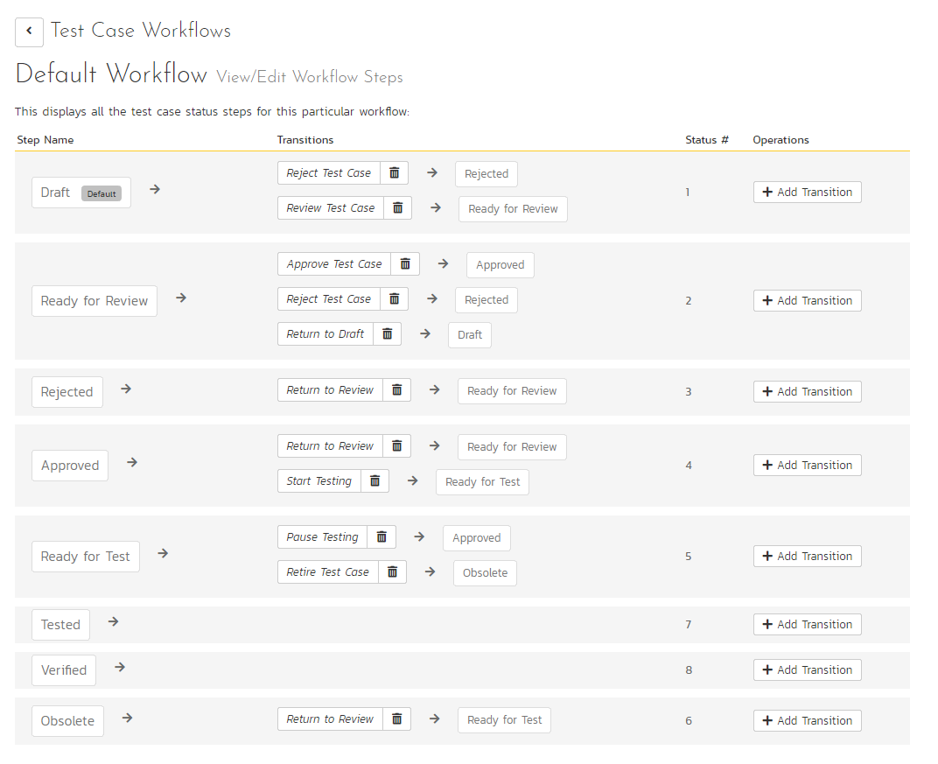

This page lists in the left-most column all the various test case statuses defined in the system. The next column lists all the possible transitions that can occur *from that status*. In addition, with each transition is listed the name of the resulting *destination status* that the transition leads to. E.g. from the Draft status, depending on your role (see elsewhere in this manual) the user can move the test case to either Rejected, or Ready for Review, depending on which transition the user takes.

Clicking on the name of a step or transition takes you to the appropriate details page (see below) where you can set the properties of the step or transition respectively. To delete an existing transition, click the ‘x button after the transition name, and to add a new transition, click the ‘Add Transition’ button in the Operations column.

#### 3.12.3.2. Edit Workflow Transition

When you click on the transition name link from the previous screen, you are taken to the workflow transition details screen:

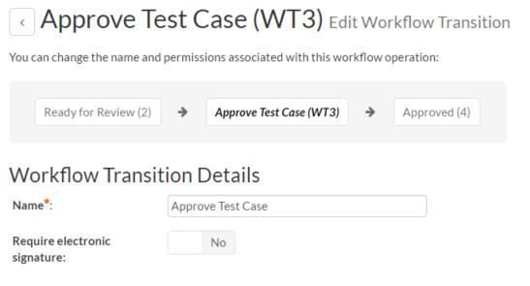

The top part of the screen is the “workflow browser” which illustrates how the transition relates to the workflow as a whole. It displays the current transition in the middle, with the originating and destination steps listed to either side. Clicking on either task status name will take you to the appropriate workflow step details page. This allows you to click through the whole workflow from start to finish without having to return to the workflow details page.

This part of the screen lets you change the name of the transition. If a digital signature from the user is required to authorize and record the transition, set the toggle to yes for “Require Electronic Signature”.

In addition, each transition has a series of conditions which need to be satisfied for a user to actually execute the transition (i.e. move the test case ease from the originating status to the destination status):



The conditions section allows you to set three types of user role:

* The author of the test case can be allowed to execute the transition. For example, when a test case is marked as Ready for Review, the author might be allowed to move it to Ready to Test.
* The owner of the test case can be allowed to execute the transition. For example, when a test case is marked as Approved, the assigned owner should be the only one who’s allowed to move it to Ready for Test.
* A user with a specified role can be allowed to execute the transition regardless of whether they are the author or owner. For example a user with role “Manager” might want the power to approve all test cases regardless of ownership status.

You can set any of these conditions by changing the drop-down list and/or check-boxes and clicking the appropriate “Save” button.

#### 3.12.3.3. Edit Workflow Step

When you click on the test case status name link from either of the previous screens, you are taken to the workflow step details screen:

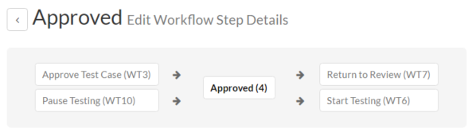

The top part of the screen is the “workflow browser” which illustrates how the step relates to the workflow as a whole. It displays the current test case status in the middle, with the possible originating and destination transitions listed to either side. Clicking on either workflow transition name will take you to the appropriate workflow transition details page. This allows you to click through the whole workflow from start to finish without having to return to the workflow details page.

This page allows you to define the behavior of the various test case fields (i.e. those that are a standard part of SpiraPlan® such as Priority):

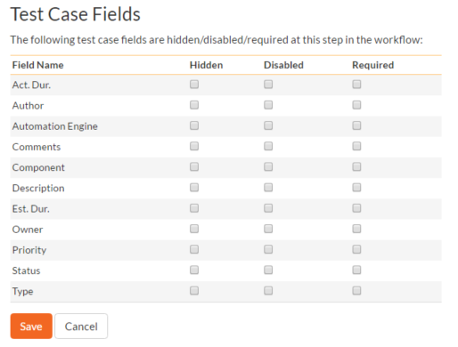

This page also allows you to define the behavior of the various test case custom properties for this particular step in the workflow:

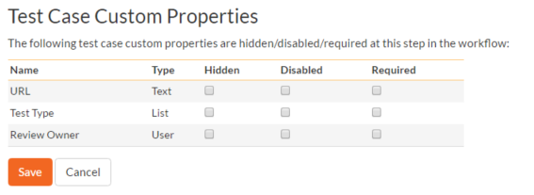

You can set each of the fields/custom properties as being:

* **Hidden** – The field / custom property will not be displayed when the test case is in this status
* **Disabled** – The field / custom property will be displayed, but will be greyed-out and read-only
* **Required** – The field / custom property will be required when the test case is in this status

Note that you cannot set a field/property as being required and either disabled or hidden since this would prevent a user from ever updating the test case. For example, when a test case is in the Draft status, you might make the owner field hidden (since the author shouldn’t need to know who will ultimately own it), when it gets to the Ready for Review status, you might make the field enabled and required, and when it gets to the Approve status, you might make it disabled. This allows you to tailor the information gathered to the appropriate place in the workflow.

To actually make these changes, all you need to do is select the appropriate checkboxes in the list of fields and custom properties and click the corresponding “Save” button.

Note that two test case fields have special meanings:

* **Test Steps?** - when this field is marked as Disabled = True, you will not be able to edit the test steps
* **Execution Status** - when this field is marked as Disabled = True, you will not be able to execute the test case in this status.

## 3.13. Template: Incidents

In addition to being able to create custom properties and values for incidents (same as for all artifacts in SpiraPlan®), you can also change the values populated in many of the standard fields used in the incident tracker – types, statuses, priorities and severities. The process for changing each of these is described below:

### 3.13.1. Edit Types

The following screen is displayed when you choose the “Types” link from the Incidents section of the administration menu:

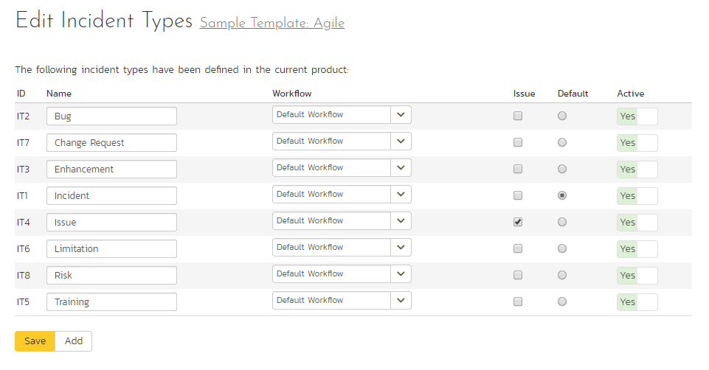

The screen displays a list of all the defined incident types for the current template. By default the screen will be populated with the standard SpiraPlan® incident types. To edit an existing incident type, change the name, associated workflow, issue check-box, risk check-box, set a default type and/or change the active flag then click “Save”.

You can’t delete an existing incident type, but to prevent it appearing in any drop-down-lists, all you need to do is change its active flag to “No” and click “Save”. To add a new incident type, click the “Add” button and a new row will be added to the list which you can now edit.

The associated workflow drop-down list allows you to specify which workflow the incident type will follow. This is a very powerful feature since it allows you to configure different workflows for different incident types; i.e. a bug may follow a workflow geared to identification and resolution, whereas a risk may only need a much simpler set of steps and actions.

The issue check-boxes allow you to specify if the incident type is an issue, which means it would be eligible for display in the issue section of the product home page. The default radio button allows you to specify which incident type should be the default for newly created incidents. This is the type that a new incident will be set to unless changed by the creator of the incident. Note that you must have at least one active incident type, and you cannot set an inactive type as the default.

### 3.13.2. Edit Statuses

The following screen is displayed when you choose the “Statuses” link from the Incidents section of the administration menu:

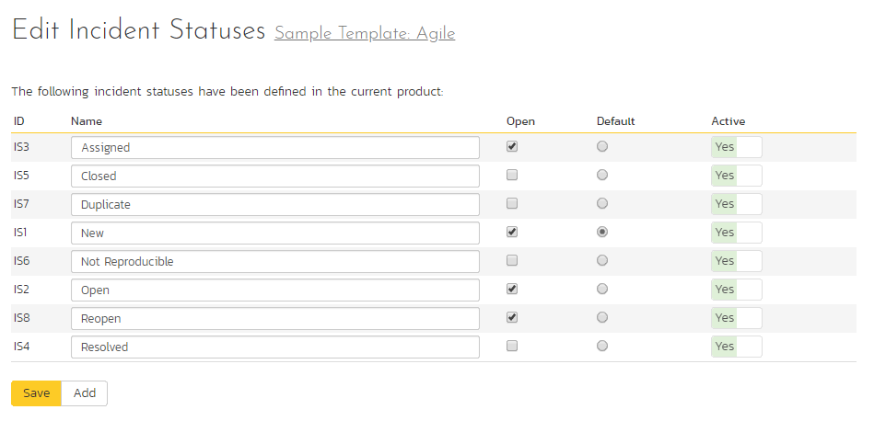

The screen displays a list of all the defined incident statuses for the current template. By default, the screen will be populated with the standard SpiraPlan® incident statuses. To edit an existing incident status, change the name, open check-box, set it as the default status and/or change the active flag then click “Save”.

You can’t delete an existing incident status, but to prevent it appearing in any drop-down-lists, all you need to do is change its active flag to “No” and click “Save”. To add a new incident status, click the “Add” button and a new row will be added to the list which you can now edit.

The open check-box allow you to specify if the incident status should be considered open or not, which means it is would be eligible for display in the various sections of the user’s home page and the product home page that list open incidents. The default radio button allows you to specify which incident status should be the default for newly created incidents. This is the status that a new incident will be set to when first created, and acts as the first step in the incident workflow. Note that you must have at least one active incident status, and you cannot set an inactive status as the default.

### 3.13.3. Priorities

The following screen is displayed when you choose the “Priorities” link from the Incidents section of the administration menu:

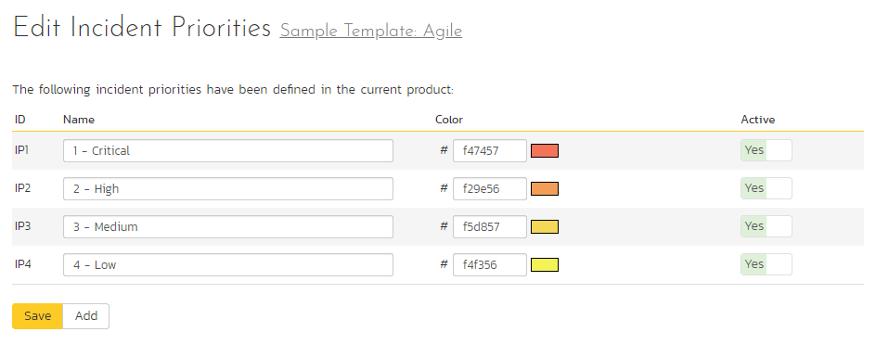

The screen displays a list of all the defined incident priorities for the current template. By default, the screen will be populated with the standard SpiraPlan® incident priorities. To edit an existing incident priority, change the name, color and/or change the active flag then click “Save”. Note that you can either enter the hexadecimal RRGGBB code for the color or use the pop-up color picker.

You can’t delete an existing incident priority, but to prevent it appearing in any drop-down-lists, all you need to do is change its active flag to “No” and click “Save”. To add a new incident priority, click the “Add” button and a new row will be added to the list which you can now edit.

### 3.13.4. Severities

The following screen is displayed when you choose the “Severities” link from the Incidents section of the administration menu:

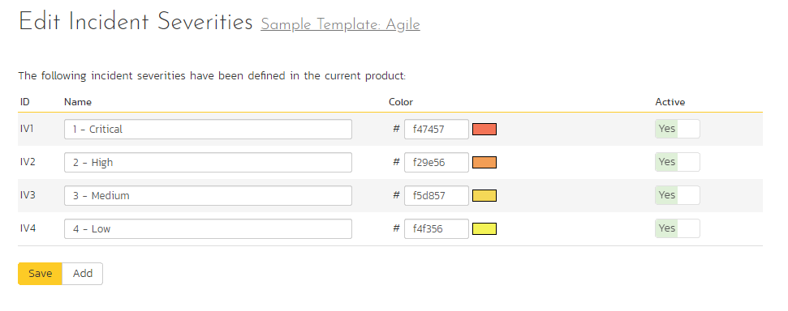

The screen displays a list of all the defined incident severities for the current template. By default, the screen will be populated with the standard SpiraPlan® incident severities. To edit an existing incident severity, change the name, color and/or change the active flag then click “Save”. Note that you can either enter the hexadecimal RRGGBB code for the color or use the pop-up color picker.

You can’t delete an existing incident severity, but to prevent it appearing in any drop-down-lists, all you need to do is change its active flag to “No” and click “Save”. To add a new incident severity, click the “Add” button and a new row will be added to the list which you can now edit.

### 3.13.5. Incident Workflows

Clicking on the “Workflows” link in the Administration menu brings up the list of defined incident workflows for the current template. A workflow is a predefined sequence of incident statuses linked together by “workflow transitions” to enable a newly created incident to be reviewed, prioritized, assigned, resolved and closed, as well as to handle exception cases such as the case of a duplicate or non-reproducible incident. The workflow list screen for a sample template is illustrated below:

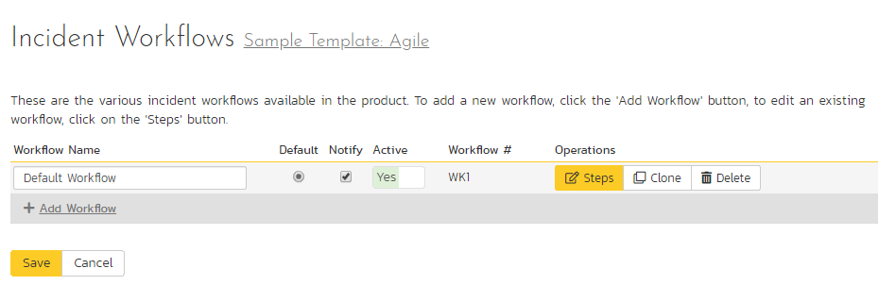

To modify the name, default status, notify and/or active flags, change the values in the appropriate text-box, radio-button, check-box or drop-down list and click the “Save” button. To add a new workflow, click the “Add” button and a new workflow will be created with the standard SpiraPlan® steps and transitions.

You can have as many workflows as you like in a template, but only one can be marked as the default. Each incident type is assigned to a workflow; this allows you to have different incident types follow different paths from creation of closure. However when a new incident type is created, it will be initially associated with the template’s default workflow. The steps and transitions that make up the default workflow are illustrated in the diagram below:

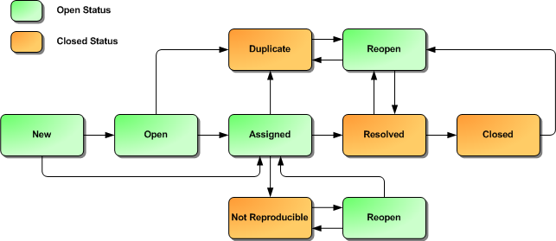

The notify flag is used to tell SpiraPlan® whether that particular workflow should have email notifications turned on or off. You define what transitions and which recipients should receive the emails in the workflow transition editor (see below), but you can globally turn on/off notifications here as well. This is useful if you find that the notifications are becoming an annoyance, or if the email server is unavailable for a period of time.

Note: You can only assign an active workflow to an incident type, and similarly you cannot make a workflow inactive that is currently linked to an incident type. This is important as all incident types need to be linked to an active workflow at all times.

#### 3.13.5.1. Edit Workflow Details

Clicking on the “Steps” button of a workflow brings up the following screen that lists all the workflow steps and workflow transitions that comprise the workflow:

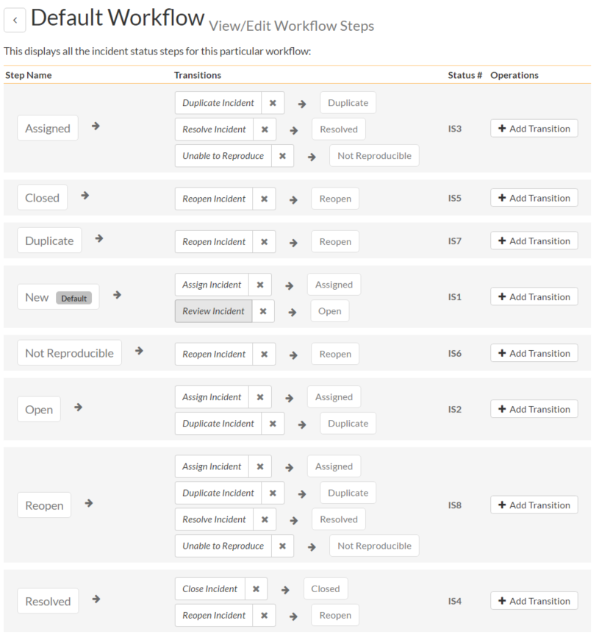

This page lists in the left-most column all the various incident statuses defined for the template. The next column lists all the possible transitions that can occur *from that status*. In addition, with each transition is listed the name of the resulting *destination status* that the transition leads to. E.g. from the assigned status, depending on your role (see later) you can move the incident to either duplicate, resolves or not-reproducible depending on which transition the user takes.

Clicking on the name of a step or transition takes you to the appropriate details page (see below) where you can set the properties of the step or transition respectively. To delete an existing transition, click the “x” button after the transition name, and to add a new transition, click the “Add Transition” button in the Operations column.

#### 3.13.5.2. Edit Workflow Transition

When you click on the transition name link from the previous screen, you are taken to the workflow transition details screen:

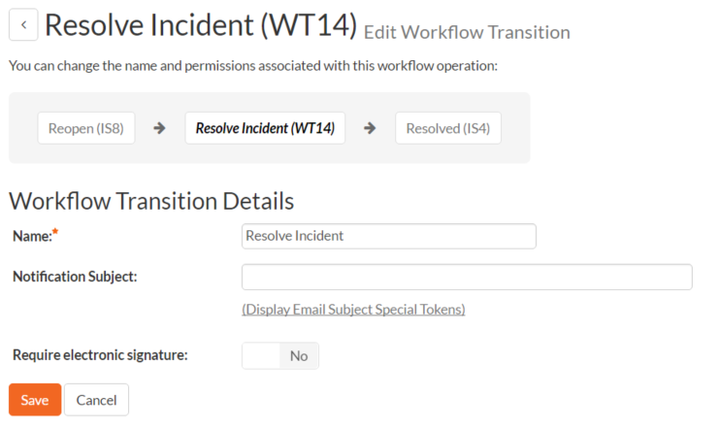

The top part of the screen is the “workflow browser” which illustrates how the transition relates to the workflow as a whole. It displays the current transition in the middle, with the originating and destination steps listed to either side. Clicking on either incident status name will take you to the appropriate workflow step details page. This allows you to click through the whole workflow from start to finish without having to return to the workflow details page.

This part of the screen lets you change the name of the transition and specify the subject line of any email notifications sent as part of this transition. To view the list of special tokens that can be used in the email subject, click on the “Display Email Subject Special Tokens” hyperlink:

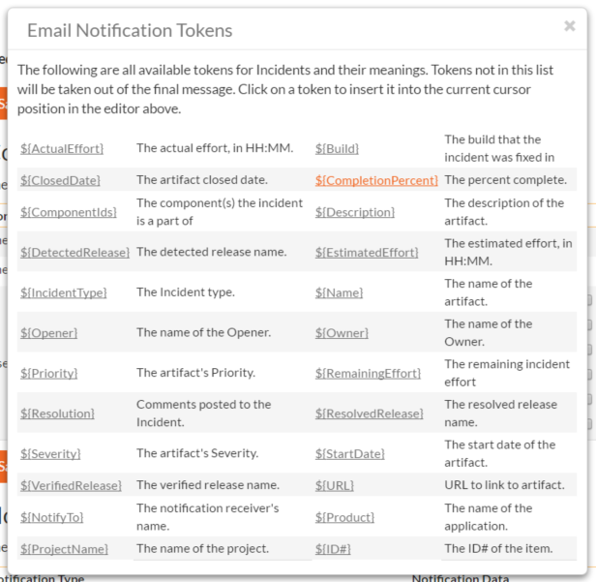

If a digital signature from the user is required to authorize and record the transition, set the toggle to yes for “Require Electronic Signature”.

Each transition has a series of conditions which need to be satisfied for a user to actually execute the transition (i.e. move the incident from the originating status to the destination status):

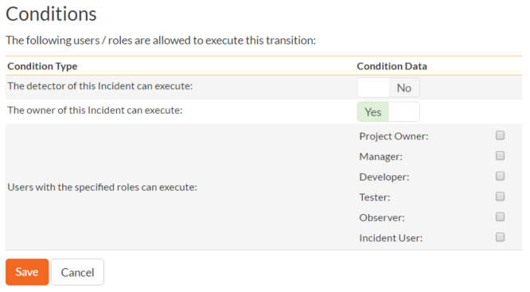

Each transition also has a set of notification rules that allow you to specify who should get an email notification if the transition is executed.

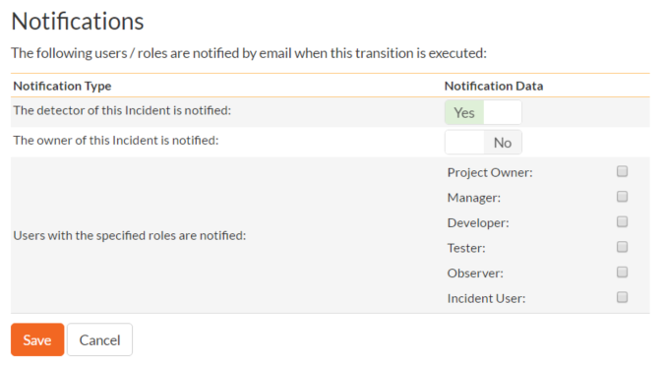

Both the conditions and notifications allow you to set three types of user role:

* The detector of the incident can be allowed to execute the transition, and/or be notified when the transition occurs. For example, when an incident is marked as Resolved, the detector should be the only one who’s allowed to move it to Closed. Similarly when an incident is moved from Assigned to Resolved, the detector should probably be notified so that he knows to log in and verify that it has been resolved satisfactorily.
* The owner of the incident can be allowed to execute the transition, and/or be notified when the transition occurs. For example, when an incident is marked as Assigned, the assigned owner should be the only one who’s allowed to move it to Resolved. Similarly when an incident is moved from Open to Assigned, the owner should probably be notified so that he knows to log in and begin resolving the incident.
* A user with a specified role can be allowed to execute the transition, and/or be notified when the transition occurs regardless of whether they are the detector or owner. For example a user with role “Manager” might want the power to close all incidents regardless of ownership status, and might also want to be notified when any incident is marked as Not-Reproducible.

You can set any of these conditions by changing the drop-down list and/or check-boxes and clicking the appropriate “Save” button.

#### 3.13.5.3. Edit Workflow Step

When you click on the incident status name link from either of the previous screens, you are taken to the workflow step details screen:

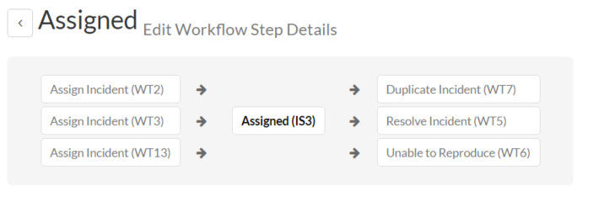

The top part of the screen is the “workflow browser” which illustrates how the step relates to the workflow as a whole. It displays the current incident status in the middle, with the possible originating and destination transitions listed to either side. Clicking on either workflow transition name will take you to the appropriate workflow transition details page. This allows you to click through the whole workflow from start to finish without having to return to the workflow details page.

This page allows you to define the behavior of the various incident fields (i.e. those that are a standard part of SpiraPlan® such as Priority):

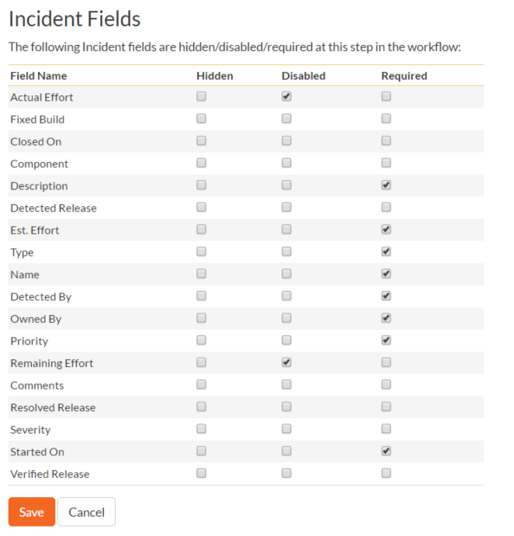

This page also allows you to define the behavior of the various incident custom properties for this particular step in the workflow:

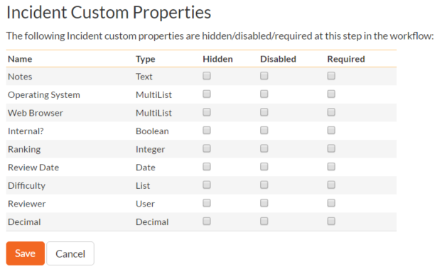

You can set each of the fields/custom properties as being:

* **Hidden** – The field / custom property will not be displayed when the incident is in this status
* **Disabled** – The field / custom property will be displayed, but will be greyed-out and read-only
* **Required** – The field / custom property will be required when the incident is in this status

Note that you cannot set a field/property as being required and either disabled or hidden since this would prevent a user from ever updating the incident. For example, when an incident is in the New status, you might make the owner field hidden (since a detector shouldn’t need to know who will ultimately own it), when it gets to the Open status, you might make the field active, and when it gets to the Assigned status, you might make it active and required. This allows you to tailor the information gathered to the appropriate place in the workflow.

To actually make these changes, all you need to do is select the appropriate checkboxes in the list of fields and custom properties and click the corresponding “Save” button.

## 3.14. Template: Tasks

This section contains administrative options that are specific to the task functionality in the system.

### 3.14.1. Priority

The following screen is displayed when you choose the “Priority” link from the Tasks section of the administration menu:

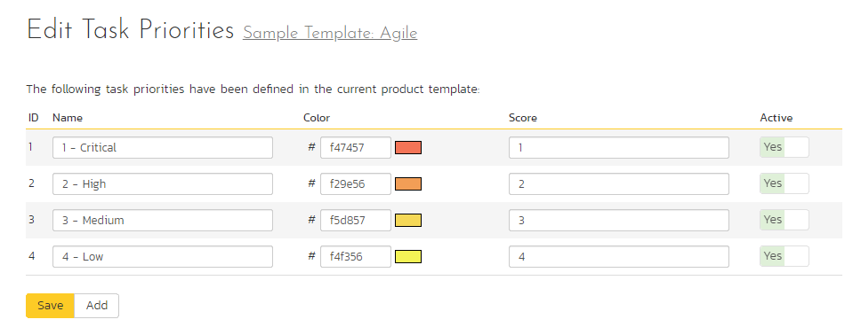

The screen displays a list of all the defined task priorities for the current template. By default, the screen will be populated with the standard SpiraPlan® task priorities. To edit an existing task priority, change the name, color, score (this is used for ranking the different items – the item with the lowest score will appear at the top of dropdown lists in the application), and/or change the active flag then click “Save”.

Note that you can either enter the hexadecimal RRGGBB code for the color or use the pop-up color picker.

You can’t delete an existing task priority, but to prevent it appearing in any drop-down-lists, change its active flag to “No” and click “Save”. To add a new task priority, click the “Add” button and a new row will be added to the list which you can now edit.

### 3.14.2. Types

The following screen is displayed when you choose the “Types” link from the Tasks section of the administration menu:

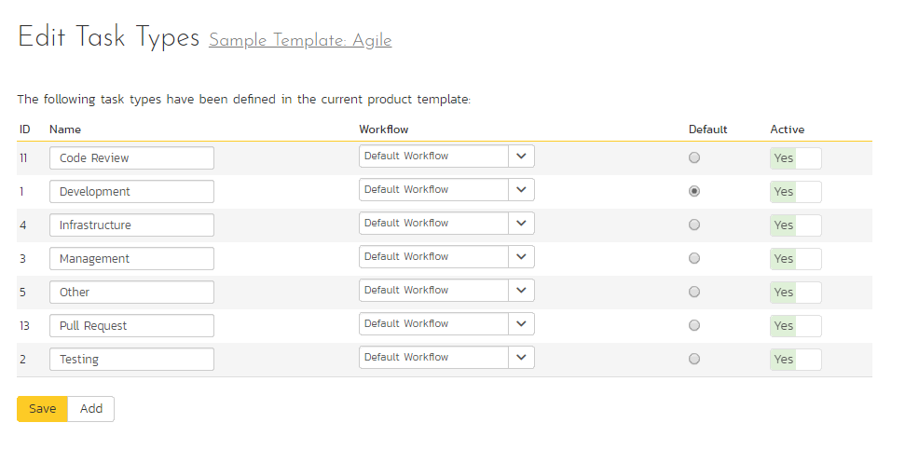

The screen displays a list of all the defined task types for the current template. By default, the screen will be populated with the standard SpiraPlan® task types. To edit an existing task type, change the name, associated workflow, set a default type, and/or change the active flag then click “Save”.

You can’t delete an existing task type, but to prevent it appearing in any drop-down-lists, change its active flag to “No” and click “Save”. To add a new type, click the “Add” button and a new row will be added to the list which you can now edit.

The associated workflow drop-down list allows you to specify which workflow the type will follow. This is a very powerful feature since it allows you to configure different workflows for different types.

The default radio button allows you to specify which type should be the default for newly created tasks. This is the type that a new task will be set to unless changed by the creator of the task. Note that you must have at least one active type, and you cannot set an inactive type as the default.

### 3.14.3. Task Workflows

Clicking on the “Task Workflows” link under the Planning heading, brings up the list of defined task workflows for the current template. A workflow is a predefined sequence of task statuses linked together by “workflow transitions” to enable a newly created task to be reviewed, prioritized, assigned, developed and tested, as well as to handle exception cases such as the case of a blocked or deferred task. The workflow list screen for the sample template is illustrated below:

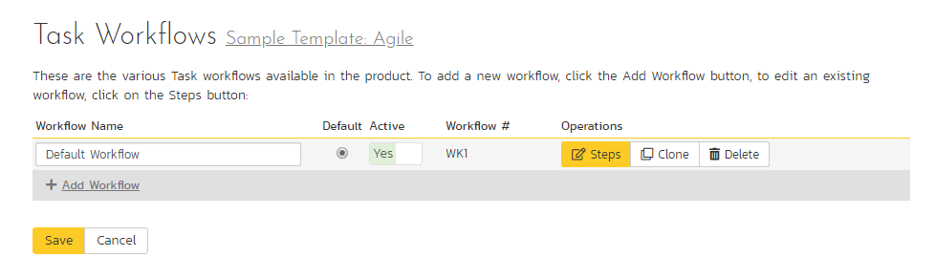

You can have as many workflows as you like in a template, but only one can be marked as the default. Each task type must be assigned to a workflow. To modify the name, default flag, and/or active flag of an existing workflow, change the values in the appropriate text-box, radio-button, or drop-down list and click the “Save” button. To add a new workflow, click the ‘Add Workflow’ link and a new workflow will be created with the standard SpiraPlan® steps and transitions.

Note: You can only assign an active workflow to a task type, and similarly you cannot make a workflow inactive that is currently linked to a task type. This is important as all task types need to be linked to an active workflow at all times.

#### 3.14.3.1. Edit Workflow Details

Clicking on the ‘Steps’ hyperlink of a workflow brings up the following screen that lists all the workflow steps and workflow transitions that comprise the workflow:

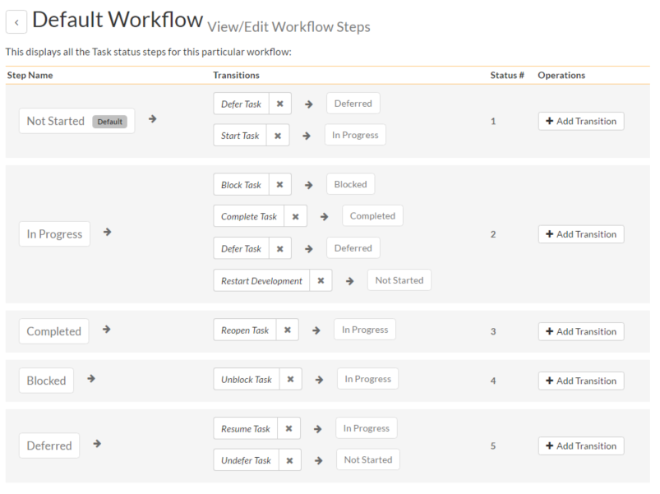

This page lists in the left-most column all the various task statuses defined in the system. The next column lists all the possible transitions that can occur *from that status*. In addition, with each transition is listed the name of the resulting *destination status* that the transition leads to. E.g. from the Not Started status, depending on your role (see later) the user can move the task to either Deferred or In Progress, depending on which transition the user takes.

Clicking on the name of a step or transition takes you to the appropriate details page (see below) where you can set the properties of the step or transition respectively. To delete an existing transition, click the ‘x button after the transition name, and to add a new transition, click the ‘Add Transition’ button in the Operations column.

#### 3.14.3.2. Edit Workflow Transition

When you click on the transition name link from the previous screen, you are taken to the workflow transition details screen:

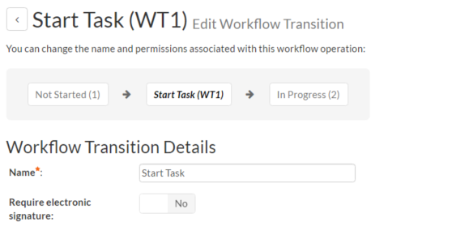

The top part of the screen is the “workflow browser” which illustrates how the transition relates to the workflow as a whole. It displays the current transition in the middle, with the originating and destination steps listed to either side. Clicking on either task status name will take you to the appropriate workflow step details page. This allows you to click through the whole workflow from start to finish without having to return to the workflow details page.

This part of the screen lets you change the name of the transition. If a digital signature from the user is required to authorize and record the transition, set the toggle to yes for “Require Electronic Signature”.

In addition, each transition has a series of conditions which need to be satisfied for a user to actually execute the transition (i.e. move the task from the originating status to the destination status):

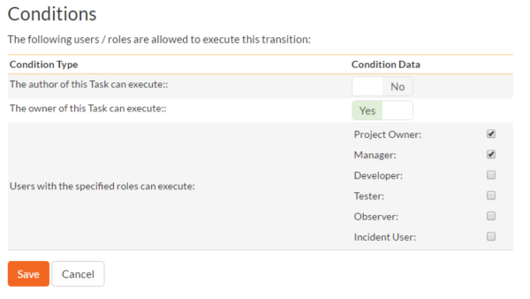

The conditions section allows you to set three types of user role:

* The author of the task can be allowed to execute the transition. For example, when a task is marked as Completed, the author might be allowed to move it to In Progress if there is still work remaining.
* The owner of the task can be allowed to execute the transition. For example, when a task is marked as In Progress, the assigned owner should be the only one who’s allowed to move it to Competed.
* A user with a specified role can be allowed to execute the transition regardless of whether they are the author or owner. For example a user with role “Manager” might want the power to defer all tasks regardless of ownership status.

You can set any of these conditions by changing the drop-down list and/or check-boxes and clicking the appropriate “Save” button.

#### 3.14.3.3. Edit Workflow Step

When you click on the task status name link from either of the previous screens, you are taken to the workflow step details screen:

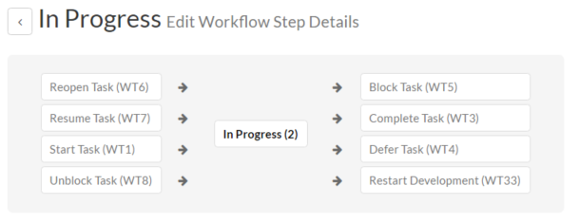

The top part of the screen is the “workflow browser” which illustrates how the step relates to the workflow as a whole. It displays the current task status in the middle, with the possible originating and destination transitions listed to either side. Clicking on either workflow transition name will take you to the appropriate workflow transition details page. This allows you to click through the whole workflow from start to finish without having to return to the workflow details page.

This page allows you to define the behavior of the various task fields (i.e. those that are a standard part of SpiraPlan® such as Priority):

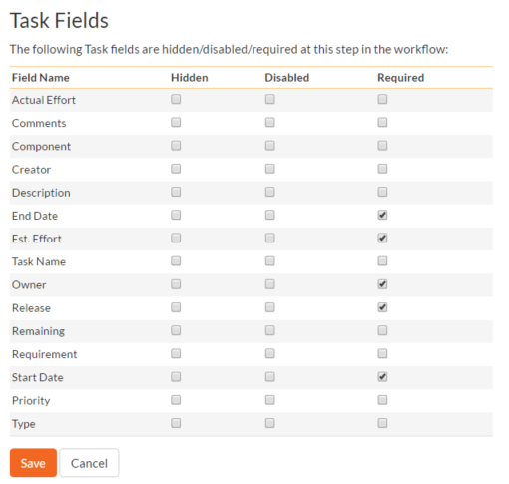

This page also allows you to define the behavior of the various task custom properties for this particular step in the workflow:

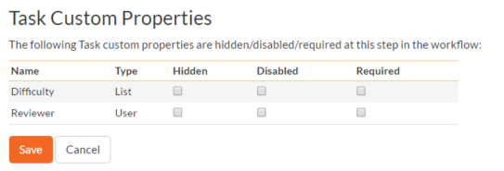

You can set each of the fields/custom properties as being:

* **Hidden** – The field / custom property will not be displayed when the task is in this status
* **Disabled** – The field / custom property will be displayed, but will be greyed-out and read-only
* **Required** – The field / custom property will be required when the task is in this status

Note that you cannot set a field/property as being required and either disabled or hidden since this would prevent a user from ever updating the task. For example, when a task is in the Not Started status, you might make the owner field hidden (since the author shouldn’t need to know who will ultimately own it), when it gets to the In Progress status, you might make the field enabled and required, and when it gets to the Completed status, you might make it disabled. This allows you to tailor the information gathered to the appropriate place in the workflow.

To actually make these changes, all you need to do is select the appropriate checkboxes in the list of fields and custom properties and click the corresponding “Save” button.

## 3.15. Template: Risks

This section contains administrative options that are specific to the risk functionality in the system.

### 3.15.1. Edit Types

The following screen is displayed when you choose the “Types” link from the Incidents section of the administration menu:

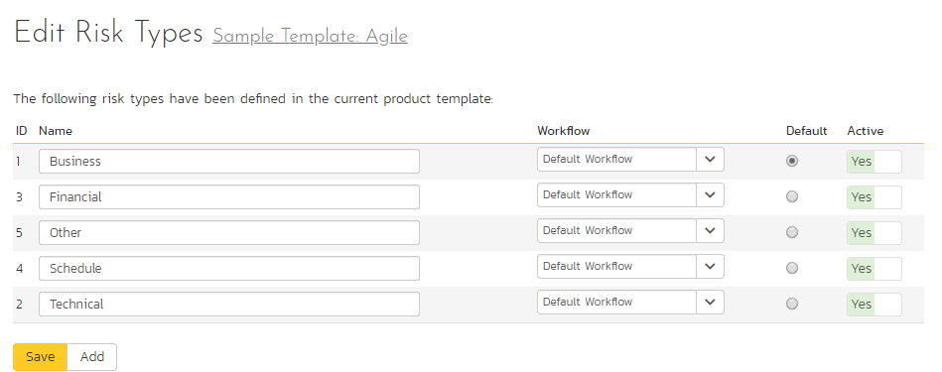

The screen displays a list of all the defined risk types for the current template. By default, the screen will be populated with the standard SpiraPlan® risk types. To edit an existing type, change the name, associated workflow, set a default type and/or change the active flag then click “Save”.

You can’t delete an existing risk type, but to prevent it appearing in any drop-down-lists, change its active flag to “No” and click “Save”. To add a new type, click the “Add” button and a new row will be added to the list which you can now edit.

The associated workflow drop-down list allows you to specify which workflow the type will follow. This is a very powerful feature since it allows you to configure different workflows for different risk types.

The default radio button allows you to specify which type should be the default for newly created risks. This is the type that a new risk will be set to unless changed by the creator of the risk. Note that you must have at least one active risk type, and you cannot set an inactive type as the default.

### 3.15.2. Edit Statuses

The following screen is displayed when you choose the “Statuses” link from the Risks section of the administration menu:

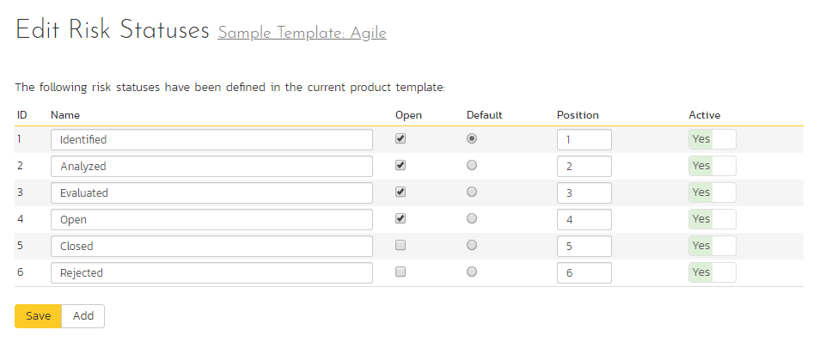

The screen displays a list of all the defined risk statuses for the current template. By default, the screen will be populated with the standard SpiraPlan® risks statuses. To edit an existing status, change the name, open check-box, set it as the default status and/or change the active flag then click “Save”.

You can’t delete an existing risk status, but to prevent it appearing in any drop-down-lists, change its active flag to “No” and click “Save”. To add a new risk status, click the “Add” button and a new row will be added to the list which you can now edit.

The open check-box allow you to specify if the risk status should be considered open or not, which means it is would be eligible for display in the various sections of the user’s home page and the product home page that list open risks. The default radio button allows you to specify which risk status should be the default for newly created risks. This is the status that a new risk will be set to when first created, and acts as the first step in the risk workflow. Note that you must have at least one active status, and you cannot set an inactive status as the default.

### 3.15.3. Impact

The following screen is displayed when you choose the “Impact” link from the Risks section of the administration menu. The impact of a risk specifies how serious it will be if the risk happens.

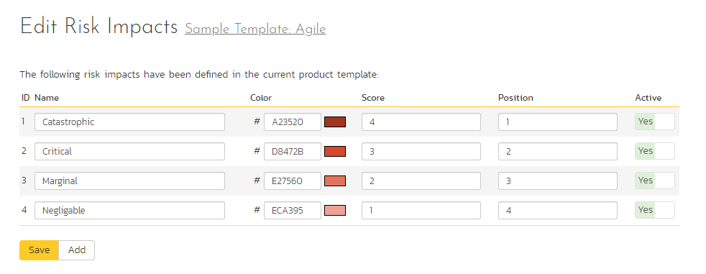

The screen displays a list of all the defined risk impacts for the current template. By default, the screen will be populated with the standard SpiraPlan® risk impacts. To edit an existing impact: change the name, color, score (which is used, together with a risks probability to calculate its exposure), position, or change the active flag then click “Save”. Note that you can either enter the hexadecimal RRGGBB code for the color or use the pop-up color picker.

You can’t delete an existing impact, but to prevent it appearing in any drop-down-lists, change its active flag to “No” and click “Save”. To add a new impact, click the “Add” button and a new row will be added to the list which you can now edit.

### 3.15.4. Probability

The following screen is displayed when you choose the “Probability” link from the Risks section of the administration menu:

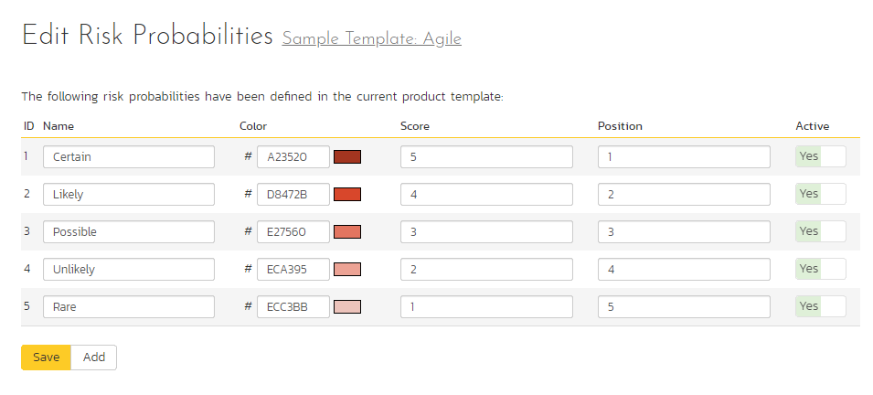

The screen displays a list of all the defined risk probabilities for the current template. By default, the screen will be populated with the standard SpiraPlan® risk probabilities. To edit an existing probability: change the name, color, score (which is used, together with a risks impact to calculate its exposure), position, or change the active flag then click “Save”. Note that you can either enter the hexadecimal RRGGBB code for the color or use the pop-up color picker.

You can’t delete an existing risk probability, but to prevent it appearing in any drop-down-lists, change its active flag to “No” and click “Save”. To add a new risk probability, click the “Add” button and a new row will be added to the list which you can now edit.

### 3.15.5. Risk Workflows

Clicking on the “Workflows” link in the Administration menu brings up the list of defined risk workflows for the current template. A workflow is a predefined sequence of risk statuses linked together by “workflow transitions” to enable a newly created risk to be reviewed, prioritized, assigned, resolved and closed. The workflow list screen for a sample template is illustrated below:

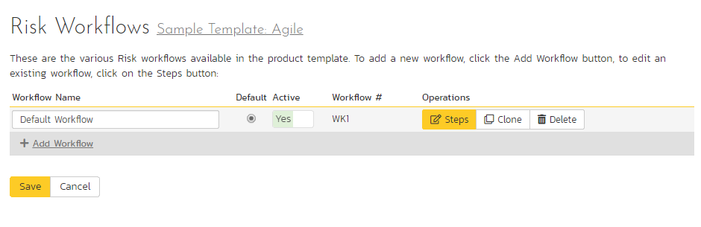

To modify the name, default status, notify and/or active flags, change the values in the appropriate text-box, radio-button, check-box or drop-down list and click the “Save” button. To add a new workflow, click the “Add” button and a new workflow will be created with the standard SpiraPlan® steps and transitions.

You can have as many workflows as you like in a template, but only one can be marked as the default. Each risk type is assigned to a workflow; this allows you to have different risk types follow different paths from creation of closure. However, when a new risk type is created, it will be initially associated with the template’s default workflow.

Note: You can only assign an active workflow to a risk type, and similarly you cannot make a workflow inactive that is currently linked to a risk type. This is important as all risk types need to be linked to an active workflow at all times.

#### 3.15.5.1. Edit Workflow Details

Clicking on the “Steps” button of a workflow brings up the following screen that lists all the workflow steps and workflow transitions that comprise the workflow:

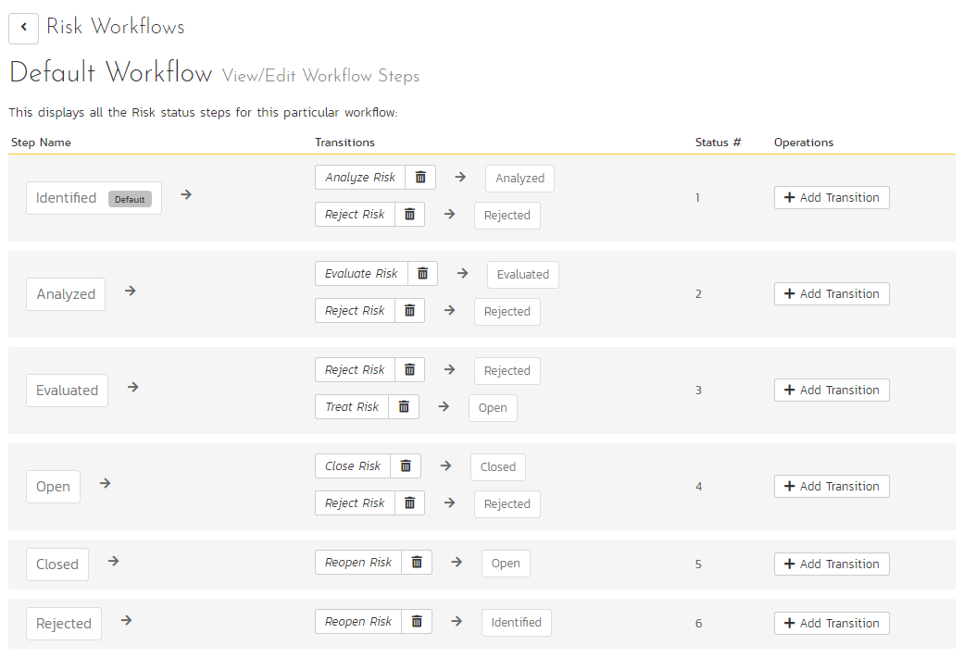

This page lists in the left-most column all the various risk statuses defined for the template. The next column lists all the possible transitions that can occur *from that status*. In addition, with each transition is listed the name of the resulting *destination status* that the transition leads to. E.g. from the evaluated status, depending on your role (see elsewhere in this manual) you can move the risk to either rejected, or open depending on which transition the user takes.

Clicking on the name of a step or transition takes you to the appropriate details page (see below) where you can set the properties of the step or transition respectively. To delete an existing transition, click the “x” button after the transition name, and to add a new transition, click the “Add Transition” button in the Operations column.

#### 3.15.5.2. Edit Workflow Transition

When you click on the transition name link from the previous screen, you are taken to the workflow transition details screen:

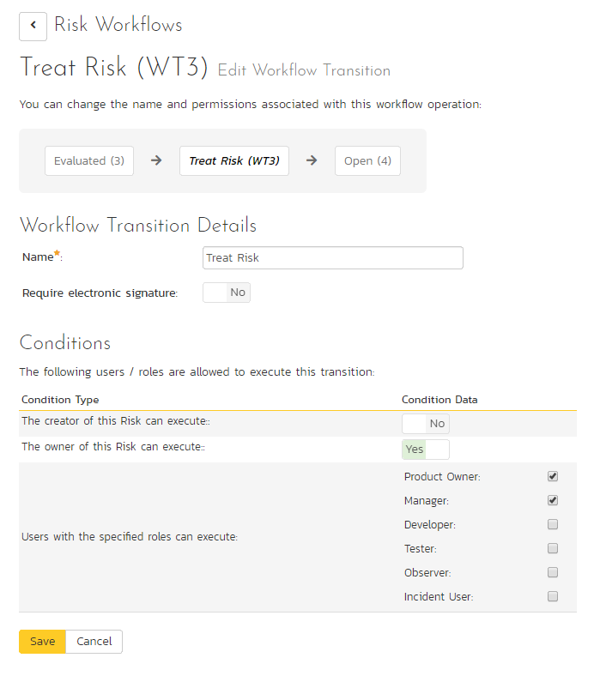

The top part of the screen is the “workflow browser” which illustrates how the transition relates to the workflow as a whole. It displays the current transition in the middle, with the originating and destination steps listed to either side. Clicking on either risk status name will take you to the appropriate workflow step details page. This allows you to click through the whole workflow from start to finish without having to return to the workflow details page.

If a digital signature from the user is required to authorize and record the transition, set the toggle to yes for “Require Electronic Signature”.

Each transition has a series of conditions which need to be satisfied for a user to actually execute the transition (i.e. move the incident from the originating status to the destination status).

#### 3.15.5.3. Edit Workflow Step

When you click on the incident status name link from either of the previous screens, you are taken to the workflow step details screen:

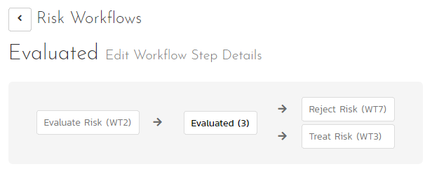

The top part of the screen is the “workflow browser” which illustrates how the step relates to the workflow as a whole. It displays the current risk status in the middle, with the possible originating and destination transitions listed to either side. Clicking on either workflow transition name will take you to the appropriate workflow transition details page. This allows you to click through the whole workflow from start to finish without having to return to the workflow details page.

This page allows you to define the behavior of the various risk fields (i.e. those that are a standard part of SpiraPlan® such as probability):

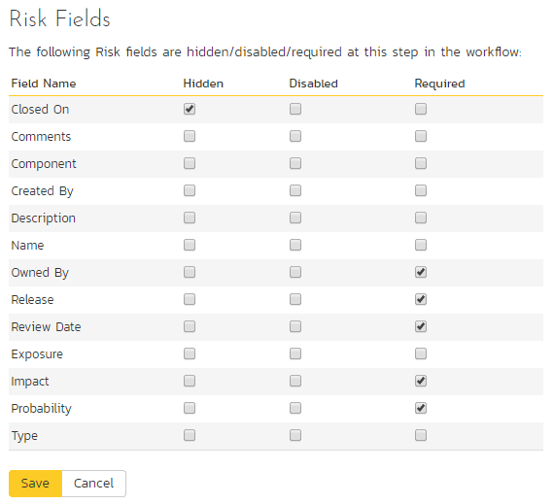

This page also allows you to define the behavior of the various risk custom properties for this particular step in the workflow:

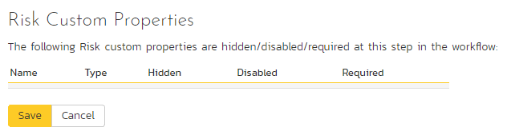

You can set each of the fields/custom properties as being:

* **Hidden** – The field / custom property will not be displayed when the risk is in this status
* **Disabled** – The field / custom property will be displayed, but will be greyed-out and read-only
* **Required** – The field / custom property will be required when the risk is in this status

Note that you cannot set a field/property as being required and either disabled or hidden since this would prevent a user from ever updating the risk. To make any changes, select the appropriate checkboxes in the list of fields and custom properties and click the “Save” button.

## 3.16. Template: Custom Properties

SpiraPlan allows you to customize all of the artifacts in the system (requirements, test cases, incidents, etc.) by adding user-defined custom properties in addition to the built-in fields. You can create a variety of different types of custom properties. This section describes how to setup different custom lists and custom properties in your templates.

Artifacts in SpiraPlan can have up to 30 different custom properties per artifact-type, per template. There are different types of custom properties allowed:

* **Text**: Normal or Rich-Text field.
* **Integer**: Whole-Number entry.
* **Decimal**: Fractional number entry (currency, etc.)
* **Boolean**: Simple yes/no (on/off) checkbox.
* **Date**: Date selector.
* **List**: Custom List selector.
* **Multi-List**: Custom List selector that allows multiple values.
* **User**: List of assignable users.

Each custom property can have optional settings applied to it. Optional settings are as follows. (Note that not all settings are allowed for all property types.)

* **Default**: The default value when a new artifact is created.
* **Allow Empty**: Whether or not an empty value is allowed.
* **Precision**: (Decimal Only) How many decimal places is allowed (or the value is rounded to).
* **Minimum Value**: The minimum value allowed.
* **Maximum Value**: The maximum value allowed.
* **Minimum Length**: The minimum length of the data required in the field.
* **Maximum Length**: The maximum length of the data allowed in the field.
* **Rich Text**: Whether or not the text field allows HTML or not.
* **Custom List**: The defined Custom List for the field that users can select from.

***Important***: Note that setting ‘Allow Empty’ to No will override any *workflow step* definitions, and will always require a value to be entered in, even if the workflow is configured to have the field disabled!

### 3.16.1. Edit Custom Lists

If you are planning on having any list based custom properties in your template, then you first need to create and populate the custom template lists that the user will be able to select from. These lists are stored separately from the individual artifact types so that you can have one set of values (e.g. list of operating systems under test) be reused by multiple artifact types.

The following screen is displayed when you choose the “Custom Lists” link from the Administration menu:

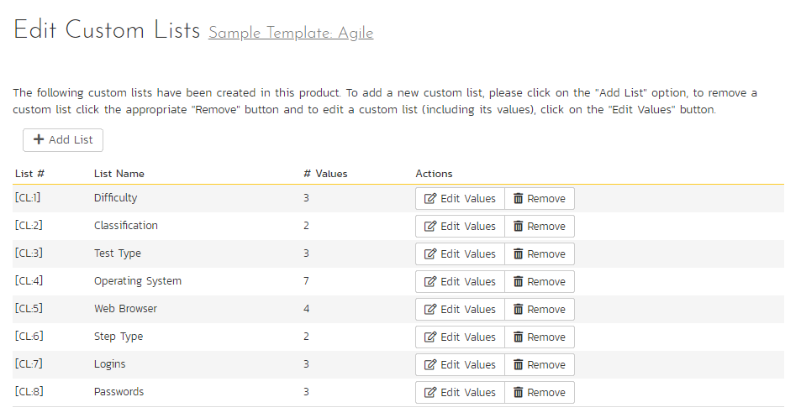

The screen displays all the custom lists currently defined within the template, together the number of values associated with each list. By default the screen will initially be empty so the first thing you need to do is click “Add List” to create a new custom list:

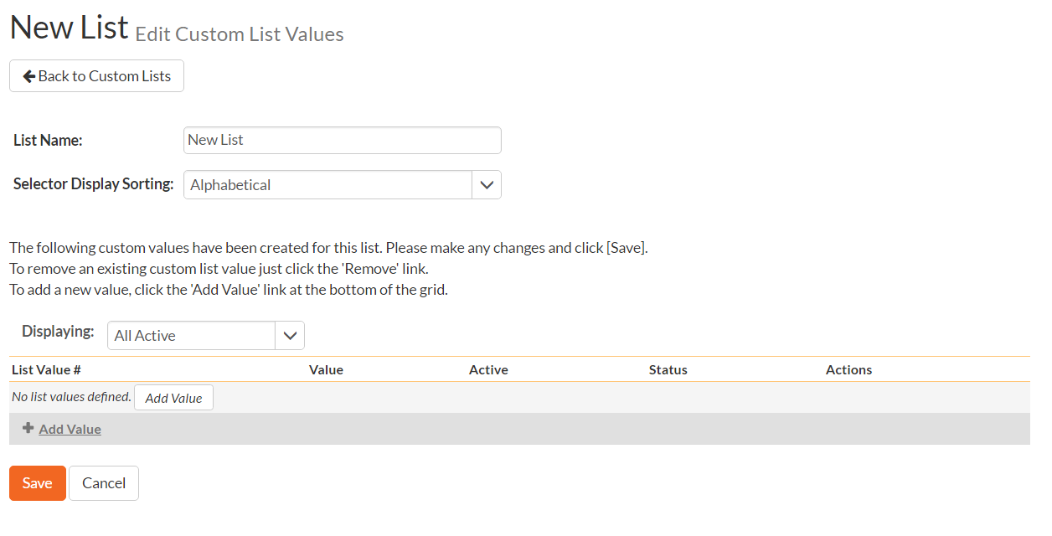

After changing the name of the list, and specifying whether the values will be ordered by their name or the order in which they were entered (called by ID), you can either click “Save” to commit the change, or click the “Add Value” option to add some list values:

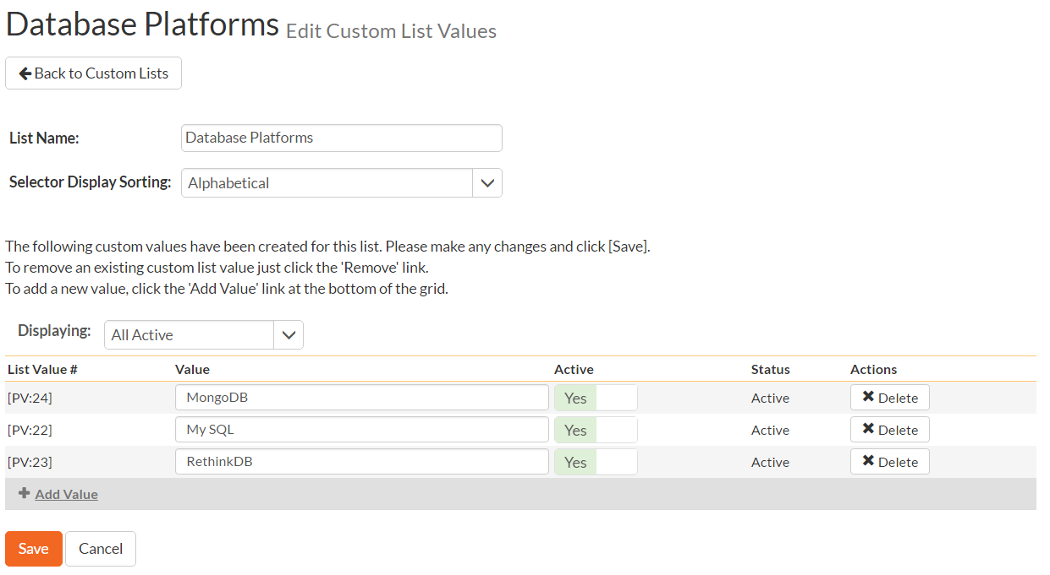

This is the set of values that the user will select from the drop-down list when the custom property is displayed. You can change the display to include:

* **All Active** – displays only custom list values that are active
* **All But Deleted** – displays all custom list values that are active or inactive but have not been deleted
* **All** – displays all custom list values, including those that have been deleted

To add a new custom list value, click the “Add Value” button and a new row will be added to the list which you can now edit. To edit an existing custom list value, change the name in the textbox and click “Save”. To delete a custom list value, click on the “Delete” hyperlink. If you want to remove an item from the list temporarily, you can set its Active dropdown list to ‘No’, if you want to remove an item permanently, just click the ‘Delete’ button.

*Note: Even if you delete a custom list value, there is an option to undelete by simply changing the display selection to “All” and clicking the ‘Undelete’ hyperlink next to a deleted value.*

To edit an existing custom list, you just need to click on the “Edit Values” button to display the custom list name and list of associated values (which is the same screen as the one displayed for a new list). To remove a custom list from the template, just click on the “Remove” button next to the custom list and the list and all its associated values will be deleted from the template.

### 3.16.2. Edit Custom Properties

This option is used to actually define the custom properties associated with each artifact type in the template. The following screen is displayed when you choose the “Custom Properties” link from the Administration menu:

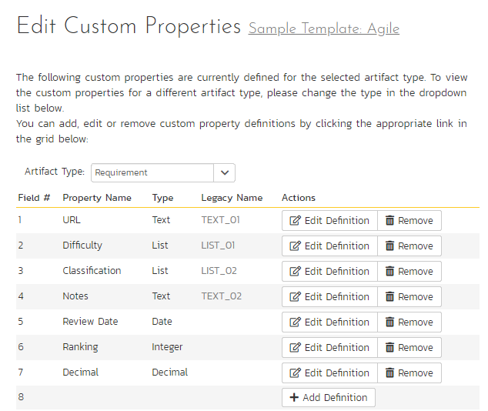

The screen displays a list of all the possible custom properties for a particular artifact type for the current template. Each artifact type (requirement, test case, etc.) can have up to thirty (30) custom properties of various types.

Initially the screen will default to showing the existing custom properties for a template’s Requirements; to change the list to a different artifact type (e.g. Incidents), all you need to do is change the artifact type in the drop-down-list. This will refresh the list to show the custom properties for that artifact type.

To edit an existing custom property definition or add a new definition, click the “Edit Definition” button for a specific property, and the following dialog will be displayed:

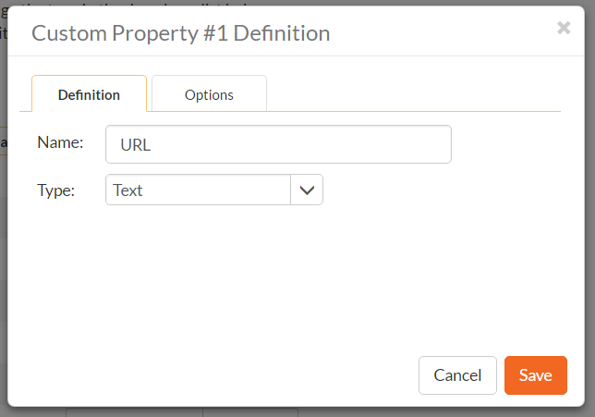

The fields visible will vary depending on the type of custom property you have selected, but every custom property will need to have a Name and a Type. The Name is the caption that will be shown to the user when viewing or editing the artifact. The type is the type of data the field allows. If the custom property is either a List or Multi-List type, you will need to choose the associated Custom List that you previously defined.

Under the Options tab will be available options that can be set for the custom property:

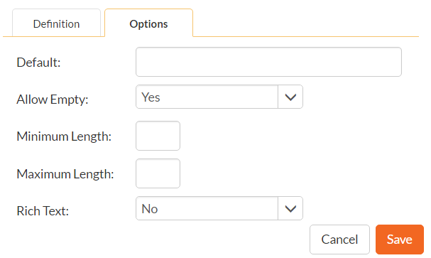

When finished, click the ‘Save’ button and you will be returned to the Custom Property list.

***Important***: When changing a custom property’s type or removing a custom property, the data is not actually removed from the artifact. Therefore, if you change a custom property from a date type to a text custom property, the field will display the old date value until it is changed by the user.

## 3.17. Template: Notifications

Section 3.3.9. above discussion how to configure emails across the entire system. However, notification events can be configured in the Notifications section of the template administration.

### 3.17.2 Notification Templates

Notification templates are used by notification events, and are defined for each artifact type in the template.

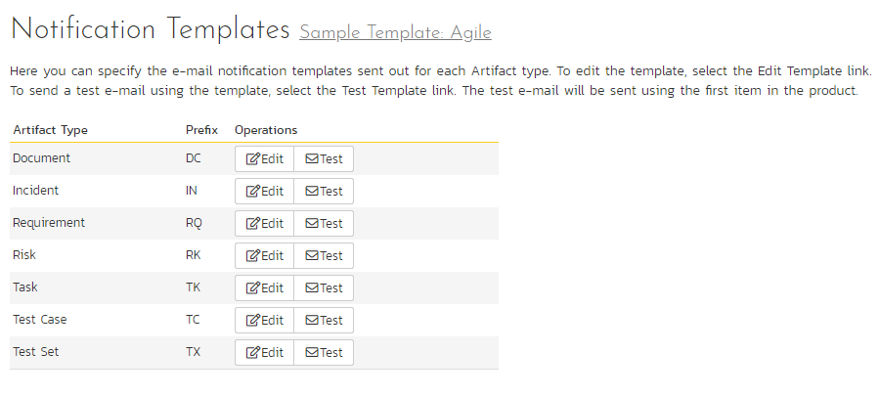

To edit a template, click the Edit button. To send a test email notification to yourself using the current template, click the Test button.

Clicking the Edit button will take you to a page similar to the following. Depending on the artifact type you selected, the list of available fields will vary.

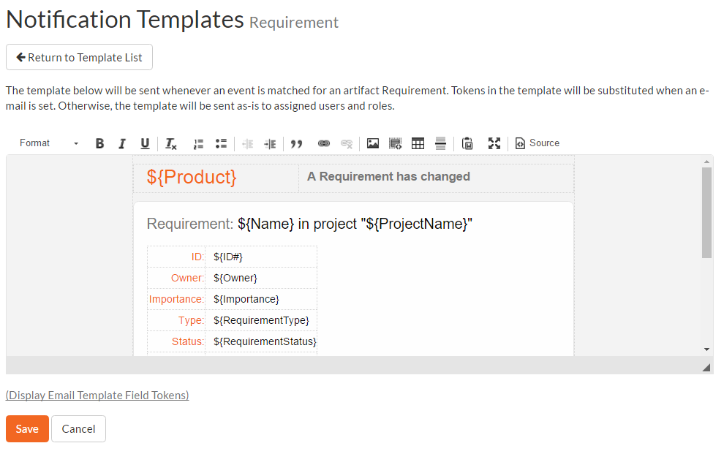

On this screen you are presented with the same rich text editor available elsewhere in the application. Displayed in it is the current template (with template tags showing) for the artifact. Template tags start with a $ (dollar sign) and then a string name enclosed in {} parentheses. When email notifications are sent, tokens will be replaced with specific information from the artifact that the notification is being sent for. Invalid tokens will be stripped from the template text. Clicking the link “(Display Email Template Field Tokens” to see a list of available tokens to insert into the textbox for easy selecting and editing.

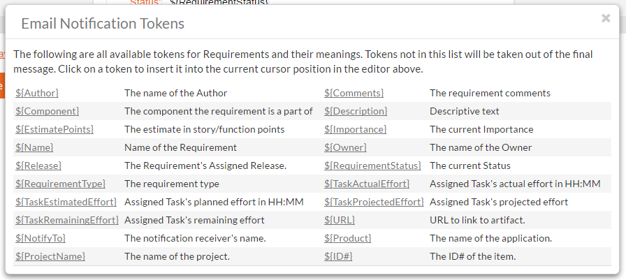

If HTML notifications are disabled, the template will be converted to plain text before sending.

When finished, click the update button to save your new template. The new template will take effect immediately.

### 3.17.3 Notification Events

The Notification Events section is where template administrators can set up when and to whom notifications are sent out to users of the system. Clicking on the Notification Events link will present you with a list of all events defined for the current template:

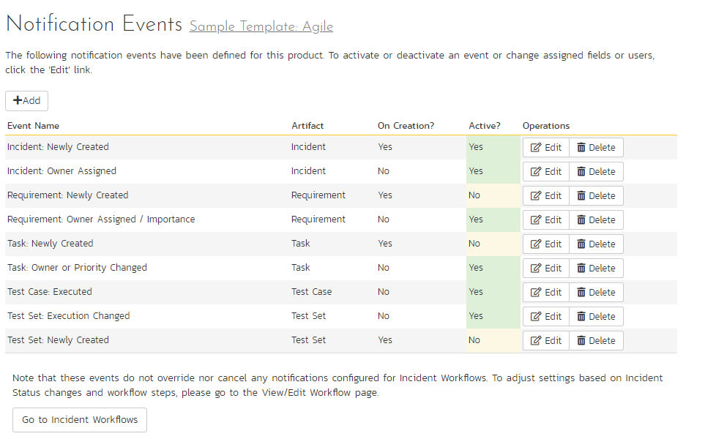

**Note:** These events can handle all changes to any of the artifacts except changes handled by Status changes to Incidents. Incident status changes are handled through the Workflow configuration.

When clicking on the Edit or Add buttons, you will be presented with the event details screen:

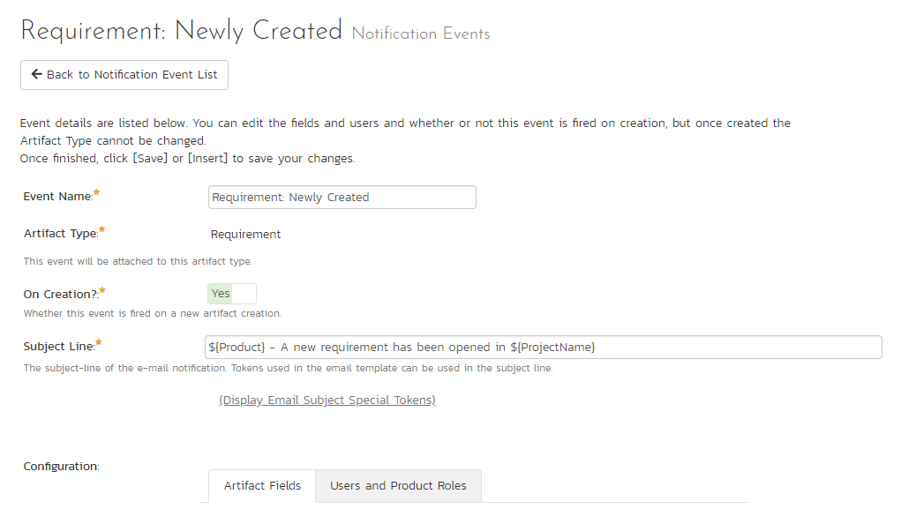

The top section defines general configuration items for the event:

* **Event Name:** used to name the event, only used for administrative purposes.
* **Artifact Type:** The artifact type this event is attached to. Once an event is created, the artifact type cannot be changed.
* **On Creation?** If set to yes, this event will fire when an artifact is created, as well as when any configured fields are changed.
* **Active?** If set to yes, this event is active and will send notifications when configured fields are modified.
* **Subject Line:** The subject line of the notification email.

The Artifact Fields will let you configure which fields will cause this notification to send an email notification:

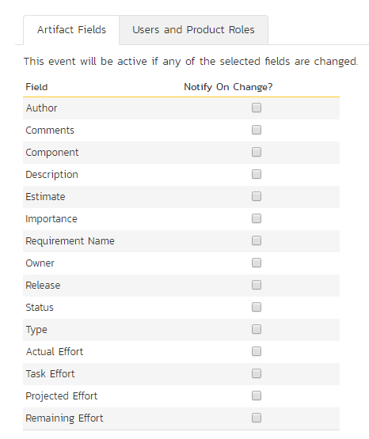

Selected fields are treated in an OR-based query, so that if you have two or more fields checked for an event, the event will send a notification if **either** of the two fields are changed. Depending on the artifact type configured above, the available fields will vary.

The last section is the configuration of whom to send the notifications to:

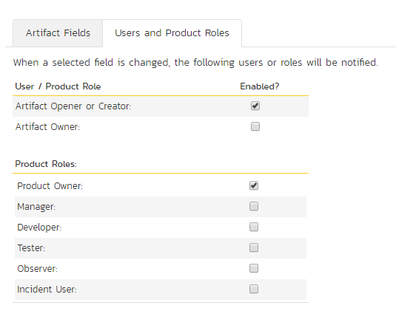

If a user belongs to more than one group or they have manually signed up to receive notifications to any changes in the artifact, they will only receive one notification for the artifact change.

# 4. Appendices

There are no appendices at this time.

#### Legal Notices

This publication is provided as is without warranty of any kind, either express or implied, including, but not limited to, the implied warranties of merchantability, fitness for a particular purpose, or non-infringement.

This publication could include technical inaccuracies or typographical errors. Changes are periodically added to the information contained herein; these changes will be incorporated in new editions of the publication. Inflectra® Corporation may make improvements and/or changes in the product(s) and/or program(s) and/or service(s) described in this publication at any time.

The sections in this guide that discuss internet web security are provided as suggestions and guidelines. Internet security is constantly evolving field, and our suggestions are no substitute for an up-to-date understanding of the vulnerabilities inherent in deploying internet or web applications, and Inflectra® cannot be held liable for any losses due to breaches of security, compromise of data or other cyber-attacks that may result from following our recommendations.

The section of the manual that describes modifying the Windows System Registry (“Registry”) should only be attempted by experienced Windows administrators who are familiar with its organization and contents. Inflectra® cannot be held liable for any losses due to damage to the system registry made by inexperienced personnel.

SpiraTest®, SpiraPlan®, SpiraTeam® and Inflectra® are registered trademarks of Inflectra Corporation in the United States of America and other countries. Microsoft®, Windows®, Explorer® and Microsoft Project® are registered trademarks of Microsoft Corporation. All other trademarks and product names are property of their respective holders.

Please send comments and questions to:

Technical Publications

Inflectra Corporation

8121 Georgia Ave

Suite 504

Silver Spring, MD 20910

U.S.A.

[*support@inflectra.com*](mailto:support@inflectra.com)